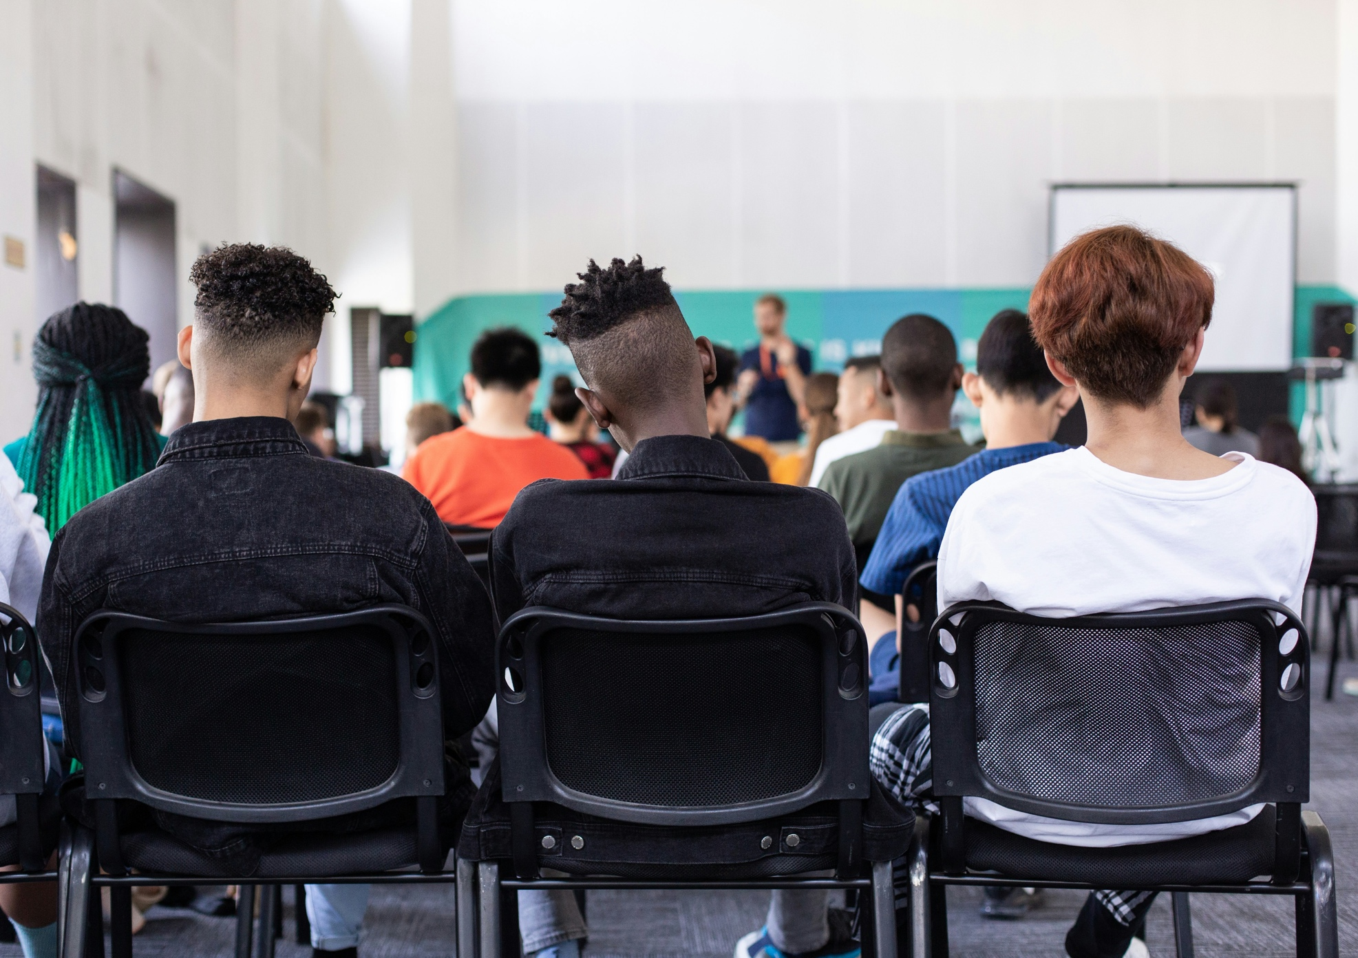

**The value and impact of Scotland’s libraries**



Preliminary findings from **secondary school** librarian surveys

Report presented by Scottish Book Trust

Report authored by   
Éadaoín Lynch

10 December 2024

**scottishbooktrust.com**

**Contents**

Executive summary 3

Aims 3

Methods 4

Findings 4

Conclusion 8

Main findings 11

Settings and librarian roles 11

Local authority 11

Qualified librarians 12

Current role 13

Provision for secondary school library services 17

Children and young people's reading for pleasure 25

Reading activities 29

Reading recommendations 31

Curriculum-based learning and the attainment gap 37

Poverty-related attainment gap 42

Digital inclusion: digital poverty, access and support 50

Digital inclusion: digital and media literacy 59

Active citizenship 62

Reaching a diverse audience 63

Safe spaces 65

Democratically engaged and informed communities 72

Final snapshot 74

Conclusion 77

References 78

## 

## Executive summary

Beginning in Libraries Week 2023, Scottish Book Trust undertook an independent research project into the value and impact of both public and school libraries in Scotland, in partnership with the National Library of Scotland (NLS), the Scottish Library and Information Council (SLIC), and the Chartered Institute of Library and Information Professionals in Scotland (CILIPS).

Scotland's school libraries have no legal statutory duty for adequate library provision. Scotland's public libraries, though they do have a statutory duty for adequate library provision, have no enforced standard for what they must offer. As a result, across the public and school library sector, Scotland's communities face a lack of equitable access.

### Aims

Scottish Book Trust works across every local authority in Scotland, striving to offer opportunities for all people to tell their stories; as such, we are uniquely positioned to bear witness.

This research intends to showcase how public and school libraries address inequality across many intersections of Scotland's communities, through the following thematic approaches:

* Reading for pleasure
* Learning opportunities / closing the poverty-related attainment gap
* Digital inclusion
* Active citizenship

### Methods

This interim report details preliminary findings from the survey completed by secondary school librarians between October 2023 and January 2024.

A separate report details the findings from the primary school librarian survey.

Further findings from in-depth librarian interviews, library user feedback, and quantitative data gathering will be available with the final report in early 2025.

There was one survey each for public librarians, primary school librarians and secondary school librarians. The response rate was positive:

1. Public librarian survey – 315 responses total  
   (The report arising from this survey is already available on the Scottish Book Trust website.)
2. Primary school librarian survey – 41 responses total
3. Secondary school librarian survey – 140 responses total

A note on the term 'librarian': in this report, this term includes both qualified librarians and any other library staff seeking to support their service. School libraries are staffed variably by pupil volunteers, teachers, school management, and/or career librarians, all of whom have fed into these findings. The breakdown of qualified and unqualified librarians in the quantitative research serves to indicate those who have had specialised training in information management – it is not a value judgement on the quality of any one service. As such, 'librarian' in this report indicates any school library worker.

### Findings

'Aside from promoting a culture of reading for pleasure, it is vital to have an information professional at hand to offer advice on research and finding information. This is particularly important in an age where information (and misinformation) is in abundance.' – School librarian

Of the 140 secondary school librarians (representing approximately 39% of Scotland's secondary schools) who participated in the survey, these findings show that:

* Nearly 3 out of 5 (59%) secondary school librarians reported restrictions on funding / resource
* The overwhelming majority of respondents (87%) are funded by their local authority. Local Government, in 2024/5, faces a £62.7m cut to core revenue budget and a [£54.9m cut to core capital budget](https://www.cosla.gov.uk/__data/assets/pdf_file/0023/47381/COSLA-Briefing-Scottish-Budget-and-Local-Government-Settlement-24-25-Final-1.pdf)[1]
* Nearly a quarter of librarians (23%) reported restriction on the dedicated school librarian role, in terms of hours or remit
* 91% of respondents indicated that their provision is managed by a librarian, with a further 10% managed or co-managed by pupil assistants

However, though there may be a dedicated library space and a librarian, that librarian may not be qualified, they may have inconsistent and uncertain financial resource, they may be excluded from making decisions affecting their library including the use of resource, and their time and capacity may be split across multiple branches.

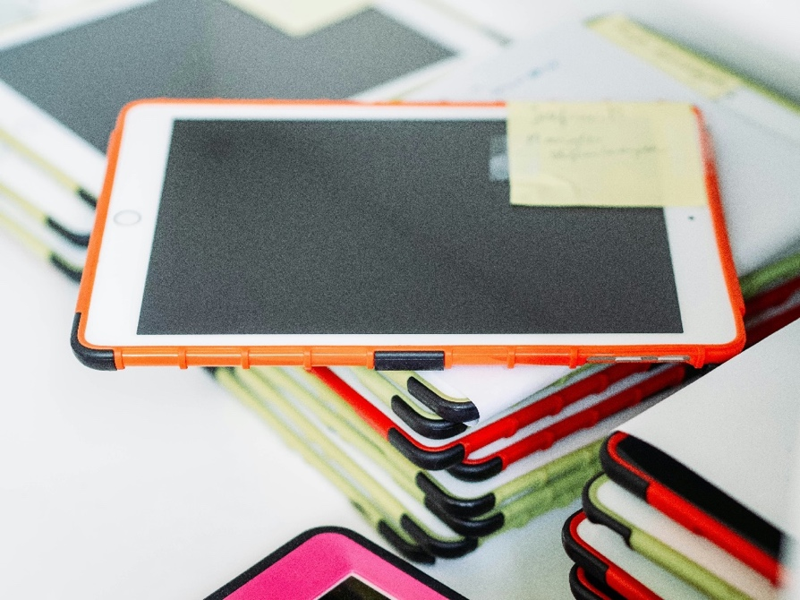

In promoting **reading for pleasure**, over 3 in 5 librarians (66%) noted time constraints as a barrier to offering reading recommendations or further support for pupil reading. Over 1 in 3 (35%) also cited capacity constraints, and a further 23% noted behaviour problems:

* 'Too much time dealing with unruly pupils who are sent to the library as there is "nowhere else for them to go". This restricts time I get to spend helping those who would appreciate it.'

Some librarians noted that the lack of budget to sufficiently stock their library led them to buy books out of their own pocket:

* 'I buy the books from 2nd [hand] stores and sites, I cannot afford whole sets, sad when a pupil loves a book and I can't afford to buy more. I buy from my wage not a budget as there is no budget for the library.'

In closing the **poverty-related attainment gap**, nearly 4 in 5 librarians (79%) feel the library is 'very' or 'quite' important in providing additional opportunities to pupils (e.g. games clubs; creative writing clubs; coding class; ICT skills classes). However, librarians also noted barriers to offering additional opportunities to their pupils:

* 'Library is only open for 13 mins at lunchtime, whilst these activities are offered not many take them up.'

The nature of poverty results in an absence of freely-available supports or resources to help people become informed and empowered. It's clear that many librarians feel their school library is intrinsic to providing equity of access, a safe space for pupils, and opportunities to develop greater skills, and they see these functions as a crucial part of addressing the poverty-related attainment gap.

Existing research confirms that one pupil in every five in the UK currently faces **digital poverty**[2], in a world that is increasingly online. These findings show that nearly half (47%) reported their school and/or its pupils face digital poverty:

* 'During the lockdowns our school had to distribute laptops to pupils who had no computers at home. In fact a few families didn't have internet service.'

Nearly all respondents (98%) felt it was 'very' or 'quite' important that the library service supports digital access / inclusion for pupils. No librarians indicated that it was 'a little' or 'not at all' important. One librarian, however, indicated the way that ICT provision can overwhelm the value of the library:

* '[The library] should be the heart of the school but it's viewed as an IT suite with books.'

Moreover, well over half of librarians (55%) reported that their library currently supports pupils with media / digital literacy skills, but a further third (34%) reported that it does not.

Digital poverty is about more than lack of devices: families still need to be able to access help to use devices and systems effectively and safely and children and young people need to learn digital skills. As one librarian noted,

‘'There are many pupils who can't effectively interact with the online environment to find information. Pupils lack the skills to discern bias and the reliability of information sources.

All pupils in [the local authority] are issued with a Chromebook. Many pupils come to school with devices uncharged or devices left / lost at home which becomes a barrier to learning.'

Over 4 in 5 librarians (88%) agreed their school library reaches a **strongly diversified audience**, and nearly all librarians (95%) agreed that their school library offers a safe space to their pupils.

In fact, many librarians shared anecdotes of the ways in which their library supports attainment, by being a **safe space**:

* 'Some pupils have a habit of absconding if they become overwhelmed, but these pupils are taught that instead of leaving the building they can go to the library, and they will be welcomed there without judgement.'
* 'The library has always been the place that guidance teachers send pupils who are struggling at lunchtimes / breaks. Without this space some pupils might choose not to come to school.'

When asked what barriers the library faces in providing a safe space, 2 in 5 librarians (40%) cited antisocial behaviour; nearly the same again noted short staffing (39%), a third (33%) noted limited opening hours, and 29% reported noise pollution.

Across the survey, librarians reported inconsistencies in management support – in those cases where support was lacking from various levels of leadership, it has a demonstrable impact on the success of the library and its pupils:

* 'DHT [Deputy Headteacher] quoted as saying "no point keeping non-fiction books, as the pupils can look things up on internet if they want to know something".'
* ‘I try my best as a librarian to provide students with transferrable skills – digital makers club / student library assistants, etc. – but I am mostly invisible to SMT. I don't think they're aware what goes on.’
* 'Lack of interest in books / reading from teaching staff; classes don't visit as much, preferring students to google everything on Chromebooks. SMT do not value the library service other than on paper (aspirations in SIP); they take little practical interest. I no longer have a library assistant. My library has just been reduced by 50% in size, and my budget looks to be vastly reduced – not sustainable.'

### Conclusion

‘It should be the heart of the school but it's viewed as an IT suite with books.' – School librarian

The evidence gathered from the librarian surveys clearly shows that school libraries have a profound, wide-ranging impact across all four themes of this research – reading for pleasure, learning opportunities, digital inclusion and active citizenship – and that they are crucial in addressing and resolving inequity.

Secondary school libraries across the UK face dwindling resources, as outlined by research from the Great School Libraries campaign: it reported in 2023 that, 'it seems clear that while spaces are being held onto, the overall quality of provision is dropping, which is having a noticeable impact on children's reading'[3]. Where 86% of UK secondary schools have a designated library space, '80% use their library for other purposes, further reducing the time when it can be used by pupils'.[4] The situation in Scotland is even more stark:

'The proportion of schools with a designated school library area on-site varies by country; with nearly a quarter of schools [in Scotland] not having a school library space (22%).'

Funding is also a continual issue – where 15% of secondary school libraries across the UK are trying to provide services with no financial support, the figures for Scotland are likely to be worse:

'Only a quarter of schools in Scotland have a designated library budget compared with schools in England (25% compared to 36% in England). Nearly two thirds (63%) report having no budget whatsoever; while 12% said they didn’t know or would prefer not to say.'

The findings from secondary school librarians in this report demonstrate much in parallel with what the Great School Libraries campaign described. They face increasing restrictions on their resource, overwhelming demands on their time and capacity, and in some cases a lack of understanding from various levels of leadership about the value of their library.

There is no statutory requirement for Scotland’s schools to have libraries, so there is no national standard for how they are run, stocked, accessed, or supported. Librarians across Scotland, many of whom have 10+ years of professional service, experience reduced job security, budgets, working space, time, and capacity against a backdrop of increasing demand and need for their services.

School libraries need funding, secure staffing provision and more public and management support to allow them to continue to be centres for unbiased information, a remedy for digital inequality, safe spaces without judgement or expectation, and a crucial point of contact to support pupil wellbeing and achievement.

## Main findings

### Settings and librarian roles

#### Local authority

The first question, which gained 140 responses, asked respondents to identify their local authority.

29 out of 32 local authorities were represented in the secondary school survey. The highest response rates were from Highland (10% of total responses), Aberdeenshire (9%) and East Dunbartonshire, City of Edinburgh and East Ayrshire (each 6%).

There were no responses obtained from Argyll and Bute, Clackmannanshire or Comhairle nan Eilean Siar. In the case of Argyll and Bute, the last school library services ceased as of 2016[5]. Comhairle nan Eilean Siar suffered a cyberattack in late 2023 that may also have impacted the ability to take part in the survey[6].

More than this, however, the response rates indicate that, despite threats to public services and potential for 'survey fatigue' among numerous public consultations, school librarians are passionately fighting and consistently advocating for their libraries and the impassioned disclosures included in the report below.

Findings from Great School Libraries' 2023 report[7] illustrate that nearly a quarter of schools in Scotland do not have a school library space, and two-thirds of school libraries in Scotland have no library budget at all. Ten years of service reductions in Scotland have left some local authorities with no librarians and many with one librarian serving between two or more schools[8].

In other words, the lower response rates could be indicative of the impact that library cuts and closures are already having on those communities.

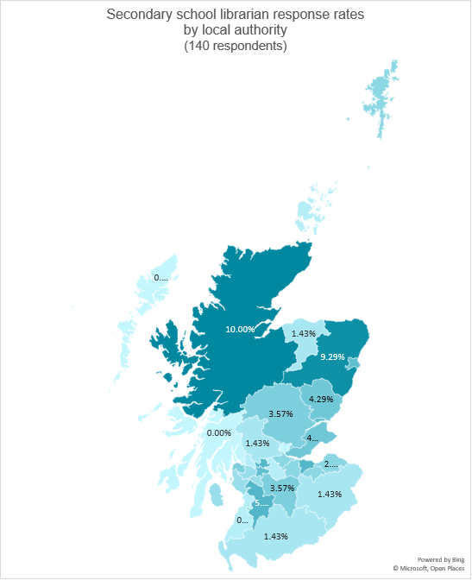

#### Qualified librarians

Each survey included a definition for a 'qualified librarian': 'someone who holds an undergraduate, postgraduate or Masters qualification obtained from a CILIP accredited course, or has a level of CILIP Professional Registration such as Certification of Chartership'. Following this definition, respondents were asked if they were qualified librarians, which drew very mixed results:

Well over half, 71% of respondents noted that they are qualified librarians, where 29% are not. In comparison to the primary school librarian survey, in which just 15% of responding librarians were qualified, this majority stat indicates a strong base from which to build robust and comprehensive school library services.

#### Current role

The survey then sought further detail about the role the respondents played in their service. Results were much more split compared to the public librarian survey.

Out of the 11% who chose 'other (please specify)' on the secondary school librarian survey, the open-ended comments broke down as follows:

* 9 'library assistants', or similar, with one noting, 'no librarian or other assistants in this library'
* 4 teachers
* 1 'library development leader'
* 1 'currently seeking Chartership; educated to degree level'

Again, it is notable that 73% (102 respondents) occupy a 'Librarian' role in their secondary school, and 71% of those (99 respondents) are qualified librarians. The split among other school roles is chiefly among library assistants, learning resource managers, and English teachers.

The high ratio of qualified librarians in the secondary school librarian survey is striking, particularly in comparison to the primary school and public librarian surveys. One potential cause for this is illuminated by responses in the open-ended comments:

* 'Assist all of the school too.'
* 'Non-qualified staff being employed as School Librarians and being paid at the same rate as qualified school librarians.'
* 'Replacement brand new school build opening 2026 will not have a library space or physical books. Plan is to go fully digital and delete the school librarian post.'
* 'I'm split between two schools so each school no longer has a fulltime librarian.'
* 'Restructure within the service meant school library assistant hours were removed. Some secondary schools are staffed by non-qualified staff. Staff are employed as 'School Librarians' but do not have the necessary qualifications of a librarian. Some secondary schools have only part-time staff.'

A similar breadth of experience was reflected in respondents' accumulated years of service to the library sector:

Scottish Book Trust is delighted to see such a robust response rate from highly experienced librarians, nearly half of whom (49%) have been working for 10+ years in the sector and can bring that cumulative lived experience and institutional memory into their reflections for this research project.

Indeed, this spread of experience is almost identical to those responding to the public librarian survey.

### Provision for secondary school library services

Existing research shows that, in the UK:

'Nearly a quarter of secondary schools reported not having a designated member of library staff due to budget constraints (23%), but the majority of secondaries indicated it was because they think appropriate levels of staffing are achieved without having a designated staff member in place (57%). This is concerning as the reading and learning support which can be delivered by a trained member of library staff is clearly being underestimated.'[9]

To gain a better picture of the current stresses on the secondary school library service, the survey led with a question asking librarians to indicate from a checklist what restrictions or losses their service has recently faced.

The responses were strongly illustrative of how the school library sector is increasingly under-resourced and depleted:

Of the 15 who chose 'other (please specify)', comments ranged over five broad themes:

* Library service closed or amalgamated with another (40% of 'other' responses)
  + 'Replacement brand new school build opening 2026 will not have a library space or physical books. Plan is to go fully digital and delete the school librarian post.'
* Loss of school librarian staffing / hours (53% of 'other' responses)
  + 'Restructure within the service meant school library assistant hours were removed. Some secondary schools are staffed by non-qualified staff. Staff are employed as "School Librarians" but do not have the necessary qualifications of a librarian. Some secondary schools have only part-time staff.'
* Unqualified staff employed in librarian posts (26% of 'other' responses)
  + 'Non-qualified staff being employed as School Librarians and being paid at the same rate as qualified school librarians.'
* Loss, or ongoing lack, of funding (13% of 'other' responses)
  + 'I've never had funding or resources from my local authority. I always have to apply to outside agencies to receive any sort of funding or materials.'
* Loss of attainment, 13% of 'other' responses)
  + 'Lost attainment and PEF funding.'

These comments indicate the ways in which libraries at secondary school level are being forced to adapt with little to no resource – whether as part of a service restructure, being 'replaced' with digital provision, or having to seek funding from third parties.

In seeking to understand what restrictions the libraries may be facing in running their service, the survey asked if the secondary schools are funded by the relevant local authority:

Of the three responses in 'other (please specify)', all comments noted their school is funded by either a Trust or a combined Trust and ALEO (arms-length external organisation of the local authority).

The overwhelming majority of respondents to the survey (87%) are funded by their local authority. Local government, in 2024/25, faces a £62.7m cut to core revenue budget and a £54.9m cut to core capital budget[10].

Because school libraries are not a statutory requirement in Scotland, there is no uniform standard for how they are accessed, stocked, supported or run. Scottish Book Trust asked secondary school librarians to give insights into how their pupils can access the library service and when:

Nearly all respondents indicated their school library is accessible for individual classes at set times (95%), and at break time (90%), or after school (74%). Much fewer – just half, 51% – indicated there was open access to their library service.

Of the 26 who chose 'other (please specify)', their responses fell into three primary categories:

* Access at lunchtimes, either occasionally, in part, or full (58% of 'other' responses)
* Access before (and/or after) school (31% of 'other' responses)
* Access is complicated due to insufficient space (15% of 'other' responses)
  + 'We have our own small book cupboard that is run by pupils – supervised by Eng[lish] staff.'
  + 'Library has been moved from dedicated library space into a small classroom space with tables / study space for eight people. Classes still have allocated timetabled slots but all have to squeeze in, and sit on floor. There are no individual study spaces available when classes are timetabled.'

In addition to better understanding when pupils can access their secondary school library, the survey sought to understand what provision the library offered:

The majority of respondents, 96%, indicated their school library has a dedicated library space. A further quarter, 26%, have book corners in some classrooms.

Of the 11 who chose 'other (please specify)', three main themes emerged:

* Library provision forced to downsize or integrate with another service (27% of 'other' responses)
  + 'It is also a Public Library.'
  + 'The library has been downsized. The purpose-built library has been taken away from me for an 'Integrated Support Hub' – essentially Guidance teachers.'
  + 'Small classroom selected as suitable to house bookshelves, books and the Librarian. Not suitable for great selection, or whole class visits or as a study space. DHT [Deputy Headteacher] quoted as saying "no point keeping non-fiction books, as the pupils can look things up on internet if they want to know something". Horrific attitude!'
* English department staff trying to set up library provision (27% of 'other' responses)
  + 'Library was closed about four years ago – books packed away – no funding for post of librarian. Eng Dept have started raising funds etc. and making a small storage area a new 'book nook' area.'
  + 'English Dept have dedicated class libraries, reading registration takes place one day per week, some teachers have put a small selection of books in their class for this.'
* Satellite collections spread throughout school (27% of 'other' responses)
  + 'We also offer book collections in faculties / departments and classrooms to promote reading across the school.'

What is clear from these additional comments is how hard librarians and English staff are working to try and keep their pupils' access to high-quality books as well as space and time for reading, despite rising pressures and decreasing resource.

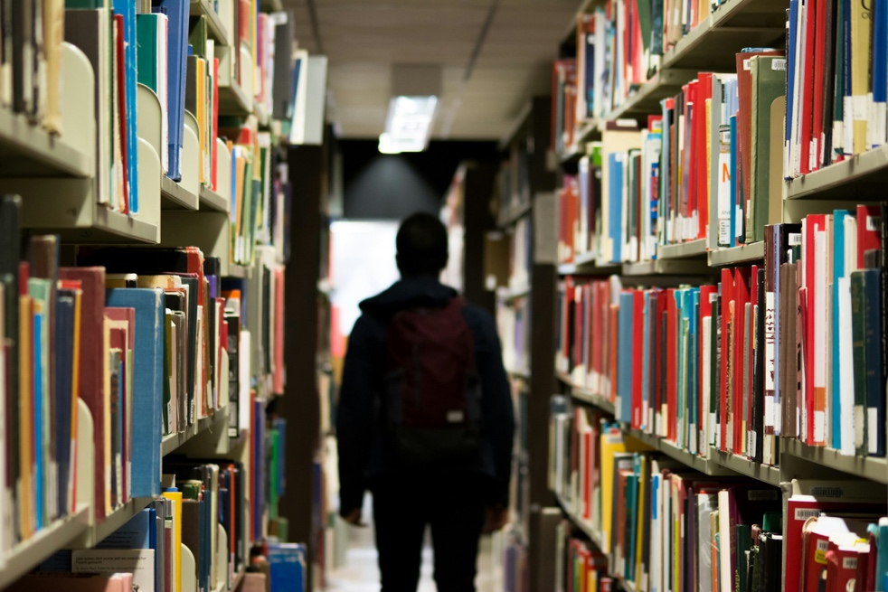

In the Great School Libraries 2023 report[11], 40% of librarians indicated that they spend 'less than three quarters of their time carrying out their core library duties due to the range of other roles and responsibilities held by the member of staff' – this stat is borne out in the picture painted by responses to the next survey question:

The majority of respondents indicated that their provision is managed by a librarian (91%), with a further 10% managed by pupil assistants.

Of the 16 who chose 'other (please specify)', 75% noted 'library assistant' or similar. Their comments indicated some concerning dynamics in library management:

* 'No one listens to the librarian[;] decisions are made by business manager.'
* 'Library assistant (me) not librarian.'
* 'Library Assistant – lone worker. Line manager based elsewhere.'
* 'Community Library Co-ordinator based in the library and Librarian managing five secondary schools.'

In these notes, there is a clearer picture of the strain on the library service – though there may be a dedicated library space and a librarian, that librarian may not be qualified, they may have inconsistent and uncertain financial resource, they may be excluded from making decisions affecting their library including the use of resource, and their time and capacity may be split across multiple branches.

Where there is variable support or inconsistent resource, there are only so many stop-gap measures a library service can take before it begins to decline. From the irregular variance in staff time or capacity, the continual need alongside dwindling resource and unpredictable management, these findings demonstrate the strain on secondary school libraries across Scotland.

### Children and young people's reading for pleasure

Research has already proven that reading for pleasure is one of the most important indicators of a child's future success[12]. Pupils who read regularly experience better educational mobility and social mobility; those who grow up in poverty are less likely to remain in poverty as adults; they have better mental wellbeing and self-esteem; and they have better speech and language development and literacy skills[13].

When asked in an open question if, or how, the librarian or their library promotes children and young people's reading for pleasure, secondary school librarians demonstrated the depth and range of what they do for their pupils in six main ways – engaging one-on-one with pupils and offering bespoke support; book displays; timetabled reading time; running book events; book talks or author visits; and bespoke book recommendations:

* Engaging one-on-one with pupils and offering bespoke support (55% of responses)
  + 'We do themed displays year-round based on the CILIPS calendar, we run a book club and a creative writing club, we do Role Playing Games in a club which is really popular, ask for pupil feedback on the library, display relevant book posters / signs to encourage reading, do permanent displays on key areas such as Shelf Help, Equalities and Anti Racism. The books are genrified in one school to assist book choice, with signage in several languages for each genre. Short books are highlighted to help ease of selection.

I give away bookmarks with reading quotes / pictures. I do inductions every year for first year pupils to speak about the library and reading. I also do training on using our specialist databases for senior students doing Highers and portfolios. We have Pupil Reading Leaders who volunteer to help in one of the school libraries and recommend books. I do a blog and a twitter account for both libraries promoting RfP [reading for pleasure].

[…] Anything we can think of, and given we don't have a huge budget we are very versatile with new ideas! And I'm sure that's not all.

[…] unfortunately time-wise and budget-wise I am not able to build up many of these areas.'

* Book displays in the library / staff posting what they're reading about (49% of responses)
  + 'We are currently working towards our [Scottish Book Trust] Reading Schools Core Award and are hoping to get pupils to be Reading Ambassadors. We hold all school quizzes to tie in with national events, e.g. BWS [Book Week Scotland]. We have a small Book Group who meet weekly in the library. We have relevant displays to encourage pupils to borrow books. We tweet/'X' relevant book-related information. We have a library website that recommends books under different genres. We occasionally hold 'DEAR' [Drop Everything and Read] sessions and 'Keep the Heid and Read'. We host author visits.'
  + ''Now Reading' posters on each teacher's classroom. Librarian providing recommendations for pupils, and even purchasing books out of my own pocket due to school claiming there is no funding available to the library.'
* Timetabled reading time / time in the library (46% of responses)
  + 'Run scheduled classes teaching kids about benefits of reading for pleasure and giving them time to swap books and support them in their reading progress and choices. Creates book displays which 'sell' books in exciting and appealing ways. Librarian buys modern stock to keep library up-to-date with changing needs of young people. Run Reading Challenge to formally celebrate reading progress.'
* Running book events e.g. World Book Day or Book Week Scotland (33% of responses)
  + 'We have a weekly book group, monthly S1 family book group, activities at lunchtime, celebrations of BWS [Book Week Scotland], WBD [World Book Day], Roald [Dahl] Day, Harry Potter Day etc., Reading Ambassadors, Reader of the Week, library periods.'
* Book talks, speed dates with books, or author visits (26% of responses)
  + 'Harry Potter Book Day, Dr Who Day, Good Omens Day (during Pride month), Star Wars Day – we try to engage with young people's interests. The English classes did have 10-minute reading sessions at the beginning of the lesson but this was discontinued as 'non-productive' following an external curricular review (!). S1 and S2 still have weekly library lessons with time for reading, however. We do hold DEAR and DEAL (Listen) sessions throughout the year.'
* Offering bespoke book recommendations (24% of responses)
  + 'We attained Reading Schools Gold accreditation which allowed us to expand our RfP offer: we reach out to the community with a reading podcast and run shared reading trips to primary schools and carers groups, where stories are read and used to connect participants. We engage with ebooks too, as another way into stories.'

These insights demonstrate how librarians are diversifying, expanding and finding local support for their activity despite little to no budget, time constraints, and demands on their capacity. Some commented further on their attempts to seek further training and qualifications in their own time, because, e.g. 'I believe that those who don't like reading simply haven't found an enjoyable book, and I like the challenge of assisting them!'.

School librarians' passion for reading and its benefits emerged clearly in their responses to this question:

'We are all READERS but not every person is a reader of books and there are many different reasons behind that. I think we should encourage and celebrate reading across all formats, e.g. online articles, magazines, blogs, podcasts, videos and would like to see that reflected in the Reading Schools programme. I think there is also a place for reading for life skills to ensure that young people have the basic literacy skills to manage their home and working lives successfully. If they gain confidence in that, and libraries continue to offer a wide and accessible range of resources and services, they may discover a love of reading for enjoyment later in their lives.'

However, what also emerged was the impact that funding cuts and devaluing of the library service have already had. In response to how their library supports reading for pleasure, one librarian shared:

'Before funding was cut our librarian had an open access policy, bought in authors, planned workshops.'

Such a final outcome seems likely for many of the librarians answering the survey – another shared that their library isn't supporting reading for pleasure, again due to a lack of resource and support:

'At the moment, very little. Currently looking for ways to make financial efficiencies and that seems to be by not buying books not supporting author visits not supporting the librarian or the English department requests for more books. I believe that the plan is to scrap school libraries.'

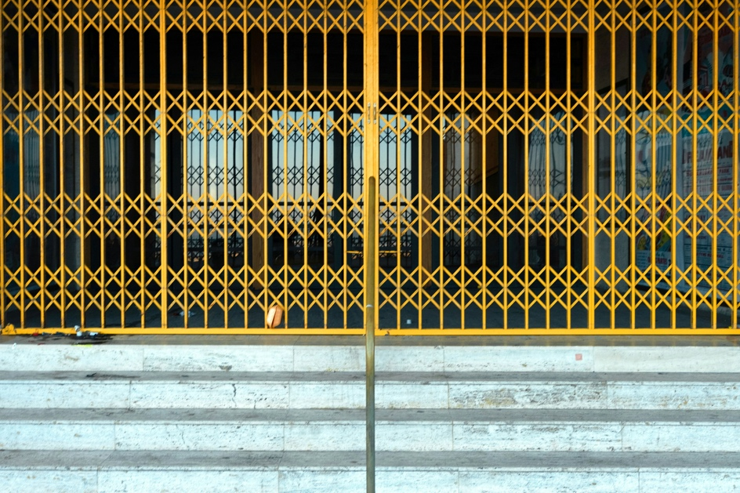

#### Reading activities

Considering the barriers that librarians face in their schools, Scottish Book Trust sought to understand what, if any, activities their library was co-ordinating in the near future.

The most popular activity by far was [Book Week Scotland](https://www.scottishbooktrust.com/book-week-scotland) (74% of respondents), an annual celebration of books and reading that takes places across the country in November, run by Scottish Book Trust and supported by Creative Scotland and the Scottish Library and Information Council (SLIC). Book Week Scotland, along with national events like World Book Day, are dates in a school calendar where there may be more leeway or leverage for staff to obtain buy-in from colleagues or management to support a focus on reading for pleasure.

Scottish Book Trust’s Live Literature, a highly competitive programme that receives a large volume of applications from schools for events as part of Book Week Scotland, is a further source of funding if school libraries wish to run events at that point in the year. Considering the lack of resources already reported, this may be a primary reason for its popularity.

The next most popular activity reported was book clubs / cafés (66%), author visits (50%) and Reading Schools (47%). [Reading Schools](https://www.scottishbooktrust.com/learning-and-resources/reading-schools) is an accreditation programme designed to help schools build and sustain a reading culture. The resources, training, funding opportunities and support from Scottish Book Trust through this programme may, again, be a primary reason for its popularity here, in the absence of similar supports from the librarians' own schools – librarians in this survey demonstrate a consistent need for further support in building a reading culture.

Of the 38 who chose 'other (please specify)', respondents noted:

* 'World Book Day, National Poetry Day, Shadowing YOTO Carnegies, Royal Society Young People's Book Prize, National Poetry Day.'
* 'Empathy Day and World Book Day are big focusses.'
* 'Cluster-wide illustration event using SLIF funding. Sci Fi week (end of November) across two high schools.'
* 'Literacy Week in school / shadowing book awards (local and national).'
* 'The English department here are involved with the Reading Schools programme that I help out with but run by English staff.'
* 'Green Library.'

A few school librarians also reported issues in organising activities in their library, for example:

'The library is not allowed to co-ordinate any activities due to not being given a budget. Luckily, we have a very supportive English dept who are pushing activities anyway. We are registered for the Reading Schools, as such we have applied for [Scottish] Book Trust funding for an author visit. Book clubs are being restricted due to times set up at lunch, senior school staff have said lunch clubs are voluntary and staff won't be able to claim any time back should they choose to get involved in a lunch club. As such many staff are opting out, as it is important for everyone's mental health to have a break.'

Schools can benefit hugely from author visits and participation in Reading Schools, a national whole-school reading for pleasure programme, yet very often the onus is placed on librarians and English teachers to run these activities, with little support from school management. Librarians continue to try to deliver the best services against a backdrop of reduced capacity, increased demands with limited time to deliver, and zero budgets. Senior managers have a duty of care to ensure that staff do not work constantly without breaks, or be forced to choose between their own wellbeing and the wellbeing of their service.



#### Reading recommendations

Having established that secondary school libraries are facing multiple barriers – restricted access times, strains on librarians' capacity, inconsistent representation of qualified experience, and decreased funding – the survey asked librarians to reflect on how much time they spend offering reading recommendations or advice to pupils, to better understand how their school library caters to reading for pleasure.

Out of 121 responses, the vast majority – well over half, at 3 out of 5 (63%) – selected 'daily / multiple times a day', indicating a healthy improvement on primary school librarians' frequency (which was at 27% for the same option).

Nearly a quarter (23%) selected 'often / multiple times a week', with a further 11% 'occasionally / weekly', and 3% 'once in a while / monthly'. None chose the 'never' option.

Scottish Book Trust sought to understand the reason for this frequency, and asked librarians to reflect on what barriers they face to supporting pupil reading. This was an open question with a comment box attached. Out of 105 responses, the main barriers to supporting pupil reading were as follows:

* Constraints on library hours and/or staff time (66% of responses)
  + 'Time constraints – we have a lot of things to get through in class so often there is not time to talk about books with pupils. Whenever I can I like to ask about what they are reading or recommend books.'
  + 'We are also a public library with limited staffing due to long term absences / vacancies and so don't always have as much time to spend with pupils as we would wish.'
  + 'Time constraints, split service between two schools. There is never enough time to build good relationships or be there when pupils actually need your help most. High number of ASN pupils who could do with further, individual support but no specialist training in this area. Lack of SLT [speech and language therapy] support in one school. Unable to reach senior pupils to discuss RfP [reading for pleasure] at all due to lack of time in schools.'
* Constraints on staff capacity (35% of responses)
  + 'Having had my hours cut to term time, there are time constraints being able to read books prior to recommending to pupils. Also, senior school staff do not accept reading as an important part of our job, suggesting this is something that we could do at home!, which would allow more time to get involved with other school tasks such as updating the school website, which despite many discussions to highlight that this task is not part of the Librarian's role, and that reading to encourage reading for pleasure actually is – still has fallen on deaf ears.'
  + 'Capacity and time constraints. Curriculum means there is less flexibility for 'luxuries' such as Reading for Pleasure.'
  + 'No barriers from school – they're incredibly supportive of staff efforts to build a reading culture. Imposed term-time working now means my time is squeezed in a way it wasn't before (less non-contact hours to plan, develop and prep programmes of work).'
* Issues with pupils' misbehaviour, attitude to reading, or inability to meet additional support needs (23% of responses)
  + 'Too much time dealing with unruly pupils who are sent to the library as there is "nowhere else for them to go". This restricts time I get to spend helping those who would appreciate it.'
  + 'Behaviour of pupils in the library. Some classes being restricted to the classroom because of this.'
* Restricted access due to limited time / space and/or use as a spare classroom (17% of responses)
  + 'Job cut in half – library regularly used for exams, meetings, events and classes cancelled.'
  + 'Being shared affects time availability. Library budget is an issue at one school.'
  + 'Use of the library has declined over the years in terms of classes coming in. Only S1 and 2 get regular library time once a week and even that is slipping at times.

Research / academic use by classes has slipped further, particular due to use of laptops in classrooms.'

* Insufficient resources and insufficient stock (24% of responses)
  + 'Time constraints. I work between two schools, so only have two or three days per week in each school. Am currently undertaking OU qualification to learn more about RfP. Finances are also a constraint. I would love to be able to buy more to expand the collection, however the budget is limited.'
  + 'Time constraints – it is hard to spend quality time with each pupil.

Lack of suitable resources – everything from being able to buy enough new books to not being able to do colour printing to make engaging materials.

Constant pressure to improve quality means a lot of time is spent on planning, paperwork and evaluation which might be better spent to pupil contact.'

* Insufficient staff training (11% of responses)
  + 'My lack of formal training can sometimes feel like a barrier to providing the pupils with advice to develop their reading. Having to leave early during lunch break also impedes the amount of interaction I have with the pupils while they are in the library, and cuts short opportunities to further their reading, such as book club during lunch break.'

These combined pressures of senior management disinterest, decreasing budgets and increased demand have led to extremely concerning situations for some librarians:

'I buy the books from 2nd [hand] stores and sites, I cannot afford whole sets, sad when a pupil loves a book and I can't afford to buy more. I buy from my wage not a budget as there is no budget for the library.'

School librarians are already under-supported in the sector. Their average salary (£22,000 p.a.[14] or £23,000 p.a. for a Library Assistant[15]) only just meets the national living wage[16]. A starting salary for a school librarian (approximately £18,000 p.a.[17]) is nowhere near the current living wage – but even an experienced librarian’s salary (approx. £30,000 p.a.[18]) falls short of an average UK weekly wage[19].

The idea that, against a backdrop of economic challenge, some dedicated librarians are buying books to re-stock their school libraries because they have little or no budget for this purpose is extremely worrying.

A further concerning isolation was reported by some school librarians who are attempting to promote reading for pleasure and library time in a school where colleagues, including management, do not appreciate the value of libraries. When reflecting on the barriers faced in supporting pupil reading, one librarian noted:

'Lack of interest in books / reading from teaching staff; classes don't visit as much, preferring students to google everything on Chromebooks. SMT do not value the library service other than on paper (aspirations in SIP); they take little practical interest. I no longer have a library assistant. My library has just been reduced by 50% in size, and my budget looks to be vastly reduced – not sustainable.'

Reductions in library provision, both stock and budget, are overshadowed here by the librarian's cornered position in a school where they feel both their role and the services they offer are undervalued, and where the reality of reduced staffing, stock and funding is not reflected in the SIP (School Improvement Plan). It is not possible to build a reading culture while simultaneously dismantling its resource.

The compounding effect of the teaching staff showing no interest in books or reading – and directing pupils to online sources for information, instead of utilising their library – indicates an overall undermining of the library service, perhaps in this case a managed decline.

Librarian isolation was reported by more than one respondent to this open question – comparable tensions with teaching staff were noted by another librarian in a clearly dejected and concerning position:

'Conflict with promoted English teachers. We have a PT English / PT4 English / PT Literacy and me. I feel I'm on my [way] out of the profession.'

### Curriculum-based learning and the attainment gap

When asked what additional opportunities the school library offers to pupils, librarians provided mixed responses:

The vast majority of additional opportunities are either board games or games clubs (74%), pupil librarians (65%), digital skills / computing and IT (55%), or Curriculum Resources and Information Service (53%). None chose typing club or the IELTS preparation programme.

Of the 28 'other (please specify)' responses, five main opportunities emerged: craft clubs (32% of 'other'), pupil volunteering (21% of 'other'), games clubs (21% of 'other'), careers resources (18% of 'other') and homework club (14% of 'other').

However, librarians also noted barriers to offering additional opportunities to their pupils:

'Library is only open for 13 mins at lunchtime, whilst these activities are offered not many take them up.'

Comparing this data to the average rating in the following question – 'on a scale of 1 (not at all important) to 5 (very important), how important would you say the library is in providing additional opportunities to pupils in your school?' – there is a demonstrable need for secondary school libraries to be further resourced.

Nearly 4 in 5 librarians (79%) feel the library is 'quite' or ‘very’ important in providing additional opportunities to pupils in their school. 1 in 5 feel it is 'moderately', 'a little', or 'not at all' important.

When asked for comment, their responses shed further light on their choice:

* The library is the heart of the school (26% of responses)
  + 'We are involved with the peer reading groups in school and a regular dyslexia group. It is important that the library is a welcoming and safe space and pupils regard it as the 'heart' of the school. The space is well used before and after school and at break and lunch. The book group and Dungeons and Dragons are very well attended, and we would love to run more clubs but am conscious that we want to be available to all pupils too.'
  + 'It should be the heart of the school but it's viewed as an IT suite with books.'
* The library is a safe and welcoming space (32% of responses)
  + 'For some vulnerable pupils the library is their safe space and somewhere they can come to get away from the noise and bustle of the corridors at lunchtime. Pupils have told me this before and are sad that they can't access the library resources on a Friday when I don't work, and the library is closed.

Also I have seen friendships develop and flourish after solitary pupils have made friends during lunchtime activities such as playing board games, or book club. These friend groups meet in the library most days at break time and lunchtime now and I see their individual confidence grow.'

* + 'The library is seen as a very different space in school: different to the classroom, different to the social area. Pupils often describe it as a haven, a sanctuary, or a safe space, and they love taking ownership of the events, activities and workshops run in the library.'
  + 'The library provides a safe space with staff support, IT and access to books that pupils may not find elsewhere or at home. Parents / guardians may not have the time or ability to support pupils in subjects or planning for the future. IT may not be available at home for pupils. Books may not be accessible or promoted at home for use. The library is also a neutral space from all subjects and can provide unbiased support across all circular areas.'
* Importance of volunteering opportunities (25% of responses)
  + 'I am very open to suggestions and pick up on things pupils might talk about. For example, our chess club started with one S1 pupil asking if they could do it. We now have a chess / games club, five chess boards and a multitude of other games such as scrabble / jigsaws which are hugely popular and add to their social and thinking skills. We keep a suggestion box for any ideas, if they can be done and add value, the school SLT will support it. It's also crucial to me to be an active listener, be open and approachable giving pupils the opportunity and time to talk. Positions such as Reading Ambassador, allows them to mix with peers of different ages, building confidence.'
* Significance of clubs, activities and games (23% of responses)
  + 'Both of the schools I work in are in extremely deprived areas, within Scotland they fall in centile 1 of the Scottish Index of Multiple Deprivation in all but one area – transport – as we are close to [a large urban centre]. Parents are not normally fully engaged in their children's learning and as such both schools have fallen further behind than most due to the pandemic. If we were not to offer these opportunities, there is nowhere in the communities I work in which offer similar things at all, and due to the pupil cohort there are very few, if any, who could afford these additional clubs. Therefore without these offerings we would see more of our already deprived pupils missing out and also perhaps not engaging with the library at all.'
* Research and ICT skills (19% of responses)
  + 'The library offers pupils a chance to develop their research skills, as well as independence, a love of reading and ICT resources. In a time of continuous cuts in funding, as well as with the cost-of-living crisis impacting the resources available at home, pupils can access books and ICT within the library with a dedicated expert close by. This is crucial for pupils in my school.'
  + 'Aside from promoting a culture of reading for pleasure, it is vital to have an information professional at hand to offer advice on research and finding information. This is particularly important in an age where information (and misinformation) is in abundance.'

The librarians also reported restrictions on their time and space (14% of responses) as well as an overall devaluing of the library service (13% of responses):

* 'Because of constraints on my time due to council cuts, I am not able to provide all the additional opportunities which I once did when I was full-time in one school.'
* 'The library should be the hub of the school, with a whole school connection. But unfortunately, this is not supported by senior school staff.'
* 'I have 20 working PCs. Out of my wage I provided mice and keyboards as many were broken when I started in the role. I explained to new students every year it was my money so they would have more respect for the PCs.'
* 'The library is quite small so there is limited space for additional clubs and roles. There are a great number of after-school clubs run by other departments so pupils tend to get spread out a lot. I have limited hours and finish at the end of the school day. Also, since the council introduced Chromebooks for all pupils I have found that very few pupils now use the library for careers and university information or curriculum resources.'
* 'I try my best as a librarian to provide students with transferrable skills – digital makers club / student library assistants, etc. – but I am mostly invisible to SMT. I don't think they're aware what goes on. Library / information handling skills are no longer embedded in school culture. I took 15 students through [a nationally recognised award that records pupil achievement] but, one year on, nothing has been progressed by school. Comm Ed took on validation for me but still no awards for kids. Demoralising.'

### Poverty-related attainment gap

Evidence from the Poverty Alliance shows that, 'just over 2 in 5 young people living in the most deprived areas achieve one or more Higher when leaving school (43.5%) compared to almost 4 in 5 young people living in the least deprived areas (79.3%)'[20].

Moreover, in 2022/23, the gap in attendance rates between children living in the most and least deprived areas of Scotland was 6.7 percentage points. This compares with 4.7 percentage points in 2016/17[21].

School libraries are proven to support improved attainment in their pupils[22] and they have a key role to play when addressing these inequalities, by giving further support to pupils from under-resourced and deprived areas.

No one library can raise a child out of poverty or compensate for the barriers to learning they might face within and outwith their school – but all school libraries are crucial to offering a pupil the best chance of achieving those ends.

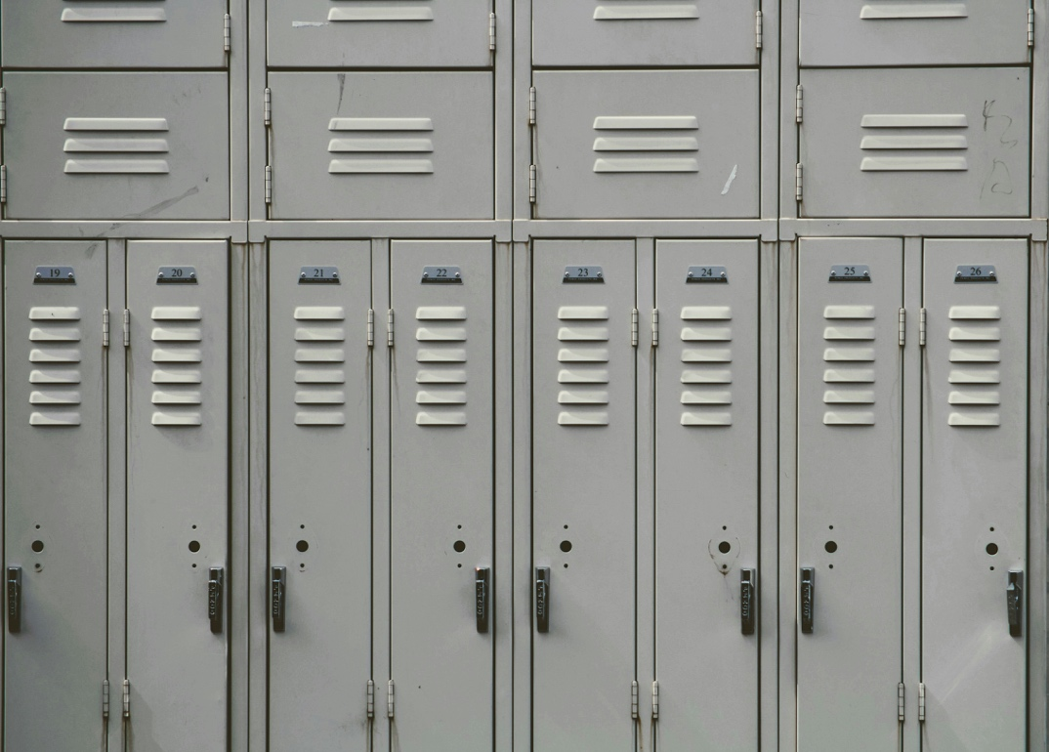

To better illustrate this point, the survey asked librarians to reflect on the ways they feel school libraries help (if at all) to close the poverty-related attainment gap. This was an open question with a comment box of unlimited length attached.

From 90 responses, four main themes emerged to clarify how school libraries help to close the poverty-related attainment gap:

* The library is (likely) the pupils' only access to books and resources (68% of responses)
  + 'Our school library helps close the poverty-related attainment gap by providing access to resources both in IT and physical resources. With free access to up-to-date literacy and numeracy resources and help from the librarian, pupils who would not have this help at home are given a more level playing field. Simply having a warm, safe and welcoming space to invite pupils to learn, revise, relax allows pupils who would not have this type of space available to them in their own homes.'
  + 'Our school catchment has a wide gap in pupils' economic circumstances and includes pupils from the wealthiest and poorest backgrounds. Rich pupils buy their own books and sometimes don't need a school library service, but poorer kids often do not have books at home. So providing books to poorer young people is a great service. However, it is not nearly enough to meaningfully close the poverty-related attainment gap. I think that trained librarians in primary schools would be an excellent idea!'
  + 'All libraries are about providing equitable access to every user that walks through the door, or interacts with the service. It's about providing them all with access to the same service, whether that be a place to study or access to materials and books (e.g. I have a huge Advanced Higher history collection) that they might not otherwise be able to access.'
  + 'I have books, many at home don't. I sometimes buy books online locally. I have gone to some houses to buy the books and cheekily they have been trying to sell me my books (marked with library stamp). They have apologized and not charged me for my own books.'
* The library is a safe, quiet, welcoming, inclusive warm space (33% of responses)
  + 'Safe, quiet neutral space, allowing free access to books, laptops, Wi-Fi and printing.

Many of our top readers are also in receipt of FSM [free school meals].'

* + 'Free access to books and comics, including ebooks and audiobooks. Rewards for reading in our Prêt-à-Lire Reading Scheme.

A safe, calm, inclusive space. I pay for pens, paper, food (cakes / sweets), crafts out of my own pockets. Sometimes even books – if the child really wants it and my budget has gone.

Until recently I took kids to Comic Cons, and they got to meet artists / authors there, and in school – funding has gone for this now though.'

* Help and advice is available from an unbiased, friendly librarian (29% of responses)
  + 'We will source wherever possible, books (and other resources) a pupil requests or needs. We have membership cards for our local public library on the desk that they can join. All pupils have a council-issued iPad which gives them digital access at all times. That allowed the library space to change, reducing the number of old desktop PCs and add a dedicated, modern and comfortable reading / study area. The library also has a grab and go trolley for any pupil that needs items such as cereal bars, pencils, paper, period products etc. We have for many years, invested in Accelerated Reader programme which supports those with any reading and maths difficulties. The library is used regularly for tutor support after school and for various other clubs.'
  + 'Having a budget for new stock means I am able to buy the books that pupils want to read, and having access to these for everyone is vitally important. I can also show pupils how to access free ebooks and audiobooks meaning pupils can access literature in a format that suits their needs best.'
* The library promotes a love of reading (27% of responses)
  + 'Attainment gap is directly linked to poverty – free libraries try to provide something of a more equal playing field – books and computers and printers etc.'
  + 'Provides equity of access to reading material for all pupils – both fiction and non-fiction, revision materials, careers and further / higher education information. This means that pupils with no books at home and no other means of access to books have the opportunity to browse and borrow books to take home.'
  + 'Most of my pupils don't have books at home, and I beg, borrow and steal to get the books of their choice so they don't disengage.'

The nature of poverty results in an absence of freely-available supports or resources to help people become informed and empowered. It's clear that many librarians feel their school library is intrinsic to providing equity of access, a safe space for pupils, and opportunities to develop greater skills, and they see these functions as a crucial part of addressing the poverty-related attainment gap.

Here, there is also a consistent thread of concern about a lack of top-down support for the library – librarians are reporting how they 'beg, borrow and steal' to get more stock, how the funding for extracurricular activities has gone, how some go house-to-house to buy books from locals. In the absence of statutory guidance for school libraries, there remains no legal requirement for school libraries to be appropriately stocked, staffed, resourced and managed.

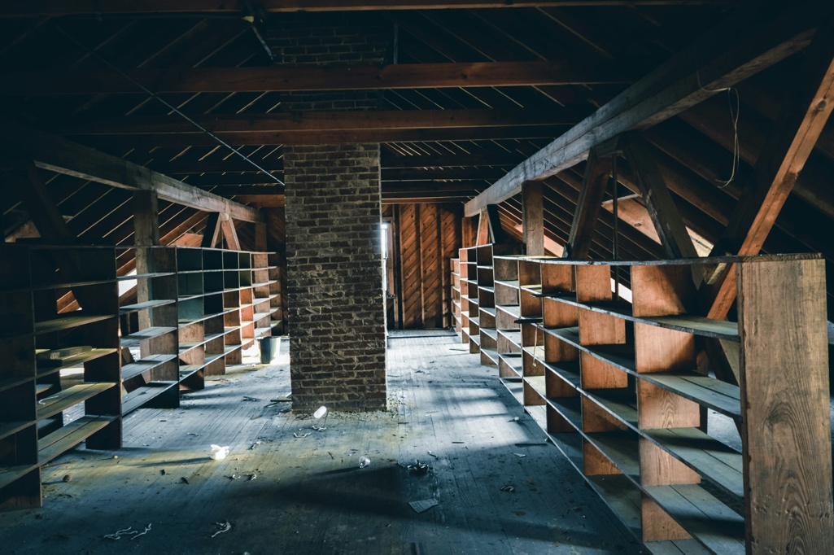

The survey then asked librarians to share what barriers (if any) their library faces to helping close the poverty-related attainment gap. Again, this was an open question with a comment box of unlimited length attached.

Their 102 responses focused on five main barriers: inadequate funding; areas of deprivation; powerlessness to improve without more support or resource; insufficient staffing; and pupil attitudes.

* Inadequate funding (50% of responses)
  + 'Lack of funding and unsuitable accommodation are major issues. Major budget cuts mean that expanding and refreshing the library collection is next to impossible and library staff regularly buy resources with their own money. A lack of classroom space around the school has resulted in the library being used as a teaching area for 23 out of 32 periods in the week so subjects across the school can't book to use it for research.'
  + 'We are constantly fighting against barriers and recognition. We have a vital role to play but the schools as well as the local authority do not seem to recognise this or prioritise the needed staffing, funding or dedicated space. Our service is now also hiring Librarians at all levels without professional qualifications. None of it seems to matter anymore to those making decisions.'
  + 'The reverse is true; a high-achieving school with low levels of FSM means we are discounted for many, many sources of additional funding meaning we cannot facilitate author visits etc.'
* Area of deprivation (14% of responses)
  + 'Our SIMD is mostly in the bottom two deciles. Poverty, lack of employment opportunities, generational unemployment means that by offering a library service it impacts beyond the school given that public libraries are closing / and or have restricted opening times.'
  + 'The sheer scale of deprivation in our community means a lot of pupils don't see the point of trying to improve their education and opportunities.'
  + 'We are no longer in the percentile that designates extreme depravation, as some parts of [local authority] are affluent, even though hardship is rife in town. Makes it harder to secure external funding.

Parental apathy is the main challenge. Many excellent initiatives are simply ignored by families, and meaningful outreach is extremely difficult to achieve.'

* Powerlessness to improve without more support or resource (14% of responses)
  + 'No funding. No ability to purchase new books unless I, the librarian, buy them myself.'
  + 'The lack of support / funding / resources from the rest of the school. The library now no longer has computers available for example.'
  + 'IT equipment is so slow it is almost unusable within a single period.'
  + 'The gap is becoming greater in this area, we have one of the poorest paid employment areas in Scotland and there seems little improvement. The school lacks funding and we have serious RAAC and water ingress problems causing school closures and lack of teaching space.'
* Insufficient staffing (13% of responses)
  + 'Council cuts to professional school librarians. The continual erosion of school libraries and the services they provide.'
  + 'Our library service is chronically understaffed, so staff don't have time to properly promote reading and support pupils. we sometimes have to close the library due to lack of staff.'
  + 'Very much so, one of the schools is in a very deprived socioeconomic area. Up until January 2023 I worked there five days, and then the library funding was cut and I now only work two days within the school.'
* Pupil attitude / confidence (12% of responses)
  + 'There are barriers in the form of lack of pupil engagement and low pupil aspiration.

There are barriers in the lack of pupil confidence in their abilities to gain and practice reading skills.

There is a lack of parental / carer engagement in the benefits of reading for enjoyment. No family / carer confidence in helping to support reading at home.'

The accumulative impact of reduced financial and management support, staffing reductions, pupil and parental disengagement and limited allocated space within schools, has resulted in school libraries being chronically undervalued.

An accessible, vibrant, safe, and supportive, well-resourced library will make an invaluable contribution to helping a school address the poverty-related attainment gap. It is therefore extremely worrying that the incidence of reduced library services or complete closure of libraries is higher in SIMD 1 and 2 areas, where these services are so essential.

### Digital inclusion: digital poverty, access and support

Digital poverty is defined as 'the inability to interact with the online world fully, when, where, and how an individual needs to'[23] and includes people without access to a laptop / smart phone / tablet, or affordable, reliable internet.

A 2023 report from the Digital Poverty Alliance (DPA) demonstrated that '20% of children in the UK lack access to necessary digital tools such as devices, broadband connectivity, and digital literacy skills'[24]. That is one pupil in every five that currently faces digital poverty, in a world that is increasingly online.

Pupils who are unable to access digital resources via their school or their school library are facing a huge skills gap, particularly when considering further education, social mobility or the job market.

Conversely, as the DPA argues in their report, addressing digital poverty could 'lead to higher earnings, reduced unemployment, reduced social exclusion and generate cost savings for government'.

When asked whether or not their school or its pupils face digital poverty, secondary school librarians were split.

Nearly half (47%) reported their school and/or its pupils face digital poverty. A further 28% disagreed, with a quarter (25%) 'unsure'.

The comments demonstrate a clearer picture of this split in opinion – out of 69 responses, four main themes emerged:

* Wi-Fi / digital device access at home may be – or certainly is – an issue (45% of responses)
  + 'Most pupils now have iPads supplied by the school. However there is still digital poverty at home such as not having internet access, not being able to afford electricity to run and charge devices. Also there is poor digital literacy in the earlier generations which is a knock-on effect of digital poverty. In [the local authority], the Librarians are not being given iPads to help the pupils despite asking at a higher level.'
  + 'During the lockdowns our school had to distribute laptops to pupils who had no computers at home. In fact a few families didn't have internet service.'
  + 'There is definitely digital poverty in families but the school (high school) has invested heavily in Chromebooks for every child, S1 -. My feeling is by the time they arrive here their reading levels are so low, and their digital skills so lacking after seven years in primary school, that it feels like it's too late to reach them; make meaningful progress at any CfE level 4 course onwards. It can seem like they have developed a learning 'disability' due to these environmental conditions. It's very depressing.'
* Students are provided with digital devices in school (42% of responses)
  + 'There are many pupils who can't effectively interact with the online environment to find information. Pupils lack the skills to discern bias and the reliability of information sources.

All pupils in [the local authority] are issued with a Chromebook. Many pupils come to school with devices uncharged or devices left / lost at home which becomes a barrier to learning.'

* Schools is in an area of high deprivation (12% of responses)
  + 'Our school is situated in an area that suffers from high deprivation. The rising cost of living has also forced more families to prioritise basic needs such as food and power over having home Wi-Fi or mobile devices.'
* Wi-Fi / digital devices in school are out of date, obsolete, or need repair (9% of responses)
  + 'Although students have access to laptops, and tablets or can use 'phones often the devices are in need of repair or updates and in parts of the school getting a signal to connect to the internet can be difficult. The main computers used by staff are ageing and need replaced in order to keep pace with the changes and improvements in software etc.'
  + 'Not enough computers to go around, aging equipment which is not replaced when it fails.'
  + 'My PCs are six years out of date and slow. I was meant to get new PCs when the pandemic hit and the budget was used on testing kits. I won't get new PCs now until the new school is built in 2025 or [2026].'

While many local authorities have funded and provided Chromebooks or tablets to school pupils to try and tackle digital poverty, it's clear from these librarian insights that consistent access to Wi-Fi, digital literacy, electricity or up-to-date resources remains an ongoing problem.

One such example of the impact of this disparity can be seen in this librarian's response:

'Many of our pupils don't have access to a PC / internet connection at home. Just today, I was talking to an S1 pupil who hadn't realised she could use the library PCs to do her homework. She doesn't have a computer at home and had been worried about not getting her work done – the relief on her face was clear to see.'



These librarian comments indicate the extent to which many secondary school pupils rely on their schools to provide them with digital access and devices. This reliance is further evidenced in the question that follows:

Well over 4 in 5 librarians (82%) indicated that the school library offers computers with internet access to their pupils, and a further 3 in 5 (67%) reporting they also offer photocopying / printing / scanning.

Over half, 57%, offer Wi-Fi that only school devices can connect to – a further 38% offer Wi-Fi that connects to any device.

Nearly 2 in 5, 39%, offer ebooks or eReaders to their pupils.

Of the 16% who chose 'other digital equipment (please specify)', comments ranged from 3D printers to MP3 players, Nintendo DS consoles, podcasting equipment, Chromebooks or AV equipment.

In seeking to understand what financial barriers schools might face, librarians were asked if any of their library's digital resources were provided at a cost to the pupil.

The vast majority of respondents – 97% – indicated that digital resources are provided free of charge to their pupils.

Only 3% indicated that pupils have to pay for digital resources – out of four comments, one said 'N/A' (who answered 'no'), one said 'school devices' (answered 'yes'), and the final two indicated that printing / photocopying comes at a cost.

Considering the prevalence and reliance on digital devices for education, Scottish Book Trust sought to further understand the value of digital provision in secondary schools, from the librarians' perspective.

Nearly all respondents (98%) felt it was 'very' or 'quite' important that the library service supports digital access / inclusion for pupils. No librarians indicated that it was 'a little' or 'not at all' important.

In seeking to understand the role the library plays, in comparison to the whole school service, the survey prompted librarians to share individual examples of how their library supports digital access / inclusion for their pupils. This was an open question with a comment box of unlimited length attached.

Out of 81 responses, three primary themes emerged: the library offers digital devices or services (58%), the library promotes digital resources, e.g. ebooks, PressReader (38%), and the librarian supports pupils with digital access, information literacy and/or ASN (33%).

* The library offers digital devices or services (58% of responses)
  + 'We bid for funding and secured iPads so that pupils can create digital content (e.g. booktrailers and digital storytelling) as well as access ebooks quickly through an app and a reliable internet connection. We have digital resources which are current and accurate and can be accessed from home and in school.'
  + 'There are pupils that have no Wi-Fi at home or their Chromebooks are broken for any reason. The library is another option for them.'
  + '1. Daily Chromebook clinic – pupils come to Library when they have issues with their Chromebook. (This is supposed to be before / after class and break times but reality is that I can be troubleshooting at any point during the school day!)

2. Charging stations within Library where pupils can charge their devices.

3. School's seed stock of spare Chromebooks is managed through the Library – pupils can borrow a device while their own device is charging / being fixed so that their access to learning is not disadvantaged.

4. Advice on using 'Read and Write' literacy help app with staff and pupils.

5. General advice on how to use Chromebooks i.e. inserting pictures, formatting documents etc.

6. Creating assisting staff with digital items for class use, e.g. online newspaper templates, creating online booklets, PowerPoints, AV skills – film, animation techniques.'

* The library promotes digital resources, e.g. ebooks, PressReader (38% of responses)
  + 'We use Renaissance Accelerated Reader for Maths and English. Support is given for them to use that to take quizzes, read articles, they can see QR codes provided or speak to me one-to-one. We also use BorrowBox (ebooks) that we support with through their iPads. Workshops have been done with external companies for STEM. Accessibility is explained and demonstrated one-to-one (e.g. pupil with a physical injury is shown how to use speak to text technology).'
  + 'Access to ebooks and audiobooks is crucial for many students – we provide this to every student.

All students need to be digitally literate in the modern world. Access not just to equipment (during and outside of school hours), but to classes that support digital and information literacy skills that are key for student development.'

* The librarian supports pupils with digital access, information literacy and/or ASN (33% of responses)
  + 'It is such a large part of literacy now and going forward into university, I train pupils on advanced information seeking and referencing to assist them. Also I do print outs for pupils who do not have access to printers at home and allow all items to be charged (if they supply chargers) in the library if the pupil is present.'
  + 'Education heavily relies on the use of ICT to access Teams and email, as well as research on the internet. Furthermore, pupils with additional support needs may require ICT to complete classwork and/or assessments, which can be accessed through library resources.

I have many pupils with ASN who benefit from library laptops; and have many, many pupils who can only access ICT or the internet using library resources. This is essential for the completion of senior coursework such as portfolios.'

However, quite a few of the responses illustrated the recent cuts and restrictions the school library has faced in recent years, for instance:

* 'I think it very important that the Library supports digital access. Unfortunately when the Library was moved to a much smaller space the opportunities to provide anything other than Wi-Fi access was removed. Thus making the library seem less important as somewhere to find information in the eyes of the students.'
* 'My library space does not have computers. There is a laptop booking system but quite often the laptops are booked by teaching staff.'
* 'I used to have a suite of PCs for pupils to access for research, class research skills. However, these were taken all away from the library.'
* 'We suggest that pupils use local library for BorrowBox etc.'

Considering that only three (Edinburgh, Glasgow, Aberdeen) of Scotland's 32 local authorities are reported as places with a low likelihood of digital exclusion[25], the multiple reports here of school libraries with insufficient funding or resource, having their ICT provision removed, or signposting pupils to their local public library (which may well be inaccessible due to location or limited opening hours), is a major concern.

Many secondary school pupils, particularly those in areas of deprivation (SIMD 1 and 2), rely on their school libraries to provide them with digital access and devices. Without that access, they face significant barriers to engaging with the curriculum, completing homework, upskilling their information literacy, or preparing for future education or employment. In other words, if school libraries are stripped of digital resources, access and support, there will be a long-term and significant impact on their pupils' attainment and progress.

### Digital inclusion: digital and media literacy

One of the greatest social challenges arising from digital poverty is reduced digital and media literacy. National Literacy Trust reported in 2018 that only 2% of children and young people in the UK currently have the skills they need to tell if a news story is real or fake[26].

School libraries can help their communities to parse disinformation (deliberately false data) and misinformation (false data, usually not deliberate), and understand how to keep their personal data safe online.

Scottish Book Trust asked secondary school librarians if their library currently supports pupils with media / digital literacy skills.

Over half (55%) of librarians reported that their library currently supports pupils with media / digital literacy skills. A further third (34%) reported that it does not. The unequal split better contextualised by the librarians' comments below.

Out of 74 responses, 37% of librarians reported that they run information literacy skills sessions or timetabled classes for their pupils.

* 'Digital literacy lessons including website evaluation. Provision of reliable websites for research projects. Demonstration of online digital resources available on NLS website. Use of online library catalogue.'

However nearly a quarter (24%) noted that no sessions or classes are currently offered in the library, and/or they are offered elsewhere in the school.

* 'We have prepared lessons on information literacy but teachers seem reluctant to allow us to offer these, as students are taught about fake news in PHSE classes and believe this is all that is required.'
* 'Sort of, but internet safety is taught in the Computing department. I have a PowerPoint that I have used in the past that looks at fake news. The library's induction for S1s has been drastically cut from 6–8 lessons to two, so the fake news is no longer covered.'

A further 11% of librarians noted they offer ad hoc advice.

* 'The Library does not have the space or the equipment to offer such skills in a formal way. The Librarian offers advice to individuals at point of need.'
* 'We used to do comprehensive digital skills classes but due to staffing constraints I no longer have the time to plan and carry out these lessons. Now I just do little bits here and there if the opportunity arises and it is done very inconsistently. I was asked weeks ago to do a presentation on digital skills to senior pupils but was unable to due to time. As a second-best option, I agreed to make up a pack for pupils to use in their own time and I still haven't had time to do this because I have too much other work because staff numbers have been cut and workloads have increased on those of us who remain.'
* 'I help when I can. I am not meant to but I am good with computers and have skills that the students appreciate being shown.'

A number of librarians also reported their concern for the lack of media / information literacy support in their school, e.g.:

* 'When Chromebooks came in (seven years ago) using the library for research went out. All 'research' is now googling on Chromebooks. I no longer deliver information handling skills classes. I cannot afford subscriptions to online platforms that provide quality, age-specific resources.'
* 'Little dedicated librarian time and no prioritisation by departments.'

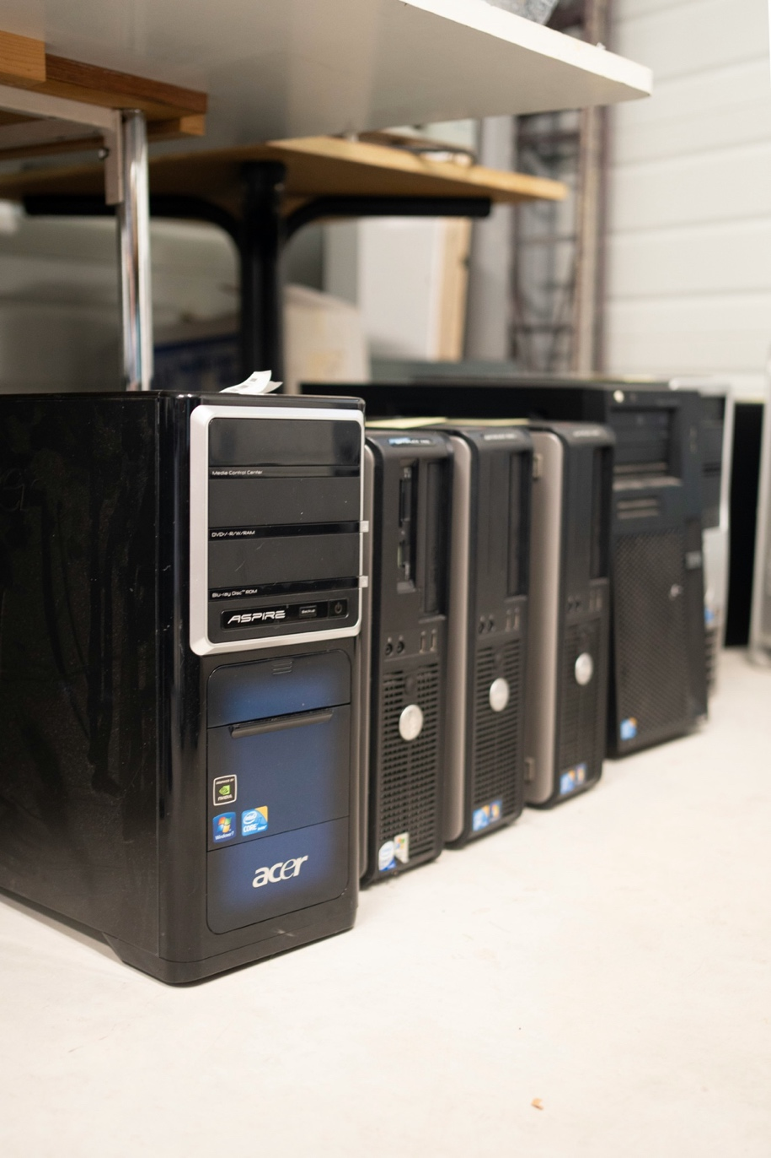

### Active citizenship

As the final theme of research, 'active citizenship' investigates the library's role in fostering pupils to be informed about their democratic rights and access, to be empowered to voice their concerns and decisions, and to engage with their local authority, all with the goal of shaping local and national services to their needs.

Research from SLIC[27] and CILIP[28] shows that libraries:

1. Reach a strongly diversified audience across all protected characteristics
2. Offer safe spaces for people to remain indefinitely, without expectation of payment
3. Provide access to trusted, accurate information which empowers communities to make informed decisions

In these ways, libraries are a key conduit to active citizenship for their community. In the school librarian survey, Scottish Book Trust asked questions to gather further evidence on each of these points: (1) reaching a diverse audience; (2) safe spaces; and (3) democratically engaged and informed communities.

#### Reaching a diverse audience

4 out of 5 librarians (88%) agreed that their school library reaches a strongly diversified audience. Just 5% disagreed, with a remaining 7% who neither agreed nor disagreed.

Out of 71 comments providing further information on the reasons for their choice, a handful of main themes emerged:

* The library provides a diverse collection (52% of responses), including examples of librarians who feel they need to be able to do more
  + 'I try and ensure I have a range of stock available to meet the needs of all our pupils, however I think there is still room for improvement in relation to languages, online and audiobooks.'
  + 'The library has a collection of books for all – with a real focus on diverse voices. I create displays promoting them throughout the year and talk about them with classes. Pupils feel seen and are then comfortable being their authentic selves in the library. I wear my LGBT+ ally and autism spectrum badges on my lanyard. The fact that the library regulars are such a diverse group shows that they feel valued and welcome.'
* The library is open and inclusive of all pupils and staff (31% of responses)
  + 'I think our library is available across diversified audiences, but we face the issue that many who might most benefit from the library are those most likely to reject what we have to offer (especially reading for pleasure).'
  + 'The library is open to everyone. Resources are available for all. However, it is difficult to provide a range of resources in all languages and formats.'
  + 'The Library is available to all staff and students equally. However, the library is now upstairs which restricts access for some, although there is a lift [it] is not always available.'
* The library is a safe space; it hosts a diverse student body; and it puts up displays and resources for diverse groups e.g. LGBT or Black History Months (18% of responses, respectively)
  + 'All students call my library the safe place in the school. I do not allow swearing or meanness and the students adhere to that. I have information on LGBT+ and the school counsellor.'
  + 'School's values signposted, and adhered to. My library is a safe, calm (for autistic students) space; everyone has to get on, and be respectful to each other. Lots of signposted [LGBT Youth Scotland supplied] affirmation that EVERYONE is welcome in my library – poster to share my pronouns, etc. Permanent LGBTQ+ book collection, permanent Diversity book collection. We celebrate Pride Month, Neurodiversity Week, Black History Month, etc., etc., every year, and book slams, displays are student-led.'

It is notable here that even when describing the ways the library is inclusive, librarians are indicating the restrictions on resource, outreach or access.

One of the 'disagree' respondents noted that, 'I could [reach a strongly diversified audience] if I was here more often.' This same librarian shared that they were based in a wealthy area, yet their job had recently been 'cut in half'.

#### Safe spaces

To better understand the role of libraries as safe spaces – that is, a place that provides a physically and emotionally safe environment for a person or group of people, free of fear, bullying or harassment – Scottish Book Trust asked primary school librarians to what extent, on a scale of 1 (strongly disagree) to 5 (strongly agree), they agreed that their library offers a safe space to their pupils.

The scale was followed by an open comment box encouraging respondents to share how important they feel a safe space is for their school.

Nearly all librarians (95%) agreed that their school library offers a safe space to their pupils.

Only 4% chose 'neither agree nor disagree', and only 1% – in effect, one respondent – chose 'strongly disagree'. That one respondent noted, 'it's essential but heartbreaking that it's only for half the time – others don't value the safe space'. They shared earlier in the survey that, 'if a library is closed for 50% of the time and for exams and meetings and parties then it can't be a whole school resource'.

Respondents were encouraged to share the reasons for their choice. Out of 72 comments, the following themes emerged:

* The library is a non-judgemental, protected space separate from school demands (86% of responses)
  + 'School libraries are often used by vulnerable pupils who develop friendships and gain confidence by taking part in library activities or simply enjoying spending time in a non-judgemental space with supportive librarian.'
  + 'Incredibly important – having a safe place to escape to when needed is crucial in keeping a pupil in school and helps them cope with the rest of their day. I have certain pupils with high anxiety levels and extreme trauma in their lives who can only manage to stay in school because they know they can come to the library when their stress levels are unmanageable.'
  + 'It is often used as a safe place for pupils who need time out, but not as a behaviour management space, and not with preferential treatment for any particular group. Behaviour expectations also allow for inclusive use.'
  + 'Pupils feel safe in the library because it is a less pressurised place than the classroom. They feel more accepted and comfortable when seeing themselves represented in the collection. It is a place of refuge for people who find the wider school environment overwhelming, overstimulating, and/or hostile.'
* The library is staffed by a supportive, unbiased, informed librarian (32% of responses)
  + 'It is extremely important. the library is not a classroom and there are no teachers, so our library is 'informal' with beanbags, etc. New S1 pupils sometimes find the challenge of going to a much bigger school frightening and they are often anxious. We are a welcoming space for these pupils. Often teachers will bring these pupils to the library for a quiet space. The pupils usually go to the beanbags. When we know of a pupil that is having problems we are there to support them by making them feel welcome and having conversations with them.'
* The library is a quiet place, often for study, in a busy and noisy school (17% of responses)
  + 'Somewhere pupils can go when they are upset, worried or just want someone to talk to. Many pupils in our school are too anxious to take part in certain lessons, so they have library time built into their timetables to allow them somewhere quiet to work or use the computer. Some pupils have a habit of absconding if they become overwhelmed, but these pupils are taught that instead of leaving the building they can go to the library, and they will be welcomed there without judgement.'
* Vulnerable pupils can gain confidence and connection in the library (19% of responses)
  + 'It's really important within an inner-city school. There can be bullying and violence in both schools and I am very strict in my tolerance of poor behaviour in those areas. I also have, on a few occasions, called on the SLT if I have heard of any such behaviour happening. Sometimes it is the only safe space […] Also I offer several factual books on ASN and health conditions which pupils often like to find out more should they have a condition such as autism for example. I have several autistic / anxious / phobic pupils who find school overwhelming and often sit in the library every day. And in one school I have had pupils come in on three occasions since August to physically escape fights. So yes, the school library is a safe place in so many ways.'

However, the comments also highlighted the stresses faced by librarians – foremost among them, restrictions on the library's opening hours, capacity and reappropriation: '[a safe space is] extremely important – this is compromised by using library for other purposes and split lunchtimes'.

Another librarian whose purpose-built library was replaced by an ''Integrated Support Hub' – essentially Guidance teachers', noted that, 'due to the downsize, less numbers can be in the library than before'.

Many librarians also reflected on the behavioural issues in the school and the impact on the library and their own role:

* 'Pupil behaviour has deteriorated in recent years and a staffed safe place is even more appreciated when faced with these problems.'
* '[A safe space] is really important because they can protect themselves from bullying. Also, it is good for them to have interaction with non-teaching staff and talk about out of school classes topics.'
* 'There are pupils with ASNs or on part-time timetables who access the library as a place of safety and calm where they know that there is someone there they can talk to or have around to deter anyone who may be hounding them.'

One respondent, who 'strongly agreed' that the school library offers a safe space to their pupils, recounted a worrying event in which they were physically assaulted by pupils in their safe space. This same librarian noted the main barriers to providing a safe space included, 'funding', and 'staff not assisting with clubs and me refusing to work alone for break clubs due to being beaten'.

Conversely, some comments also shed light on how the library, as a safe space, is supporting attainment:

* 'The library has always been the place that guidance teachers send pupils who are struggling at lunchtimes / breaks. Without this space some pupils might choose not to come to school.'

A 'safe space' is not a luxury, a buzzword, or a superficial need – it is a crucial enabling factor for many pupils to be able to attend school, to gain access to study space they may not have at home, to avoid bullying or harassment, to find support for ASN or neurodiverse needs, to be treated as individuals.

In a climate that increasingly recognises the necessity of mental as well as physical health and wellbeing, the library is in many cases the only point of support for pupils who are struggling and have nowhere else to go.

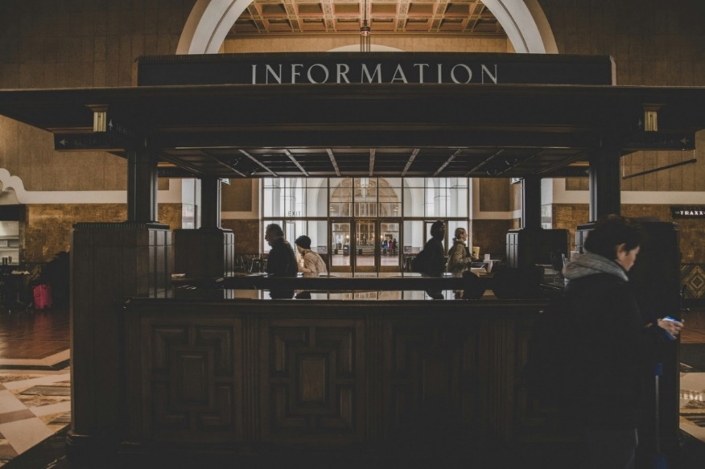

The survey then asked school librarians to share what barriers (if any) their school library faces in providing a safe space to their pupils, with an open comment box.

One longer response indicated the combined issues typical of barriers that school libraries are trying to address:

'The new school building opened in 2020 and merged two secondary schools into a combined campus with early years, primary and special needs schools. Issues with the size of the building have resulted in the Library computer suite being used as a teaching classroom for most of the week.

This means that English class access to borrow resources is restricted and other subjects are prevented from booking the library to carry out research. If a class is being taught others can only visit in small groups and study space in the library is practically non-existent.

Noise pollution from staggered lunch breaks in the dining area next door can be an issue. We operate an open house policy before morning registration, at lunch time and after school for pupils to browse, change loans, do school work or simply relax but sometimes the small space limits the numbers we can accommodate and some students can find it too busy.

Funding for new resources has been cut drastically in the last decade to the point that the 2023/24 library budget was £400 to cater for the needs of over 1600 students.'

Here, as the survey analysis has demonstrated throughout, we see manifold and knock-on impacts of budget cuts, capacity constraints and undervaluing of the library service.

Out of 72 responses, four main themes emerged:

* Antisocial behaviour (40% of responses)
  + 'Poor behaviour of some students can spill over into library, and can intimidate my regulars. SMT [Senior Management Team] have never dealt with this successfully, and meaningful consequences for anti-social behaviour / bullying are risible.'
* Short staffing (39% of responses)
  + 'Short staffing – only one member of staff available and she will give up her break and lunch to ensure pupils can access the library at these times.'
* Limited opening hours (33% of responses)
  + 'Limited opening hours, I work five days between two schools.

Decreased funding – my funding for book buying this year has decreased by 25% in each school.

Job insecurity – [Local authority] is not recruiting new permanent school librarians and I am on a consistent six month contract – budget depending if these are extended or not.

Anti-social behaviour – yes both schools have significant challenges in this area – my three-day school is not too bad, but my two-day school is very, very challenging.'

* + 'Staff only contracted school hours so we can't open early or after school to help pupils who might appreciate a space after or before school.'
  + 'Not open all week due to being split between two schools and pupils have commented on this – having nowhere to go when the library is shut.'
* Noise pollution (29% of responses)
  + 'The main barrier in my library is the lack of [physical] barriers – there are effectively no walls or doors in the library, only shelves to mark it off from the hall. We're adjacent to the main lunch hall, and the noise is ridiculous during break times. Pupils who would love to use the library as a safe space retreat to classrooms with kind teachers who can maintain a more calm environment.'
  + 'Reduction of size of library by 50%.

Huge decrease in funding / short of support staff.

Noise pollution – there is no wall / door – from community campus. There is a lot of vandalism / theft as a consequence. SMT [Senior Management Team] are not interested.'

These responses indicate the compounding and multifaceted barriers that librarians are trying to manage and often reflects how isolated they feel in their roles.

Some librarians are not taking a break during the day to ensure the space can be open for pupils, their short-term contracts with uncertain job security for years at a time, often working across several schools, an expectation to offer a full service with decreasing budgets, with insufficient support from senior management – these circumstances are indefensible and unsustainable.

#### Democratically engaged and informed communities

SLIC's *Forward* strategy notes that, 'as the mechanics of learning have moved beyond print, the role of libraries as curators of the vast array of information sources has been amplified'.

The same strategy envisions a future in which, 'libraries will open access to and build trust in public data to increase participation in the democratic process'[29].

The survey prompted librarians to share their thoughts on how important libraries are to building informed and democratically engaged pupils. Many commented on the stresses already mentioned above:

* ‘I'm a librarian – a solo worker–- there's only so much I can do without burning out. Senior school is focussed on the exam diet and there is no room in the junior years either. I can do lots of jobs really badly or focus on the things that really count. Nearly half of our pupils have reading ages below their actual age. Many have reading ages of eight or under. Without helping raise their literacy levels they will be unable to make head or tail of information sources.'
* 'At present, I feel like the majority of the time we are 'firefighting' and doing the minimum to keep libraries open and not always managing that. I do believe that libraries should be well placed to help the public access quality and trustworthy information online. School libraries should be helping to ensure people develop the skills to make their way through the deluge of information and be able to disregard unreliable sources. At present I believe we don't have capacity to do this in a consistent, widespread way.'
* 'I often hear from older pupils that they choose not to vote as they don't feel it will change their situation, therefore I hold conversations where I show them the worth of their voice and what they can do to change things.'

To round out the questions on active citizenship, the survey asked librarians to reflect how often their school library operates as a student hub for informed debate / decision-making.

The overwhelming majority reported their library rarely or never operates as a hub for informed debate or decision-making (54%); over a quarter (29%) reported it happens 'on occasion'. Just 1 in 6 (17%) reported that it happens 'at least weekly' or 'regularly'.

Considering the varied and multiple barriers to the opening hours, staffing constraints, and pupil access reported earlier in these findings, the inconsistency in fostering informed debate or decision-making seems to follow as a natural consequence.

### Final snapshot

A final two quantitative questions were asked of secondary school librarians at the end of the survey. These were both matrices, scaled from 1 (no, not at all) to 5 (yes, a lot).

The first question asked librarians to reflect on the extent to which their library supports seven essential needs: access to books; access to digital devices / Wi-Fi; access to essential warm spaces; access to learning resources and training; access to trusted sources of information; having a quiet space at school and opportunities for reading for pleasure.

The overwhelming majority indicated their library supports access to books ('yes, a lot', 82%), opportunities for reading for pleasure ('yes, a lot', 77%), and access to essential warm spaces ('yes, a lot', 69%).

Having a quiet space in school was more moderately reflected ('yes, a lot', 63%; 'often', 20%) as was access to trusted sources of information ('yes, a lot', 64%; 'often', 15%), digital devices / Wi-Fi ('yes, a lot', 67%; 'often', 11%), or learning resources and training ('yes a lot', 47%; 'often', 26%; 'moderately', 9%).

This snapshot reflects a reliance on the secondary school library as a place that provides books, opportunities to read, digital access, trusted sources of information and a quiet or warm space, but less so a service that offers learning resources or training.

It also indicates a stark departure from the responses that make up the rest of the survey: clearly, school libraries are supporting these essential needs where they can, but given the issues and restrictions outlined, it can only be a fraction of their potential. They are doing their best to fulfil these needs despite the many barriers they face, demonstrating their commitment and value.

The last question asked librarians to reflect on the extent to which their library addresses the six following issues: addressing social isolation; closing the poverty-related attainment gap; developing media / information literacy; improving literacy; mental health and wellbeing support; and tackling poverty and cost-of-living crisis.

For 'developing media / information literacy', there is almost a perfect split – 50% of librarians reported their library addresses it 'often' (28%) or 'yes, a lot' (22%); the other half was separated between 'moderately' (22%), 'a little' (21%) or 'no, not at all' (6%).

Similarly for 'tackling poverty and cost-of-living crisis', the findings are ambiguous: some librarians agreed the library addresses it 'often' (25%) or 'yes, a lot' (17%). The largest percentage selected 'moderately' (28%), followed by 'a little' (19%), or 'no, not at all' (11%).

However, 3 in 5 librarians agreed their library addresses 'closing the poverty-related attainment gap' ('yes, a lot', 24%; 'often', 40%), and nearly 3 in 4 agreed their school addresses social isolation ('yes, a lot' and 'often', both 37%).

4 in 5 librarians agreed their library addresses 'improving literacy' ('yes, a lot', 55%; 'often', 27%) and 'mental health and wellbeing support' ('yes, a lot', 46%; 'often', 35%).

These findings illustrate that many secondary school libraries are primarily directing their increasingly limited resources towards literacy and mental health and wellbeing. Societal issues, such as tackling poverty, or closing the poverty-related attainment gap, are too big for a school library to address in isolation, however, libraries can make a huge contribution to the whole-school strategy to address these issues. School libraries are in many cases pupils' only point of access for holistic support. (Perhaps one reason why 'addressing social isolation' is strongest after 'improving literacy' and 'mental health and wellbeing support'.)

The split response regarding media and information literacy is perhaps indicative of the digital inequalities across Scotland, as well as reports of school libraries being treated as 'an IT suite with books'.

## Conclusion

School librarians are direct and clear in their account of the sector: they are passionate about their work, dedicated to their pupils, innovative and resourceful in their activity, and a stalwart correction to dis- and misinformation online. They are able to adapt to competing needs of the school curriculum, digital access, media literacy, stock demands and pastoral care.

They are also trying to function to the best of their ability while facing drastic funding cuts, a lack of buy-in from management or sector leaders, restrictions and demands on their dedicated library space, and very limited time.

 The school librarians who are keeping their service going are often doing so alone or with few volunteers, on a shoestring budget, in between competing priorities and with no guarantee that their effort or its results will be recognised.

The full impact of a library service cannot be measured in the short-term, yet budgets can only be drawn up year-on-year, creating a situation where libraries are working extra hard to meet their pupils’ needs, but with dwindling resource.

School libraries need funding, secure staffing provision and more public and management support to allow them to continue to be centres for unbiased information, a remedy for digital inequality, safe spaces without judgement or expectation, and a crucial point of contact to support pupil wellbeing and achievement.

*Scottish Book Trust recommendations will be published with the final reporting arising from this research project in 2025.*

## References

1. COSLA. (2024). *Briefing for MSPs draft Scottish budget and local government settlement 24/25.* <https://www.cosla.gov.uk/__data/assets/pdf_file/0023/47381/COSLA-Briefing-Scottish-Budget-and-Local-Government-Settlement-24-25-Final-1.pdf>
2. The Poverty Alliance. (2021). *The poverty-related attainment gap: a review of the evidence.* The Robertson Trust. <https://www.therobertsontrust.org.uk/news-and-blogs/new-report-the-poverty-related-attainment-gap-evidence-review/>
3. Great School Libraries. (2023). *Equal futures? An imbalance of opportunities.* <https://www.greatschoollibraries.org.uk/_files/ugd/8d6dfb_b6f1af1fa9ec48b08b93566dc7608d95.pdf>
4. Ibid.
5. Campbell, R. (2016, September 21). *VIDEO: Island pupils create film to voice anger over school librarian cuts*. Press and Journal. <https://www.pressandjournal.co.uk/fp/news/highlands-islands/1033106/island-pupils-in-video-campaign-over-school-librarian-cuts/>
6. Comhairle nan Eilean Siar. (2023, November 20). *Cyber Attack Update – Comhairle nan Eilean Siar*. <https://cne-siar.gov.uk/cyber-attack-update/>
7. Great School Libraries. (2023). *Equal futures? An imbalance of opportunities.* <https://www.greatschoollibraries.org.uk/_files/ugd/8d6dfb_b6f1af1fa9ec48b08b93566dc7608d95.pdf>
8. Hepburn, H. (2023, February 23). *School librarians being 'wiped out' in parts of Scotland.* Tes. <https://www.tes.com/magazine/news/general/school-librarians-scotland-wiped-out>
9. Great School Libraries. (2023). *Equal futures? An imbalance of opportunities.* <https://www.greatschoollibraries.org.uk/_files/ugd/8d6dfb_b6f1af1fa9ec48b08b93566dc7608d95.pdf>
10. COSLA. (2024). *Briefing for MSPs draft Scottish budget and local government settlement 24/25.* <https://www.cosla.gov.uk/__data/assets/pdf_file/0023/47381/COSLA-Briefing-Scottish-Budget-and-Local-Government-Settlement-24-25-Final-1.pdf>
11. Great School Libraries. (2023). *Equal futures? An imbalance of opportunities.* <https://www.greatschoollibraries.org.uk/_files/ugd/8d6dfb_b6f1af1fa9ec48b08b93566dc7608d95.pdf>
12. Kirsch, I., de Jong, J., Lafontaine, D., McQueen, J., Mendelovits, J., & Monseur, C. (2002). *Reading for change: Performance and engagement across countries: Results from PISA 2000.* OECD. <https://www.oecd.org/education/school/programmeforinternationalstudentassessmentpisa/33690904.pdf>
13. BookTrust. *The benefits of reading.* Retrieved October 3, 2024, from <https://www.booktrust.org.uk/globalassets/resources/research/booktrusts-benefits-of-reading-june-2024.pdf>
14. Think Teaching. *School librarian salary.* Retrieved October 3, 2024, from <https://www.thinkteaching.co.uk/careers-advice/school-librarian/salary/>
15. TFPL. (2019). *Salary surveys*. <https://www.tfpl.com/salary-surveys>
16. Living Wage Foundation. *What is the real Living Wage?* Retrieved October 3, 2024, from <https://livingwage.org.uk/what-real-living-wage>
17. Think Teaching. *School librarian salary.* Retrieved October 3, 2024, from <https://www.thinkteaching.co.uk/careers-advice/school-librarian/salary/>
18. Living Wage Foundation. *What is the real Living Wage?* Retrieved October 3, 2024, from <https://livingwage.org.uk/what-real-living-wage>
19. Office for National Statistics. (2024). *Average weekly earnings in Great Britain: September 2024.* <https://www.ons.gov.uk/employmentandlabourmarket/peopleinwork/employmentandemployeetypes/bulletins/averageweeklyearningsingreatbritain/september2024>
20. The Poverty Alliance. (2021). *The poverty-related attainment gap: a review of the evidence.* The Robertson Trust. <https://www.therobertsontrust.org.uk/news-and-blogs/new-report-the-poverty-related-attainment-gap-evidence-review/>
21. Cabinet Secretary for Education and Skills (2023). *Education: National Improvement Framework and improvement plan 2024.* Scottish Government. <https://www.gov.scot/publications/education-national-improvement-framework-improvement-plan-2024/pages/7/>
22. Willians, D., Wavell, C., & Morrison, K. (2013). *Impact of school libraries on learning: Critical review of published evidence to inform the Scottish education community.* Robert Gordon University, Institute for Management, Governance & Society (IMaGeS). <http://hdl.handle.net/10059/1093>
23. Allmann, K. (2022). *UK digital poverty evidence review 2022.* Digital Poverty Alliance. <https://digitalpovertyalliance.org/uk-digital-poverty-evidence-review-2022/>
24. Deloitte. (2023). *Digital poverty in the UK: A socio-economic assessment of the implications of digital poverty in the UK.* Digital Poverty Alliance. <https://digitalpovertyalliance.org/digital-poverty-in-the-uk-a-socio-economic-assessment-of-the-implications-of-digital-poverty-in-the-uk/>
25. Digital Directorate, Digital Health and Care Directorate. (2023). *Connecting Scotland programme: Full business case.* Scottish Government. <https://www.gov.scot/publications/full-business-case-connecting-scotland/pages/3/>
26. National Literacy Trust. (2018). *Fake news and critical literacy: The final report of the Commission on Fake News and the Teaching of Critical Literacy in Schools.* <https://literacytrust.org.uk/research-services/research-reports/fake-news-and-critical-literacy-final-report/>
27. Scottish Library and Information Council. (2021). *Forward: Scotland's public library strategy 2021–2025.* <https://scottishlibraries.org/media/3462/slic-public-library-strategydigital_final.pdf>
28. CILIP. (2018). *Public libraries: The case for support.* <https://cdn.ymaws.com/www.cilip.org.uk/resource/resmgr/cilip/information_professional_and_news/press_releases/2019_10_report_case_for_support/public_libraries_-_the_case_.pdf>
29. Scottish Library and Information Council. (2021). *Forward: Scotland's public library strategy 2021–2025.* <https://scottishlibraries.org/media/3462/slic-public-library-strategydigital_final.pdf>