

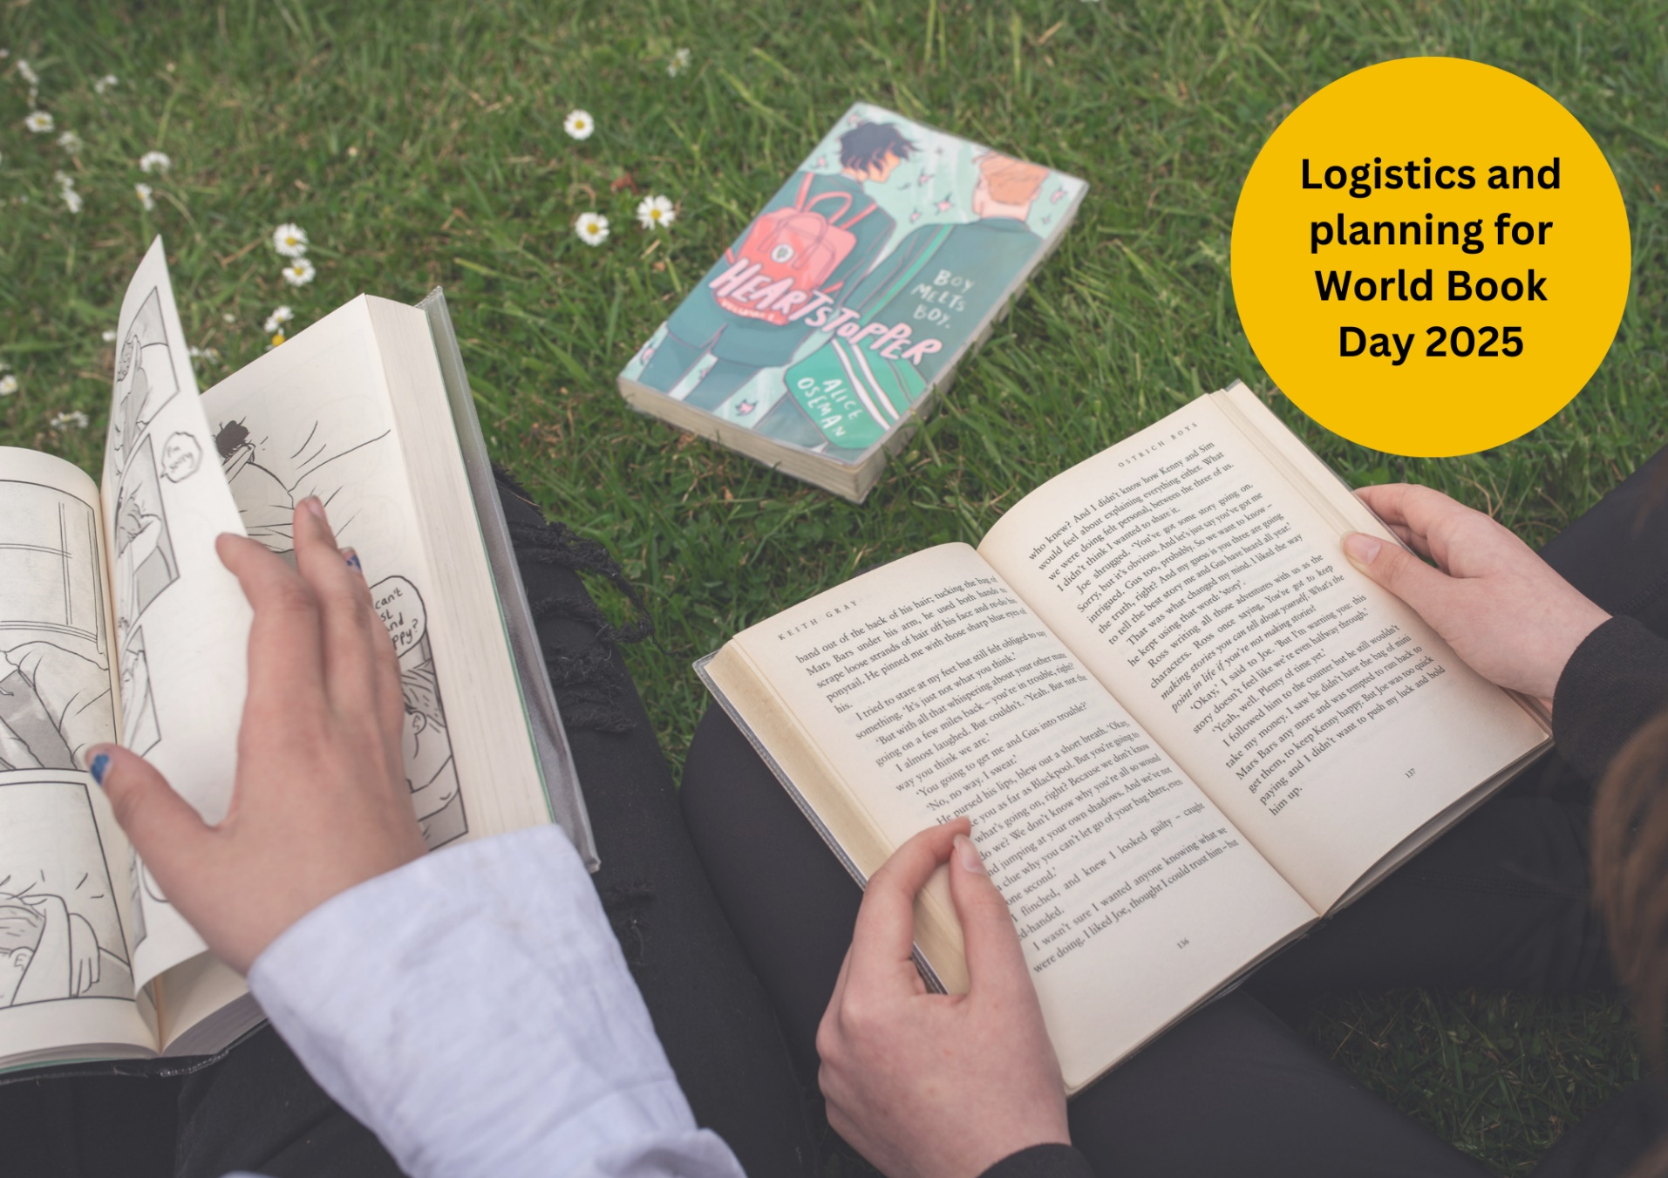

# World Book Day: Planning toolkit

A toolkit designed to help you prepare for World Book Day 2025

## Suitable for teachers, librarians, early years practitioners and other learning professionals Created with World Book Day



scottishbooktrust.com



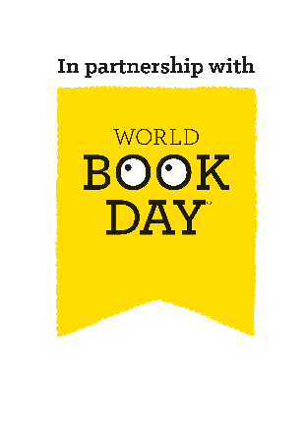Scottish Book Trust is a registered company (SC184248)

and a Scottish charity (SC027669).

## Contents

About this resource 2

Why celebrate World Book Day? 3

Your World Book Day timeline 4

Key dates 4

December 5

January 5

February 5

March 6

World Book Day events programme 6

For practitioners 6

For pupils 7

Next steps 7

## About this resource

[Scottish Book Trust](https://www.scottishbooktrust.com/) is a national charity that believes everyone living in Scotland should have equal access to books. Our Schools programmes include book gifting, tours and live events, our [Reading Schools](https://www.readingschools.scot/) accreditation programme, as well as professional support, training and resources to support you to embed reading for pleasure in your school or setting. Bookbug is Scotland's universal early years book gifting programme which supports families to read, sing, and play with their little ones from birth to give them the best start in life. Our Bookbug sessions are free events for children aged 0-5 years and their mums, dads and carers, comprising of stories, rhymes and songs.

[World Book Day](https://www.worldbookday.com/about-us/) is a national celebration which changes lives through a love of books and reading. They are a national charity that operates in the U.K. and Ireland to promote reading for pleasure, offering every child and young person the opportunity to have a book of their own. World Book Day 2025 is **Thursday 6 March**.  
  
We have partnered with [World Book Day](https://www.worldbookday.com/) to adapt their toolkit and resources for Scottish schools and settings and help you celebrate World Book Day 2025! On [the Scottish Book Trust website](https://www.scottishbooktrust.com/learning-resources/celebrating-world-book-day-in-your-school), you can find all of the resources including:

* A World Book Day planning toolkit
* Celebrating World Book Day: early years resource
* Celebrating World Book Day: primary resource
* Celebrating World Book Day: secondary resource
* Celebrating World Book Day: school library resource
* Celebrating World Book Day: home educator resource

You can also find our [designated World Book Day page on the Scottish Book Trust website](https://www.scottishbooktrust.com/learning-and-resources/world-book-day), which gathers activities, articles, videos, and more resources that have been handpicked to help you further explore reading for pleasure and the World Book Day £1 titles!  
  
Throughout this resource we’ll include links to resources from book the World Book Day website and the Scottish Book Trust website to support you with delivery.

## Why celebrate World Book Day?

Reading for pleasure is a key indicator of a child’s future success. In fact, studies show its more important for a child’s educational success than the socio-economic class they grow up in[1]. Reading for pleasure has benefits across the curriculum for a child’s skills and learning, as well as their motivation to learn[2]. It also helps develop key life skills such as empathy, imagination, problem-solving and communication skills[3].   
  
By celebrating days like World Book Day and giving reading for pleasure a high profile in your school or setting, you are demonstrating to pupils that reading is a fun and worthwhile way to spend their time. By sharing your habits and preferences as a reader, you are also acting as reading role model, which is something that they may not have at home. Throughout this resource, we suggest ways to make reading engaging and fun for all pupils as well as how to extend these ideas in your school or setting beyond World Book Day.  
  
World Book Day has six key principles of reading for pleasure. They believe children are more likely to love reading if:

* Someone reads to them regularly
* They find time to read
* They have books at home and at school
* They know a trusted person who can help them find the right books
* We make reading fun for them
* They are given a choice in what they read

Similarly, Scottish Book Trust’s [Reading Schools](https://www.readingschools.scot/) accreditation programme is designed to champion your efforts as you build and sustain a reading culture in your school or setting. Our framework, mapped onto [How Good is Our School? 4](https://education.gov.scot/media/dtnnmvjh/frwk2_hgios4-4.pdf), includes elements that are key to building a reading culture. Many of these key areas support celebrating World Book Day, including role modelling reading to pupils, creating a school environment that encourages and supports reading, and connecting pupils with reading social networks.   
  
By working together to celebrate World Book Day, we can help share the joy of reading and books with more children and their families!

## Your World Book Day timeline

### Key dates

|  |  |
| --- | --- |
| **Date** | **Activity** |
| Monday 9 December | All World Book Day 2025 online materials are released |
| Monday 9 December | School Librarian briefing webinar |
| January (whole month) | World Book Day physical tokens and posters arrive in your setting (except early years settings – please see the February row below). |
| February (whole month) | Bookbug Explorer Resource Packs arrive in early years settings. These will contain digital tokens for the £1 books. |
| Wednesday 15 January | Educators’ briefing webinar |
| Thursday 13 February | Books are available in shops |
| Thursday 6 March | World Book Day 2025 |
| Sunday 23 March | Final day of token exchange |

### December

#### Getting ready

* Read this information pack
* Explore the World Book Day £1 book selection
* Ensure your colleagues access our online resource banks:
  + Early years
  + Primary schools
  + Secondary schools
  + School library

### January

#### Start planning your day with colleagues

* World Book Day £1 book tokens and posters will be delivered to your school. Contact [wbd@education.co.uk](mailto:wbd@education.co.uk) if you have any questions
* Plan your activities with our resource bank and [Scottish Book Trust’s World Book Day packages](https://www.scottishbooktrust.com/learning-and-resources/world-book-day)
* Choose the World Book Day events you’re going to join, and display the [World Book Day poster](https://www.worldbookday.com/download/63385/?tmstv=1733309719) in your staff room so everyone is in the know

### February

* Give out the £1 book tokens! Children can swap their World Book Day £1 token for a free £1 book between Thursday 13 February and Sunday 23 March. The earlier they have the tokens, the wider their choice of books will be
* Order your accessible copies – braille, audio or large-print £1 books are available via [Guide Dogs, RNIB, Vision Ireland and Calibre Audio](https://www.worldbookday.com/diversity-and-inclusion/)
* Help your pupils choose the right book for them using the resources available on the World Book Day website
  + [Look insides:](https://www.worldbookday.com/2024/11/take-a-sneak-peek-inside-the-2025-1-e1-50-books/) the opening pages of each book, developed with Nielsen
  + [Games, conversation starters and sensory activities](https://www.worldbookday.com/download/63391/?tmstv=1733142202), developed with Coram Beanstalk and Bag Books
  + [Videos from the World Book Day £1 authors](https://youtube.com/playlist?list=PL_hqLJPmFPSTBvTunt_yV4O4oHNxKk3UJ&si=F296ia7bluhGGBrf)
* Share your World Book Day plans with your school or early years community using the [World Book Day Caregiver Communications Toolkit](https://www.worldbookday.com/download/63361/?tmstv=1733309719)

### March

#### Share the celebration!

World Book Day is Thursday 6 March. You can share any photos or videos (with relevant permissions) with:

* Hashtag: #WorldBookDay
* Facebook: WorldBookDayUK or ScottishBkTrust (for early years, see BookbugSBT)
* Instagram: @WorldBookDaySocial or @scottishbktrust (for early years, see @bookbug_sbt)
* X: @WorldBookDayUK or @scottishbktrust
* YouTube: @WorldBookDayUK

## World Book Day events programme

### For practitioners

[**Webinar: Preparing for World Book Day**](https://www.worldbookday.com/events/2025-educators-webinar/) **– Wednesday 15 January, 4pm**Hear about World Book Day’s approach to reading for pleasure and let them answer your questions. Book online via the World Book Day website.  
  
[**Webinar: Preparing for World Book Day 2025 for School Library Staff**](https://www.worldbookday.com/events/2025-schools-library-staff-webinar/) **– available from Sunday 15 December**World Book Day’s session for school librarians on 9 December will be available on their YouTube channel from the week beginning 15 December.  
  
[**Webinar series: Overcoming barriers to reading for pleasure**](https://youtube.com/playlist?list=PL_hqLJPmFPSSJx_hvjbLjuUaTTn6005e6&si=5_uliQlxEcIhrdE7)In preparation for World Book Day, explore World Book Day’s 2024 webinar series, created in partnership with the Open University Reading for Pleasure team.

### For pupils

[**Great World Book Day Footy and Booky Quiz – Thursday 6 March, 9:30am**](https://literacytrust.org.uk/world-book-day-live.)[**BBC Teach Live Lesson – Thursday 6 March, 11am**](https://www.bbc.co.uk/teach/live-lessons/articles/z33hcxs) **Scottish Book Trust resources**Visit the [World Book Day section of the Scottish Book Trust website](https://www.scottishbooktrust.com/learning-and-resources/world-book-day) to find curated activities, on demand Authors Live broadcasts and more that you can use to both celebrate World Book Day and further explore the World Book Day £1 titles

Next stepsPromoting reading for pleasure in your school is important all year, not just on World Book Day! For more support to build a reading culture in your school see:

* Our [World Book Day section of the Scottish Book Trust website](https://www.scottishbooktrust.com/learning-and-resources/world-book-day) gathers activities, articles, videos and further resources to further extend reading for pleasure and World Book Day’s £1 titles.
* Our [free Reading Schools programme](https://www.readingschools.scot/) which offers an accreditation for building a reading culture in your school, as well as support and resources to help you with delivery.
* Our [Schools guide](https://www.scottishbooktrust.com/learning-and-resources/our-schools-guide) contains more information on the programmes, CLPL and resources from Scottish Book Trust created to support teachers, educators and librarians in schools.
* For early years, [the Bookbug section of the Scottish Book Trust website](https://www.scottishbooktrust.com/topics/bookbug) contains articles, webinars and resources to support staff to use books with early years children. You can also find out about [Bookbug Sessions in your area](https://www.scottishbooktrust.com/reading-and-stories/bookbug/find-your-local-bookbug-session) to share with families.
* Our [Building a reading culture webinar and resource](https://www.scottishbooktrust.com/learning-resources/create-a-reading-culture-get-your-school-reading) contains a guide to building a reading culture in your school, including supporting pupils to read for pleasure, developing your staff’s knowledge and ideas for groups and activities.
* World Book Day’s [Resources Hub](https://www.worldbookday.com/resources) contains lots more reading for pleasure ideas, resources for World Book Day and all year round!

1. ## Endnotes

   [“Reading for Change: Performance and Engagement across Countries”](https://read.oecd-ilibrary.org/education/reading-for-change-performance-and-engagement-across-countries_9789264099289-en#page1), PISA 2020
2. [“Motivation During an Excessively Challenging Reading Task: The Buffering Role of Relatvie Topic Interest”](https://www.researchgate.net/publication/233060749_Motivation_During_an_Excessively_Challenging_Reading_Task_The_Buffering_Role_of_Relative_Topic_Interest), The Journal of Experimental Education. 2011.
3. [“The role of home learning environment and emerging insights into the impact of the pandemic”](https://cdn.literacytrust.org.uk/media/documents/The_role_of_the_home_learning_environment_and_emerging_insights_-_FINAL_LedgnMX.pdf). National Literacy Trust. 2022.