

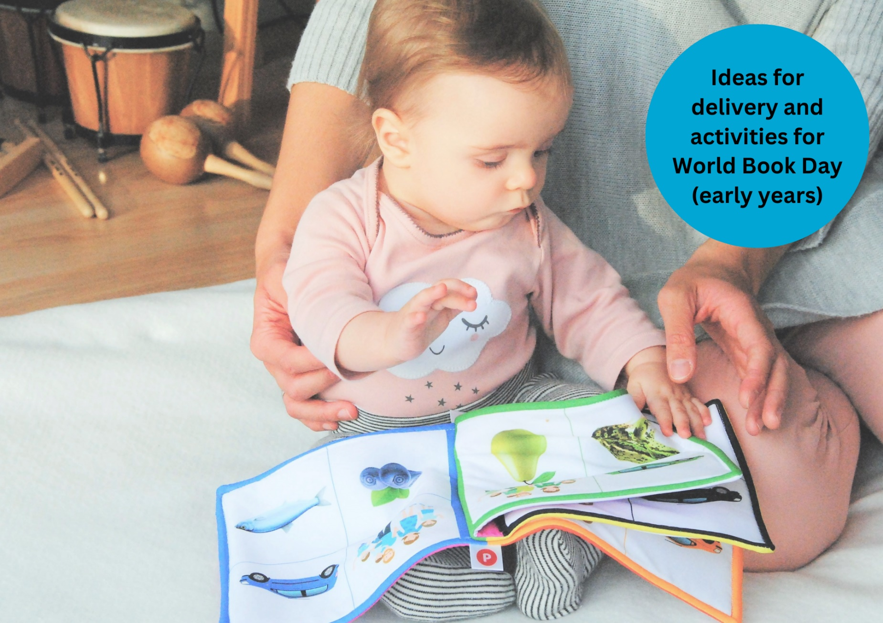

# Celebrating World Book Day: early years

A guide to World Book Day including suggested activities and ideas for your setting

## Suitable for early years settings

## Resource created by Scottish Book Trust and World Book Day



scottishbooktrust.com



Scottish Book Trust is a registered company (SC184248)

and a Scottish charity (SC027669).

## Contents

About this resource 2

Why celebrate World Book Day? 4

Scottish Book Trust packages 5

Creating a whole setting plan 5

Involving families 6

Setting activities 8

Next steps 10

## About this resource

[Scottish Book Trust](https://www.scottishbooktrust.com/) is a national charity that believes everyone living in Scotland should have equal access to books. Bookbug is Scotland's universal early years book gifting programme which supports families to read, sing, and play with their little ones from birth to give them the best start in life. Our Bookbug sessions are free events for children aged 0-5 years and their mums, dads and carers, comprising of stories, rhymes and songs.  
  
[World Book Day](https://www.worldbookday.com/about-us/) is a national celebration which changes lives through a love of books and reading. They are a national charity that operates in the U.K. and Ireland to promote reading for pleasure, offering every child and young person the opportunity to have a book of their own. World Book Day 2025 is **Thursday 6 March**.

We have partnered with World Book Day to adapt their toolkit and resources for Scottish schools and settings and help you celebrate World Book Day 2025! On [the Scottish Book Trust website](https://www.scottishbooktrust.com/learning-resources/celebrating-world-book-day-in-your-school), you can find all of the resources including:

* A World Book Day planning toolkit
* Celebrating World Book Day: early years resource
* Celebrating World Book Day: primary resource
* Celebrating World Book Day: secondary resource
* Celebrating World Book Day: school library resource
* Celebrating World Book Day: home educator resource

You can also find our [designated World Book Day webpage on the Scottish Book Trust website](https://www.scottishbooktrust.com/learning-and-resources/world-book-day), which gathers activities, articles, videos, and more resources that have been handpicked to help you further explore reading for pleasure and the World Book Day £1 titles!   
  
This resource, created in partnership with World Book Day, contains advice and ideas for celebrating World Book Day in your early years setting. Throughout, we’ve highlighted Scottish Book Trust resources you can use as part of your celebration, or to deliver further opportunities to read for pleasure. If you need more information on the tokens or practical elements of planning for world book day see our [World Book Day planning toolkit](https://www.scottishbooktrust.com/learning-resources/celebrating-world-book-day-in-your-school).  
  
The key areas of this resource are:

* How to create a whole setting plan to celebrate World Book Day
* Suggested activities to celebrate World Book Day
* Communicating with families to support all-year reading
* How to continue to support reading for pleasure in your setting, build a reading culture and make reading fun using World Book Day and Scottish Book Trust resources and programmes

## Why celebrate World Book Day?

Reading for pleasure is a key indicator of a child’s future success[1]. In fact, studies show it’s more important for a child’s educational success than the socio-economic class they grow up in. Babies who are read to every day, on average, perform better at school and have higher levels of wellbeing[2]. Reading for pleasure, as well as supporting literacy and key learning skills, also develops life skills such as empathy, imagination, problem-solving and communication skills[3].  
  
Reading for pleasure is a lifelong habit, and it’s never too early to start! Even before they are born, babies can hear in the womb. [This short video with Suzanne Zeedyk on the Scottish Book Trust website](https://www.scottishbooktrust.com/reading-and-stories/bookbug/ideas-from-early-years-experts/dr-suzanne-zeedyk) looks at how shared experiences of reading and singing helps babies’ brains to develop (2 minutes, 49 seconds). As a practitioner, supporting reading for pleasure and celebrating books can have a huge impact on a children’s confidence with reading, as well as making books for fun and engaging!  
  
World Book Day has six key principles of reading for pleasure. They believe children are more likely to love reading if:

* Someone reads to them regularly
* They find time to read
* They have books at home and at nursery
* They know a trusted person who can help them find the right books
* We make reading fun for them
* They are given a choice in what they read

## Scottish Book Trust packages

On the Scottish Book Trust website, we’ve created [a World Book Day page](https://www.scottishbooktrust.com/learning-and-resources/world-book-day) which gathers activities, articles, videos and more resources to help you celebrate World Book Day, including advice on how to choose picture books for young children or top tips for reading with your baby. If you just need book recommendations, you can also find our [What to read after World Book Day book list for beginning and early readers](https://www.scottishbooktrust.com/book-lists/what-to-read-after-world-book-day-beginning-and-early-readers) which suggest books that children might like based upon what they have chosen from the World Book Day £1 titles.

## Creating a whole setting plan

### Key actions

* The [World Book Day planning toolkit](https://www.scottishbooktrust.com/learning-resources/celebrating-world-book-day-in-your-school) gives more information on the tokens and logistics of planning
* Arrange a planning meeting with staff
* Plan World Book Day delivery with staff
  + Decide if children will dress up. See [World Book Day’s dressing up guide](https://www.worldbookday.com/celebrate-world-book-day/dressing-up/) on how to make this accessible or alternatives you can offer.
* Remind families about the link to their digital £1 tokens in their Bookbug Explorer Resource Pack (to find more information on the £1 titles and tokens, see [the information page on the World Book Day website](https://www.worldbookday.com/books-and-tokens/books/participating-retailers/))
* Communicate activities to families. See [World Book Day’s Parent and Caregivers’ communication toolkit](https://www.worldbookday.com/download/63361/?tmstv=1733309719) for more information on how to communicate with families so they’re prepared and excited for World Book Day

### Key things to consider

* Are our children being read to regularly at home and in the setting?
* What access to books do they have at home and in the setting?
* How confident are they in choosing books they like?
* How do we recommend books to children and families?
* Are families aware of alternative ways to engage with reading – as well as how to access books for free?
* Do we know about our children’s home reading environments? How can we celebrate these?
* Are our delivery and texts representative of the children in our school? Children are more likely to engage with reading when they see characters like them[4].

## Involving families

[World Book Day’s Parent and Caregivers’ communication toolkit](https://www.worldbookday.com/download/63361/?tmstv=1733309719) contains advice on communicating with families, including both World Book Day and reading all-year round. You can also share Scottish Book Trust’s [Home Activities Hub](https://www.scottishbooktrust.com/home-activities) with families or share [our webpage on how to find your local Bookbug Session](https://www.scottishbooktrust.com/reading-and-stories/bookbug/find-your-local-bookbug-session). Bookbug Sessions are free events for 0-5s and their families and include sharing stories, songs and rhymes.  
  
You can also consider the following:

Remind families about the Bookbug Bags. Every child in Scotland is entitled to four free [Bookbug Bags](https://www.scottishbooktrust.com/reading-and-stories/bookbug/bookbug-bags) between birth and age five to help them develop an early love of stories, songs and rhymes. Each bag contains books and fun age-appropriate resources. Families can find out how to get theirs on [the Scottish Book Trust website](https://www.scottishbooktrust.com/reading-and-stories/bookbug/bookbug-bags).

|  |  |
| --- | --- |
| **Date** | **Activity** |
| February | Bookbug Explorer Resource Packs will arrive in your setting. Remind families that in them they can find a link to their digital £1 token. |
| 13 February | Books available in shops. The earlier you take your tokens to a bookshop, the wider the choice of books will be. |
| 6 March | World Book Day 2025 |
| 23 March | Final day of token exchange |

### Finding out how families read

Celebrate how families read at home by inviting them to share photographs or bring in books. Include and encourage dual-coded or home language books. You could encourage families to take “extreme reading” photographs, where they try to read in the silliest place possible! Creating a display of these is a great way to make reading fun and prompt discussion about how reading can make us feel.

### Share information on reading

Share information with families about how to access reading, including the [Scottish Book Trust Home Activities Hub](https://www.scottishbooktrust.com/home-activities) and [local Bookbug Sessions](https://www.scottishbooktrust.com/reading-and-stories/bookbug/find-your-local-bookbug-session) links, as well as how to find their local library [via MyScotGov](https://www.mygov.scot/find-library) and bookshop [via the Booksellers Association](https://www.booksellers.org.uk/bookshopsearch).

### Host a family reading session

Show families how to read with their children by hosting a family reading session where you model reading aloud. You could theme this around World Book Day or have a bedtime story to show some of the benefits of reading before bed.

### Host a book or costume swap

Invite families to visit for a book swap. If you’re planning on dressing up, you could also have a costume swap or costume rail where people can leave or take a costume.

## Setting activities

### Activity 1: A big World Book Day welcome

LIT 0-01b/0-11b  
Welcome the children with a display of photographs of their favourite texts for the families to see. Invite children and families to share home stories in response. You could also host a stay and read at either the start, or the end of the day.

### Activity 2: Decorate your setting

#### Design your own hot air balloons (*The Magic Balloon*)

EXA 0-02a, SCN 0-04a, SCN 0-07a  
Invite children to design their own hot-air balloons to hide around your setting. With your help, children might want to experiment with creating flying balloons by blowing on different materials with a hairdryer and then working together to create a hot-air-balloon shape.

#### Make a reading den (*Bluey’s Little Book*)

TCH 0-04b, TCH 0-04c, TCH 0-09a, TCH 0-10a  
Bluey’s family love making dens and other areas to read in. Can the children create their own reading den, inside or outside, with the materials you provide?

#### Create your own small-world (*Who’s in Acorn Wood?*)

TCH 0-09a, TCH 0-10a  
The Acorn Wood characters love visiting each other’s houses. Can the children make them somewhere to visit, using small-world materials or role play?

#### Reading mood characters (*Barbara’s Very Useful Guide to Moods*)

EXA 0-02a, EXA 0-04a, TCH 0-09a, TCH 0-10a  
Talk to children about how reading makes them feel and about how they would like it to make them feel. Share the image of Barbara – can they draw or create reading-mood characters?

### Activity 3: Get to know your books

LIT 0-01b, LIT 0-04a, LIT 0-07a, LIT 0-09b, LIT 0-11b LIT 0-16a, ENG 0-17a,   
LIT 0-31a  
You can use this activity for any of the £1 books, or any other books in your setting. Before you read the book together, take time to look at the cover and endpapers. Talk about:

* What you can see – people, animals, objects, colours, details
* What you think this story might be about

Record your discussion and display it on the wall, or in a floor book. Include children’s questions, observations and drawings. After reading the story, revisit your initial ideas. Are there questions you would like to add to your display? What has sparked children’s interest from the story? Think about how you can use this to inspire follow up activities, learning and play. If the book features different animals, perhaps they would like to find out more about a particular animal. Or learn about a different place, culture or food.

This activity has been taken from our [10 things you can do with any book at early level resource](https://www.scottishbooktrust.com/learning-resources/great-activities-to-do-with-any-book-early-level), which you can use for any of the £1 titles, or any other books in your setting.

### Activity 4: Using songs and rhymes

HWB 0-21a, HWB 0-22a, EXA 0-08a  
You can use [the Bookbug Song and Rhyme Library](https://www.scottishbooktrust.com/songs-and-rhymes) or the [Bookbug Songs and Rhymes app](https://www.scottishbooktrust.com/reading-and-stories/bookbug/bookbug-app) to explore songs and rhymes in your setting. Why not add a second layer onto the £1 titles by exploring some songs or rhymes on the similar theme? For example –

#### *The Magic Balloon*: [“What do you see?”](https://www.scottishbooktrust.com/songs-and-rhymes/what-do-you-see)

Imagine everything you could see if you were in a magic balloon. Ask the children to add their suggestions of what you see next.

#### *Bluey’s Little Book*: [“B-I-N-G-O!”](https://www.nurseryrhymes.org/bingo.html)

Ask everyone to take turns to share their pets’ names when you sing.

#### *Who’s in Acorn Wood?*: [“Teddy Bear, Teddy Bear”](https://www.scottishbooktrust.com/songs-and-rhymes/teddy-bear-teddy-bear)

Join in with the actions as you sing!

#### *Barbara’s Very Useful Guide to Moods*: [“If You’re Happy and You Know It”](https://www.scottishbooktrust.com/songs-and-rhymes/if-youre-happy-and-you-know-it-makaton)

Add in different emotions and explore acting out how they make you look. You can also find [a Makaton version of this song on our website](https://www.scottishbooktrust.com/songs-and-rhymes/if-youre-happy-and-you-know-it-makaton).

### Activity 5: Create a sensory story

Our resources [Getting started with sensory stories](https://www.scottishbooktrust.com/learning-resources/getting-started-with-sensory-stories) and [Turning picture books into sensory stories](https://www.scottishbooktrust.com/learning-resources/turning-picture-books-into-sensory-stories) suggest some ideas, inspiration and activities for adapting texts into sensory experiences. You could base these onthe £1 books, or any books that are well-loved in your settings!

## Next steps

Promoting reading for pleasure in your setting is important all year, not just on World Book Day!

* Our [World Book Day section of the Scottish Book Trust website](https://www.scottishbooktrust.com/learning-and-resources/world-book-day) gathers activities, articles, videos and further resources to further extend reading for pleasure and World Book Day’s £1 titles.
* See the [Bookbug section of the Scottish Book Trust website](https://www.scottishbooktrust.com/topics/bookbug) for webinars and resources to support staff understand and knowledge about using books with early years children.
* [Find out more about Bookbug Sessions in your area](https://www.scottishbooktrust.com/reading-and-stories/bookbug/find-your-local-bookbug-session) – this is a great resource for families, as all sessions are free and designed to help families read, sing together and bond.

## Endnotes

1. [“Reading for Change: Performance and Engagement across Countries”](https://read.oecd-ilibrary.org/education/reading-for-change-performance-and-engagement-across-countries_9789264099289-en#page1), PISA 2020
2. [“Reading for pleasure at home with babies and toddlers”](https://thehub-beta.walthamforest.gov.uk/sites/default/files/2020-02/Reading_for_pleasure_at_home_with_babies_and_two_year_olds.pdf), Waltham Forest. 2020
3. [“The role of home learning environment and emerging insights into the impact of the pandemic”](https://cdn.literacytrust.org.uk/media/documents/The_role_of_the_home_learning_environment_and_emerging_insights_-_FINAL_LedgnMX.pdf). National Literacy Trust. 2022
4. [“How teachers can put the right book in the right hand”](https://www.scottishbooktrust.com/articles/how-teachers-can-put-the-right-book-in-the-right-hand), Katherine Wilkinson for Scottish Book Trust