

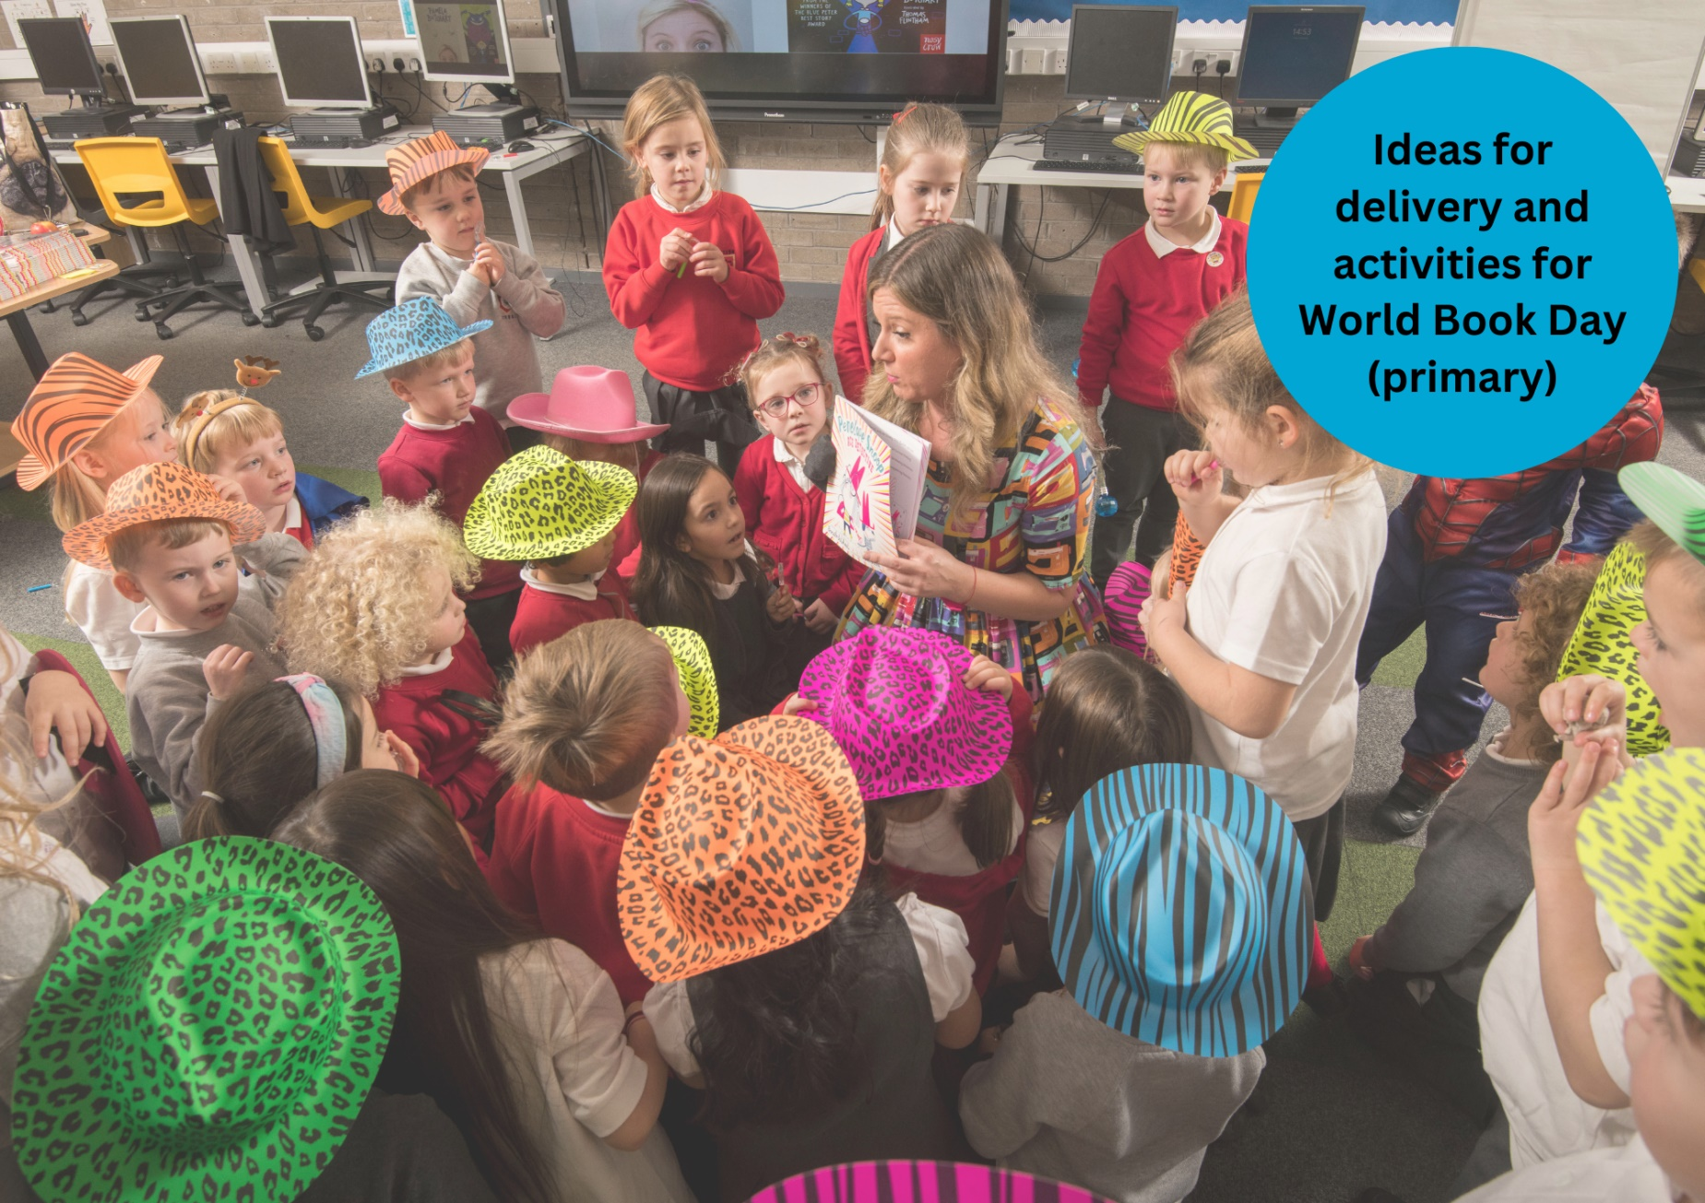

# Celebrating World Book Day: primary resource

A guide to World Book Day including whole school and classroom activities

## Suitable for primary pupils

## Resource created by Scottish Book Trust and World Book DayDecorative image

scottishbooktrust.com

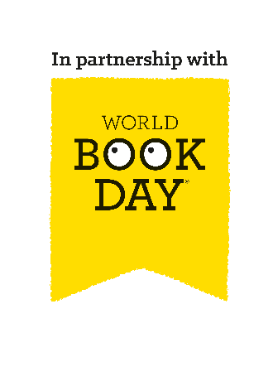

Scottish Book Trust is a registered company (SC184248)

and a Scottish charity (SC027669).

## Contents

About this resource 2

Why celebrate World Book Day? 3

Scottish Book Trust packages 4

Creating a whole-school plan 5

Whole-school activities 7

Classroom activities 10

Next steps 12

## About this resource

[Scottish Book Trust](https://www.scottishbooktrust.com/) is a national charity that believes everyone living in Scotland should have equal access to books. Our Schools programmes include book gifting, tours and live events, our [Reading Schools](https://www.readingschools.scot/) accreditation programme, as well as professional support, training and resources to support you to embed reading for pleasure in your school or setting.   
  
[World Book Day](https://www.worldbookday.com/about-us/) is a national celebration which changes lives through a love of books and reading. They are a national charity that operates in the U.K. and Ireland to promote reading for pleasure, offering every child and young person the opportunity to have a book of their own. World Book Day 2025 is **Thursday 6 March**.

We have partnered with World Book Day to adapt their toolkit and resources for Scottish schools and settings and help you celebrate World Book Day 2025! On [the Scottish Book Trust website](https://www.scottishbooktrust.com/learning-resources/celebrating-world-book-day-in-your-school), you can find all of the resources including:

* A World Book Day planning toolkit
* Celebrating World Book Day: early years resource
* Celebrating World Book Day: primary resource
* Celebrating World Book Day: secondary resource
* Celebrating World Book Day: school library resource
* Celebrating World Book Day: home educator resource

You can also find our [designated World Book Day webpage on the Scottish Book Trust website](https://www.scottishbooktrust.com/learning-and-resources/world-book-day), which gathers activities, articles, videos, and more resources that have been handpicked to help you further explore reading for pleasure and the World Book Day £1 titles!   
  
This resource, created in partnership with World Book Day, contains advice and ideas for celebrating World Book Day in your class and school. Throughout, we’ve highlighted Scottish Book Trust resources you can use as part of your celebration, or to deliver further opportunities to read for pleasure. If you need more information on the tokens or practical elements of planning for world book day see our [World Book Day planning toolkit](https://www.scottishbooktrust.com/learning-resources/celebrating-world-book-day-in-your-school).  
  
The key areas of this resource are:

* How to create a whole-school plan to celebrate World Book Day
* Suggested activities to celebrate World Book Day
* How to continue to support reading for pleasure in your school, build a reading culture and make reading fun using World Book Day and Scottish Book Trust resources and programmes

## Why celebrate World Book Day?

Reading for pleasure is a key indicator of a child’s future success. In fact, studies show its more important for a child’s educational success than the socio-economic class they grow up in[1]. Reading for pleasure has benefits across the curriculum for a child’s skills and learning, as well as their motivation to learn[2]. It also helps develop key life skills such as empathy, imagination, problem-solving and communication skills[3].   
  
By celebrating days like World Book Day and giving reading for pleasure a high profile in your school, you are demonstrating to pupils that reading is a fun and worthwhile way to spend their time. By sharing your habits and preferences as a reader, you are also acting as reading role model, which is something that they may not have at home. Throughout this resource, we suggest ways to make reading engaging and fun for all pupils as well as how to extend these ideas in your school beyond World Book Day.

World Book Day has six key principles of reading for pleasure. They believe children are more likely to love reading if:

* Someone reads to them regularly
* They find time to read
* They have books at home and at school
* They know a trusted person who can help them find the right books
* We make reading fun for them
* They are given a choice in what they read

Similarly, Scottish Book Trust’s [Reading Schools](https://www.readingschools.scot/) accreditation programme is designed to champion your efforts as you build and sustain a reading culture in your school or setting. Our framework, mapped onto [How Good is Our School? 4](https://education.gov.scot/media/dtnnmvjh/frwk2_hgios4-4.pdf), includes elements that are key to building a reading culture. Many of these key areas support celebrating World Book Day, including role modelling reading to pupils, creating a school environment that encourages and supports reading, and connecting pupils with reading social networks.  
  
By working together to celebrate World Book Day, we can help share the joy of reading and books with more children and their families!

## Scottish Book Trust packages

On the Scottish Book Trust website, we’ve created [a World Book Day page](https://www.scottishbooktrust.com/learning-and-resources/world-book-day) which gathers activities, articles, videos and more resources to help you celebrate World Book Day. For example, if your pupils have enjoyed *All Poems Aloud*, you can watch [Joseph Coelho’s Authors Live](https://www.scottishbooktrust.com/authors-live-on-demand/joseph-coelho-poetry-is-for-everyone) or have a go yourself with [our poetry writing resources](https://www.scottishbooktrust.com/learning-resources/write-a-rondel-poem-with-joseph-coelho). If they preferred *The Soccer Diaries: Rocky Takes the Lead* you can find [our article on how reading makes you a better player](https://www.scottishbooktrust.com/articles/5-reasons-why-books-will-make-you-better-at-football), and our [top picks of football and sports books](https://www.scottishbooktrust.com/book-lists/middle-grade-football-favourites)!  
  
If you need book recommendations, you can also find our “What to read after World Book Day” book lists for [beginning and early readers](https://www.scottishbooktrust.com/book-lists/what-to-read-after-world-book-day-beginning-and-early-readers) as well as [fluent and independent](https://www.scottishbooktrust.com/book-lists/what-to-read-after-world-book-day-fluent-and-independent-readers), which suggest books that pupils might like based upon what they have chosen from the World Book Day £1 titles.

## Creating a whole-school plan

### For school leads

#### Key actions

* The [World Book Day planning toolkit](https://www.scottishbooktrust.com/learning-resources/celebrating-world-book-day-in-your-school) gives more information on the tokens and logistics of planning
* Arrange a planning meeting with staff
* Plan World Book Day delivery with staff and pupils
* Communicate activities to families
* Hand out World Book Day £1 book tokens
* See [World Book Day’s Caregivers’ communication toolkit](https://www.worldbookday.com/download/63361/?tmstv=1733309719) for more information on how to communicate with families so they’re prepared and excited for World Book Day

#### CLPL

To develop staff knowledge, consider attending, or viewing, the following webinars from World Book Day and Scottish Book Trust:

* World Book Day’s [Introduction to World Book Day 2025 webinar](https://www.worldbookday.com/events/2025-educators-webinar/) will be held on Wednesday 15 January at 4pm
* You can also watch [Overcoming Barriers to Reading for Pleasure](https://youtube.com/playlist?list=PL_hqLJPmFPSSJx_hvjbLjuUaTTn6005e6&si=5_uliQlxEcIhrdE7) from World Book Day in partnership with The Open University on the World Book Day website
* On the Scottish Book Trust website you can also find a webinar on [Building a reading culture in your school](https://www.scottishbooktrust.com/learning-resources/create-a-reading-culture-get-your-school-reading) which shares tips and activities to get your school reading!

#### Key things to consider

Throughout your planning consider the following:

* Make sure you find ways for students to respond to what they’re reading, including expressing their reading passions or hopes, or books they do or don’t like
* Explicitly teach and model core skills, such as choosing and talking about books
* Celebrate all reading! All reading is good reading, including [manga](https://www.scottishbooktrust.com/articles/all-reading-is-good-reading-manga), [audiobooks](https://www.scottishbooktrust.com/articles/all-reading-is-good-reading-audiobooks), [magazines and comics](https://www.scottishbooktrust.com/articles/all-reading-is-good-reading-comics-and-magazines), as well as books marked as younger than a pupil’s age
* Focus on how students want to feel, and respond to their reading rather than their book knowledge
* Ask yourself - is this activity helping students read what they want in their spare time?
* Ask yourself - does this activity make room for students who don’t currently choose to read? Is it accessible for them?
* Ask yourself – is our delivery and texts representative of the children in our school? Children are more likely to engage with reading when they see characters like them[4].

#### Dressing up

Dressing up is one of a huge number of ways to celebrate children’s reading identities. If you’d like dressing up to be part of your World Book Day celebrations, we suggest you read World Book Day’s [Dressing up ideas for educators guide](https://www.worldbookday.com/resource/dressing-up-ideas-for-educators/) which suggests ways to make dressing up accessible for families who cannot afford costumes, for example:

* Host a costume swap-shop
* Ask pupils to dress in their favourite outfit for reading
* Ask pupils to dress up using only three items of clothing
* Ask pupils to dress in a plain t-shirt and provide sticky labels for teachers and pupils to stick book recommendations on each other
* Alternatives to dressing up, such as:
  + Creating dioramas or collections to represent favourite books
  + Creating reading mood boards (see page 11)

Remember to tell families that the purpose of dressing up is so that children can recommend books to each other.

## Whole-school activities

### Day planner

|  |  |
| --- | --- |
| Timings | Activity |
| As children arrive | **The big World Book Day playground book swap** Invite children and families to bring books to swap at drop-off. Cover your classroom doors in brown paper and invite children and families to write or draw their favourite books on them. |
| Assembly | **Assembly** Use the editable World Book Day pack, developed with Shapes for Schools to create a World Book Day assembly. |
| 9:30am | **Great World Book Day Footy and Booky Quiz** Join in with this live online event! |
| 11am | **BBC Teach Live Lesson** Join in with this live online event! |
| In class | **Classroom activities (see** **page 10****)** Try our classroom activities, including Reading Mood Boards or Reading Rivers to give children the opportunity to share reading recommendations with each other.  **Authors Live (see** **page 8****)** Authors Live brings world-class children’s authors and illustrators into your classroom. Use our on demand library on the Scottish Book Trust website to choose a broadcast to enjoy. Why not put your pupils in charge of creating a watchlist or screening room with snacks?  **Choosing the books** Use World Book Day’s YouTube videos, book information sheets and Look Insides to share books with the children. Then invite them to choose a book. Use our downloadable bookmarks to record their choices. |
| Outdoors | **Information sheet activities** Ask your P6s/7s to lead the activities from the [World Book Day £1 book information sheets](https://www.worldbookday.com/resource/world-book-day-2024-1-e1-50-book-information-sheets/).  **Scavenger hunts** You can also use our [10 things to do with any book outdoors](https://www.scottishbooktrust.com/learning-resources/10-things-to-do-with-any-book-outdoors) to find out how to set up an interactive scavenger hunt for your pupils. Why not theme it around this year’s £1 titles, or some of your pupil’s favourite books? |
| Home time | **Hand out a £1 book tokens**  Explain how to redeem the token and where they might find £1 books near them. Use our caregivers’ communication toolkit for advice on sharing information with caregivers. |

### Activity 1: Whole-school assembly

Use the [World Book Day assembly template](https://www.worldbookday.com/download/63371/?tmstv=1733309719) to get children excited about reading.

### Activity 2: Authors Live

You could also start the day by screening an Authors Live broadcast [from Scottish Book Trust’s on demand library](https://www.scottishbooktrust.com/authors-live-on-demand). Why not put pupils in charge of who to watch? You’ll find some of the World Book Day authors in there, including [Axel Scheffler](https://www.scottishbooktrust.com/authors-live-on-demand/axel-scheffler-25-years-of-the-gruffalo), [Kiran Milwood Hargrave](https://www.scottishbooktrust.com/authors-live-on-demand/kiran-millwood-hargrave), [Nadia Shireen](https://www.scottishbooktrust.com/authors-live-on-demand/nadia-shireen-welcome-to-grimwood), [Joseph Coelho](https://www.scottishbooktrust.com/authors-live-on-demand/joseph-coelho-poetry-is-for-everyone) and more! For more information see our [Making the most of Authors Live resource](https://www.scottishbooktrust.com/learning-resources/make-the-most-of-authors-live).

### Activity 3: Create social experiences

World Book Day is a great way to jumpstart social groups and events over books! Use our [Running reading groups and events resource](https://www.scottishbooktrust.com/learning-resources/create-a-reading-culture-get-your-school-reading) to find out how to set up reading groups, book clubs, book speed dating or play games like Book Jenga! These can be played all year round to promote chatting and socialising over books. On World Book Day, why not set up different activities in different classrooms and allow pupils to choose what they join in with?

### Activity 4: Cosy reading zones

Put out blankets, cushions and boxes of books. Why not ask each year group to prepare a book box of favourites for the year below? You could also come up with themes, for example, inspired by favourite stories or what to read after this year’s £1 book titles.

### Activity 5: Reading recommendation bookmarks

Invite students to create a bookmark or shelf shouter to recommend a book to someone else! You could also use [World Book Day’s printable activity sheet](https://www.worldbookday.com/resource/reading-recommendation-bingo/) to play a game of Book recommendation bingo as a warm up activity.

### Activity 6: Choosing their £1 book

Try out the activities on the [£1 book information sheets on the World Book Day website](https://www.worldbookday.com/resource/world-book-day-2024-1-e1-50-book-information-sheets/) to help pupils decide on what book they can spend their £1 token on!

### Activity 7: Shared reading

Invite several teachers to pitch a book they will read aloud, so children can sign up to listen to the book they most like the sound of. Alternatively, invite older students to read aloud books that younger buddies have chosen.

### Activity 8: Set a reading dare!

You can use [Scottish Book Trusts’ Bookzilla app](https://www.scottishbooktrust.com/learning-resources/using-bookzilla-in-your-school) to set yourself a reading dare.

### Activity 8: Dressing up pack

Use [World Book Day’s pack](https://www.worldbookday.com/celebrate-world-book-day/dressing-up/) to help students design a low-cost costume to go with their favourite book.

## Classroom activities

### Activity 1: Create a reading river

LIT 0-01b/0-11b/1-01a/2-01a, LIT 0-14a/1-14a/2-14a, LIT 0-07a/0-16a/1-16a/2-16a, LIT 1-28a/1-29a/2-28a, EXA 0-02a/1-02a/2-02a, EXA 0-04a/1-04a/2-04a  
A reading river is a poster that charts what a child has read, allowing them to reflect on their own reading journey and celebrate the reading they do at home. From the books they read as a baby, to recipes or the instruction guides from favourite hobbies to magazines or comics. To find out more about Reading rivers, see the [Multilingualism in Schools guide on their website](https://www.multilingualism-in-schools.net/rivers-of-reading/). The following activity has been developed by Dr. Sabine Litte from the University of Sheffield:  
  
Five steps to creating a (multilingual) Reading river:  
Step 1  
Think back to when you were little: who were the people reading with you? Ask them for help to remember which books and other texts were important to you then, and what languages they were in.  
  
Step 2  
Think beyond books: in a river of reading, all texts matter. Is reading messages from your friends important, or reading a particular magazine? Do you love cooking and read recipes? Do you read as part of gaming, or to follow celebrities online? It all counts, and it all matters!  
  
Step 3  
“Important” doesn’t always mean “favourite”. In fact, some reading might be important because you didn’t enjoy it at all, or because it was super hard! Or perhaps it links to a special person: a book received from a grandparent, or something you read together with a friend. It could also be what a book stands for: the first book you read in a specific language or the first thing you read after moving to a new country. You, and only you, decide what is important and why.  
  
Step 4  
Think about the languages you speak, and when and where they come into your river of reading. Has this changed over time or is it different for different things you read (books, magazines, webpages, gaming, etc)?  
  
Step 5  
Your river of reading is your story, so make sure you tell it. You can present it at school, share it with family and friends or even record yourself presenting it.

### Activity 2: Create a reading mood board

LIT 0-04a/1-04a/2-04a, LIT 0-01b/0-11b/1-11a/2-11a  
World Book Day has created a [downloadable PowerPoint](https://www.worldbookday.com/download/63379/?tmstv=1733309719) which you can use to create your own reading mood board. This is a great way to promote conversations about reading and how reading should feel, as well as role modelling reading and sharing book recommendations.

### Activity 3: Make a mini book!

EXA 1-02a/2-02a, LIT 1-20a/2-20a  
[Use our guide to create your own mini book](https://www.scottishbooktrust.com/learning-resources/how-to-make-a-book) – it’s up to you what you put in it! It could be a new book journal to keep track of your favourite books, a sequel to your favourite story, somewhere to keep your favourite jokes or a World Book Day inspired poem.

### Activity 4: Create your own World Book Day inspired hat

EXA 0-02a/1-02a/2-02a  
A big party needs a party hat! Use [our printable template](https://www.scottishbooktrust.com/learning-resources/make-a-hat-inspired-by-a-book) to create your own hat by cutting it out and either drawing, colouring or collaging.

### Activity 5: Make a book trailer

LIT 1-04a/2-04a, LIT 1-14a/2-14a, TCH 1-01a/2-01a, EXA 1-14a/2-14a  
Share book recommendations by filming your own book trailers. Use our [Book review and trailers resource](https://www.scottishbooktrust.com/learning-resources/book-reviews-and-trailers-on-film) created with IntoFilm to learn about how to create, share and screen your book trailers!

## Next steps

Promoting reading for pleasure in your school is important all year, not just on World Book Day! For more support to build a reading culture in your school see:

* Our [World Book Day section of the Scottish Book Trust website](https://www.scottishbooktrust.com/learning-and-resources/world-book-day) gathers activities, articles, videos and further resources to further extend reading for pleasure and World Book Day’s £1 titles.
* Our [free Reading Schools programme](https://www.readingschools.scot/) which offers an accreditation for building a reading culture in your school, as well as support and resources to help you with delivery.
* Our [Schools guide](https://www.scottishbooktrust.com/learning-and-resources/our-schools-guide) contains more information on the programmes, CLPL and resources from Scottish Book Trust created to support teachers, educators and librarians in schools.
* Our [Building a reading culture webinar and resource](https://www.scottishbooktrust.com/learning-resources/create-a-reading-culture-get-your-school-reading) contains a guide to building a reading culture in your school, including supporting pupils to read for pleasure, developing your staff’s knowledge and ideas for groups and activities.
* World Book Day’s [Resources Hub](https://www.worldbookday.com/resources) contains lots more reading for pleasure ideas, resources for World Book Day and all year round!

## Endnotes

1. [“Reading for Change: Performance and Engagement across Countries”](https://read.oecd-ilibrary.org/education/reading-for-change-performance-and-engagement-across-countries_9789264099289-en#page1), PISA 2020
2. [“Motivation During an Excessively Challenging Reading Task: The Buffering Role of Relatvie Topic Interest”](https://www.researchgate.net/publication/233060749_Motivation_During_an_Excessively_Challenging_Reading_Task_The_Buffering_Role_of_Relative_Topic_Interest), The Journal of Experimental Education. 2011.
3. [“The role of home learning environment and emerging insights into the impact of the pandemic”](https://cdn.literacytrust.org.uk/media/documents/The_role_of_the_home_learning_environment_and_emerging_insights_-_FINAL_LedgnMX.pdf). National Literacy Trust. 2022.
4. [“How teachers can put the right book in the right hand”](https://www.scottishbooktrust.com/articles/how-teachers-can-put-the-right-book-in-the-right-hand), Katherine Wilkinson for Scottish Book Trust