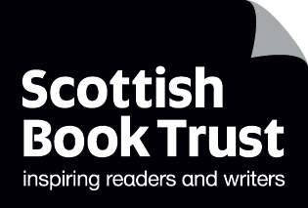

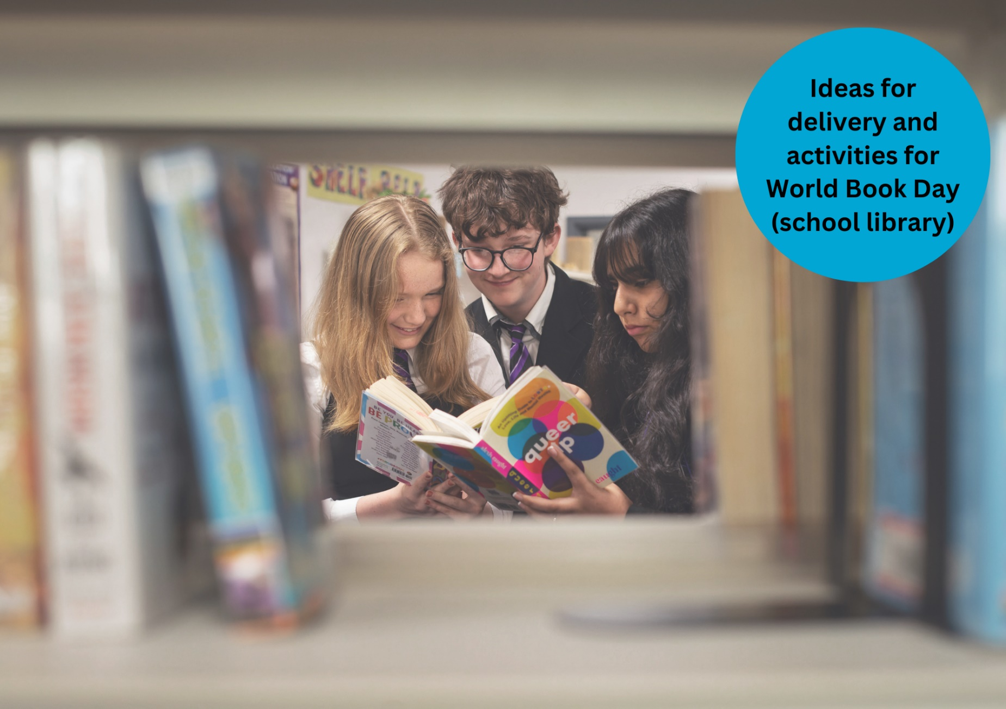

# Celebrating World Book Day: school library resource

A guide to World Book Day in your school library

## Decorative imageResource created by Scottish Book Trust and World Book Day

scottishbooktrust.com

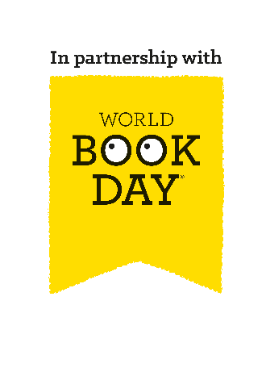

Scottish Book Trust is a registered company (SC184248)

and a Scottish charity (SC027669).

## Contents

About this resource 2

Scottish Book Trust packages 3

Library activities for World Book Day 3

Next steps 6

## About this resource

[Scottish Book Trust](https://www.scottishbooktrust.com/) is a national charity that believes everyone living in Scotland should have equal access to books. Our Schools programmes include book gifting, tours and live events, our [Reading Schools](https://www.readingschools.scot/) accreditation programme, as well as professional support, training and resources to support you to embed reading for pleasure in your school or setting.   
  
[World Book Day](https://www.worldbookday.com/about-us/) is a national celebration which changes lives through a love of books and reading. They are a national charity that operates in the U.K. and Ireland to promote reading for pleasure, offering every child and young person the opportunity to have a book of their own. World Book Day 2025 is **Thursday 6 March**.

We have partnered with World Book Day to adapt their toolkit and resources for Scottish schools and libraries and help you celebrate World Book Day 2025! On [the Scottish Book Trust website](https://www.scottishbooktrust.com/learning-resources/celebrating-world-book-day-in-your-school), you can find all of the resources including:

* A World Book Day planning toolkit
* Celebrating World Book Day: early years resource
* Celebrating World Book Day: primary resource
* Celebrating World Book Day: secondary resource
* Celebrating World Book Day: school library resource
* Celebrating World Book Day: home educator resource

You can also find our [designated World Book Day webpage on the Scottish Book Trust website](https://www.scottishbooktrust.com/learning-and-resources/world-book-day), which gathers activities, articles, videos, and more resources that have been handpicked to help you further explore reading for pleasure and the World Book Day £1 titles!

This resource, created in partnership with World Book Day, contains advice and ideas for celebrating World Book Day in your school library. Throughout, we’ve highlighted Scottish Book Trust resources you can use as part of your celebration, or to deliver further opportunities to read for pleasure. If you need more information on the tokens or practical elements of planning for world book day see our [World Book Day planning toolkit](https://www.scottishbooktrust.com/learning-resources/celebrating-world-book-day-in-your-school).

## Scottish Book Trust packages

On the Scottish Book Trust website, we’ve created [a World Book Day page](https://www.scottishbooktrust.com/learning-and-resources/world-book-day) which gathers activities, articles, videos and more resources to help you celebrate World Book Day. For example, if your pupils have enjoyed *All Poems Aloud* you can you can watch [Joseph Coelho](https://www.scottishbooktrust.com/authors-live-on-demand/joseph-coelho-poetry-is-for-everyone) on Authors Live, or learn how to [make your own poetry stones](https://www.scottishbooktrust.com/learning-resources/how-to-make-poetry-stones). If they preferred *The Wolf Trials*, you can watch [Kiran Milwood Hargrave](https://www.scottishbooktrust.com/authors-live-on-demand/kiran-millwood-hargrave) or read [our top tips for writing your own fantasy fiction](https://www.scottishbooktrust.com/articles/top-tips-for-writing-fantasy-fiction). If children are after book recommendations, you can also find our “What to read after World Book Day” book lists for [beginning and early readers](https://www.scottishbooktrust.com/book-lists/what-to-read-after-world-book-day-beginning-and-early-readers) as well as [fluent and independent](https://www.scottishbooktrust.com/book-lists/what-to-read-after-world-book-day-fluent-and-independent-readers), which suggest books that pupils might like based upon what they have chosen from the World Book Day £1 titles.

## Library activities for World Book Day

### Activity 1: Library tours

Give each class a tour of the library, during which they can choose a book to borrow or sign up for a library card.

### Activity 2: Authors Live

You could set up your library to screen Authors Live on demand broadcasts throughout the day. Why not put pupils in charge of who to watch? You’ll find some of the World Book Day authors in there, including [Axel Scheffler](https://www.scottishbooktrust.com/authors-live-on-demand/axel-scheffler-25-years-of-the-gruffalo), [Kiran Milwood Hargrave](https://www.scottishbooktrust.com/authors-live-on-demand/kiran-millwood-hargrave), [Nadia Shireen](https://www.scottishbooktrust.com/authors-live-on-demand/nadia-shireen-welcome-to-grimwood), [Joseph Coelho](https://www.scottishbooktrust.com/authors-live-on-demand/joseph-coelho-poetry-is-for-everyone) and more! For more information see our [Making the most of Authors Live resource](https://www.scottishbooktrust.com/learning-resources/make-the-most-of-authors-live).

### Activity 3: Three books I like

Invite teaching staff to select three books they’ve enjoyed to display in their classroom. This could spark book talk in the classroom and encourage pupils to visit the library to borrow books.

### Activity 4: Whose book is this?

Compile a quiz where students have to match the shelfie (image of a bookshelf) or favourite book to the correct member of staff.

### Activity 5: Make your own photo booth

Set up a makeshift photo booth, using a cardboard box as a frame, and invite students to have their photos taken with their chosen book or magazine. You can collect props to match different types of books.

### Activity 6: Set yourself a reading dare

Use the [Bookzilla app](https://www.scottishbooktrust.com/learning-resources/using-bookzilla-in-your-school) to set yourself a reading dare! Pupils can download this on their own device or on a school iPad.

### Activity 7: Create your own genre fortune teller

Use our [Bookzilla Genre fortune teller template](https://www.scottishbooktrust.com/learning-resources/using-bookzilla-in-your-school) to create your own fortune teller that tells you what genre you try for your next read!

### Activity 8: Design your own bookmarks or shelf shouters

Invite students to create a bookmark or shelf shouter to recommend a book to someone else! You could also use [World Book Day’s printable activity sheet](https://www.worldbookday.com/resource/reading-recommendation-bingo/) to play a game of Book recommendation bingo as a warm up activity.

### Activity 9: Hide and seek books

Ask pupils to write a paragraph on a topic of your choosing and challenge them to hide as many book titles as they can in the text.

### Activity 10: Dream reading spaces

Ask pupils to design their ideal reading space, including all the accessories needed for a good reading session.

### Activity 11: Audio samples

Select snippets of audiobooks that might appeal to your students’ interests. Ask them to try 10 different titles for five minutes each. Are there any they’d spend another 5 – or 10 – minutes with?

### Activity 12: Book speed dating

This is a great activity for allowing pupils to sample a variety of different books in a short space of time, and to help you get an indication of the books that pupils enjoy reading. Set out a few different book stations and ask pupils to pick a book and spend a few minutes reading, before moving onto the next station. Pupils jot down their first impressions of the book as they go, and whether they would like to keep reading. This activity was taken from our [Running reading groups and events](https://www.scottishbooktrust.com/learning-resources/create-a-reading-culture-get-your-school-reading) resource where you can find more activities!

### Activity 13: Book Jenga

Transform a game of Jenga into an incredible (and fun!) tool for Book Talk. Book Jenga was a game brought to the attention of Scottish Book Trust by secondary school librarian Deena Wren, winner of our [Scottish Book Trust Learning Professional Award](https://www.scottishbooktrust.com/learning-and-resources/scottish-book-trust-awards/reading-champion-awards).   
  
All you will need to create book Jenga is a set of Jenga blocks, a biro or fine liner pen, and your chosen questions!   
  
You play book Jenga by building your tower and taking it in turns to pull out a block and answer the question on it. You can play either by answering the question yourself, or by asking everyone in the group to answer the question before moving on to the next one. The used block is then placed on top of the tower. Gradually the tower builds and becomes less stable. As with all Jenga, the aim is not to topple the tower. The game ends when the tower falls!  
  
To find this full activity see our [Running reading groups and events](https://www.scottishbooktrust.com/learning-resources/create-a-reading-culture-get-your-school-reading) resource which also contains suggested questions you can use.

### Activity 14: Make a mini book!

[Use our guide to create your own mini book](https://www.scottishbooktrust.com/learning-resources/how-to-make-a-book) – it’s up to you what you put in it! It could be a new book journal to keep track of your favourite books, a sequel to your favourite story, somewhere to keep you favourite jokes or a World Book Day inspired poem.

### Activity 15: Create your own World Book Day inspired hat

A big party needs a party hat! Use [our printable template](https://www.scottishbooktrust.com/learning-resources/make-a-hat-inspired-by-a-book) to create your own hat by cutting it out and either drawing, colouring or collaging.

## Next steps

Promoting reading for pleasure in your school is important all year, not just on World Book Day! For more support to build a reading culture in your school see:

* Our [World Book Day section of the Scottish Book Trust website](https://www.scottishbooktrust.com/learning-and-resources/world-book-day) gathers activities, articles, videos and further resources to further extend reading for pleasure and World Book Day’s £1 titles
* Our [Schools guide](https://www.scottishbooktrust.com/learning-and-resources/our-schools-guide) contains more information on the programmes, CLPL and resources from Scottish Book Trust created to support teachers, educators and librarians in schools
* Our [Running reading groups and events](https://www.scottishbooktrust.com/learning-resources/create-a-reading-culture-get-your-school-reading) resource suggests easy and fun activities you can run in your library to help the pupils in your school start talking about, and engaging with, books.
* Our [teen discussion guides](https://www.scottishbooktrust.com/learning-resources/teen-book-discussion-guides) have been designed for you to run a book group for secondary pupils with a wide range of contemporary teen titles, including authors such as Keith Gray, Maisie Chan, Brian Conaghan, Elle McNicoll, Dean Atta, Patrice Lawrence and more!
* World Book Day’s [Resources Hub](https://www.worldbookday.com/resources) contains lots more reading for pleasure ideas, resources for World Book Day and all year round!

### 