

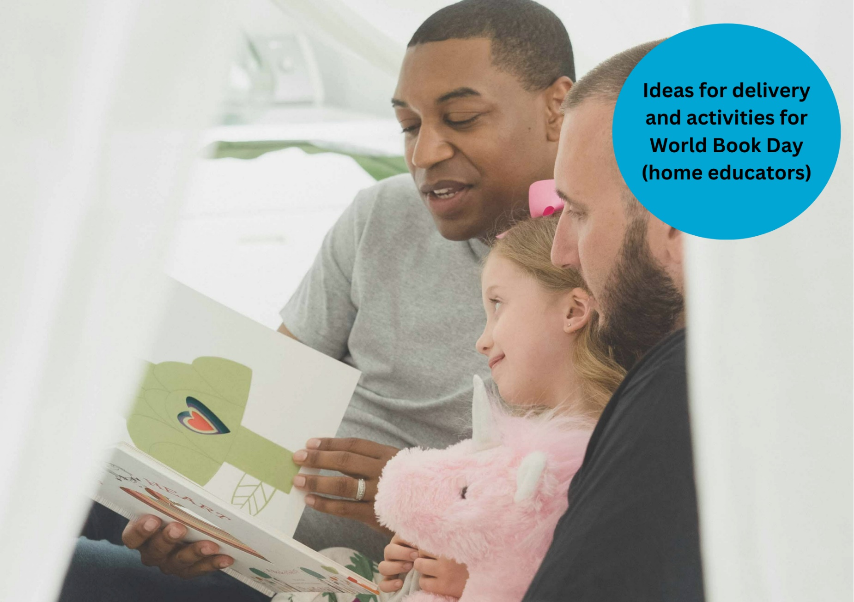

# Celebrating World Book Day: home educators resource

A guide to World Book Day for home educators

## Suitable for early years to older children

## Decorative imageResource created by Scottish Book Trust and World Book Day

scottishbooktrust.com

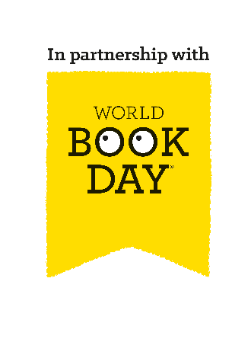

Scottish Book Trust is a registered company (SC184248)

and a Scottish charity (SC027669).

## Contents

About this resource 2

Why celebrate World Book Day? 3

Scottish Book Trust packages 4

Choosing your £1 book 5

Home learning activities 5

For all ages 5

For babies 6

For early years children 7

For school-age children 8

For older children 10

Next steps 11

## About this resource

[Scottish Book Trust](https://www.scottishbooktrust.com/) is a national charity that believes everyone living in Scotland should have equal access to books. Our programmes for children include book gifting, online resources, articles and videos and our on demand Authors Live broadcasts.   
  
[World Book Day](https://www.worldbookday.com/about-us/) is a national celebration which changes lives through a love of books and reading. They are a national charity that operates in the U.K. and Ireland to promote reading for pleasure, offering every child and young person the opportunity to have a book of their own. World Book Day 2025 is **Thursday 6 March**.

We have partnered with World Book Day to adapt their toolkit and resources for Scottish schools, libraries and home educators and help you celebrate World Book Day 2025! On [the Scottish Book Trust website](https://www.scottishbooktrust.com/learning-resources/celebrating-world-book-day-in-your-school), you can find all of the resources including:

* A World Book Day planning toolkit
* Celebrating World Book Day: early years resource
* Celebrating World Book Day: primary resource
* Celebrating World Book Day: secondary resource
* Celebrating World Book Day: school library resource
* Celebrating World Book Day: home educator resource

You can also find our [designated World Book Day webpage on the Scottish Book Trust website](https://www.scottishbooktrust.com/learning-and-resources/world-book-day), which gathers activities, articles, videos, and more resources that have been handpicked to help you further explore reading for pleasure and the World Book Day £1 titles!   
  
This resource, created in partnership with World Book Day, contains advice and ideas for celebrating World Book Day as part of home education. Throughout, we’ve highlighted Scottish Book Trust resources you can use as part of your celebration, or to deliver further opportunities to read for pleasure. If you need more information on the tokens or practical elements of planning for world book day see our [World Book Day planning toolkit](https://www.scottishbooktrust.com/learning-resources/celebrating-world-book-day-in-your-school).

### Dates for your diary

|  |  |
| --- | --- |
| **Date** | **Activity** |
| 13 February | Books available in shops. The earlier you take your tokens to a bookshop, the wider the choice of books will be. See [the World Book Day website](https://www.worldbookday.com/resource/world-book-day-2025-home-educators-pack/) to access your £1 home educator token. |
| 6 March | World Book Day 2025  11am: BBC Teach Live Lesson (online) |
| 23 March | Final day of token exchange |

## Why celebrate World Book Day?

Reading for pleasure is a key indicator of a child’s future success. In fact, studies show its more important for a child’s educational success than the socio-economic class they grow up in[1]. Reading for pleasure has benefits across the curriculum for a child’s skills and learning, as well as their motivation to learn[2]. It also helps develop key life skills such as empathy, imagination, problem-solving and communication skills[3].   
  
By celebrating days like World Book Day, you are demonstrating to children that reading is a fun and worthwhile way to spend their time. By sharing your habits and preferences as a reader, you are also acting as reading role model, helping build a life-long habit. Throughout this resource, we suggest ways to make reading engaging and fun all year round, not just on World Book Day!

World Book Day has six key principles of reading for pleasure. They believe children are more likely to love reading if:

* Someone reads to them regularly
* They find time to read
* They have books at home
* They know a trusted person who can help them find the right books
* We make reading fun for them
* They are given a choice in what they read

## Scottish Book Trust packages

On the Scottish Book Trust website, we’ve created a [World Book Day page](https://www.scottishbooktrust.com/learning-and-resources/world-book-day) which gathers activities, articles, videos and more resources to help you celebrate World Book Day. For example, if your child or children have enjoyed *All Poems Aloud* you can you can watch [Joseph Coelho](https://www.scottishbooktrust.com/authors-live-on-demand/joseph-coelho-poetry-is-for-everyone) on Authors Live, or learn how to [make your own poetry stones](https://www.scottishbooktrust.com/learning-resources/how-to-make-poetry-stones). If they preferred *The Wolf Trials*, you can watch [Kiran Milwood Hargrave](https://www.scottishbooktrust.com/authors-live-on-demand/kiran-millwood-hargrave) or read [our top tips for writing your own fantasy fiction](https://www.scottishbooktrust.com/articles/top-tips-for-writing-fantasy-fiction).   
  
If you’re not sure what to read next, you can also find our “What to read after World Book Day” book lists for [beginning and early readers](https://www.scottishbooktrust.com/book-lists/what-to-read-after-world-book-day-beginning-and-early-readers) as well as [fluent and independent](https://www.scottishbooktrust.com/book-lists/what-to-read-after-world-book-day-fluent-and-independent-readers), which suggest books that pupils might like based upon what they have chosen from the World Book Day £1 titles.  
  
Scottish Book Trust also have a [Home Activities Hub](https://www.scottishbooktrust.com/home-activities) which we keep up-to-date all year round with activities, videos, book lists, articles and more resources to support you to read for pleasure at home together.

## Choosing your £1 book

You can find a full list of the £1 books on the [World Book Day website](https://www.worldbookday.com/books-and-tokens/books/). There are also resources to help you choose the right book, including:

* Look insides: the opening pages of each book (developed with Nielsen)
* Games, conversation starters and sensory activities (developed with Coram Beanstalk and Bag Books)
* Videos from the £1 World Book Day book authors

To find out where you can get your £1 book title, find your local stockist on [the World Book Day website](https://www.worldbookday.com/books-and-tokens/books/participating-retailers/).

## Home learning activities

### For all ages

#### Visit (and revisit!) your Bookbug and Read Write Count with the First Minister bags

[Bookbug Bags](https://www.scottishbooktrust.com/reading-and-stories/bookbug/bookbug-bags) and [Read Write Count bags](https://www.scottishbooktrust.com/reading-and-stories/about-read-write-count) are gifted as follows:

* [Bookbug Baby Bag](https://www.scottishbooktrust.com/reading-and-stories/bookbug/whats-inside-the-2024-bookbug-baby-bag) (3-5 weeks)
* [Bookbug Toddler Bag](https://www.scottishbooktrust.com/reading-and-stories/bookbug/whats-inside-the-2024-bookbug-toddler-bag) (13-15 months)
* [Bookbug Explorer Bag](https://www.scottishbooktrust.com/reading-and-stories/bookbug/whats-inside-the-2024-bookbug-explorer-bag) (age 3)
* [Bookbug Primary 1 Family Bag](https://www.scottishbooktrust.com/reading-and-stories/bookbug/whats-inside-the-2024-bookbug-primary-1-family-bag) (primary 1)
* [Read Write Count with the First Minister](https://www.scottishbooktrust.com/reading-and-stories/about-read-write-count) ([P2](https://www.scottishbooktrust.com/learning-resources/read-write-count-for-p2) and [P3](https://www.scottishbooktrust.com/learning-resources/read-write-count-for-p3))

Whether you’ve just received a bag or are revisiting a bag, the books and resources have been chosen to be read, played with and explored again and again. This could offer a great conversation starter about how our reading identities change over time. What did you notice the first time you read these books? What do you notice now? What has changed?  
  
If you have older children, putting them in charge of reading to their younger siblings can be a great way to get the whole family reading together. Who can do the best voices?

#### Dressing up or decorating

Dressing up can be a fun way to celebrate your child’s favourite book. World Book Day’s dressing-up webpage contains lots of top tips for cheap, easy-to-make costumes that connect meaningfully to reading.  
  
If you’d rather not dress up, there’s loads of alternative activities, for example: creating dioramas or collections to represent favourite books or making your own reading mood boards (see page 10).

#### Revisiting your books

Look at what books you have at home and where you keep them. World Book Day is a great chance to revisit what books you have and set up a cosy reading space. It doesn’t have to be complex – a blanket fort can make reading exciting and new!

#### Visit your local library

Going to the library is a great way to make books fun and familiar. Use the [mygov.scot website](https://www.mygov.scot/find-library) to find your local library. Your librarian will be able to offer book recommendations, and show you how you, and your children, can access books, newspapers, magazines or audio content.

#### Celebrate together

Go out together to your local library or bookshop for a book recommendation. You could also connect with your local home-educator community – why not set up a book swap?

### For babies

Bookbug sessions  
Bookbug Sessions are free events for children aged 0-5 years and their mums, dads and carers. Sessions last around 30 minutes and include songs, rhymes and a story. Going to a Bookbug Session is a great way for families to spend time bonding with each other and meeting other families in their local area. You can find your local one via [the Scottish Book Trust website](https://www.scottishbooktrust.com/reading-and-stories/bookbug/find-your-local-bookbug-session).

#### Notice their reading preferences

Allow them to choose a book from a small selection and notice which is their favourite (even if it’s their favourite to chew!). If you’re not sure where to get started, see our article of top tips for reading to babies and young children on [the Scottish Book Trust website](https://www.scottishbooktrust.com/reading-and-stories/sharing-books-with-babies-and-young-children).

#### Reading regularly

Incorporate reading into their routine – for example, before bed or at naptime. If you need some ideas or inspiration, see our article on building routine with stories, songs and rhymes [on the Scottish Book Trust website](https://www.scottishbooktrust.com/articles/you-and-your-baby-building-routines-with-stories-songs-and-rhymes). You can also use [the Bookbug Song and Rhyme Library](https://www.scottishbooktrust.com/songs-and-rhymes) or the [Bookbug Songs and Rhymes app](https://www.scottishbooktrust.com/reading-and-stories/bookbug/bookbug-app) on your phone to regularly share songs and rhymes together.

#### What does reading look like for you?

Think about what reading looks like for you as a family – it can be a quiet moment to relax and cuddle, or it can be a more playful activity that takes you all around the house.

#### Books are play

Add books to your baby’s play. Try tying it into activities they’re already enthusiastic about.

### For toddlers and preschool children

#### World Book Day activities

See the World Book Day website for activities, including:

* The [£1 book information sheets](https://www.worldbookday.com/resource/world-book-day-2024-1-e1-50-book-information-sheets/) which contain sensory activities, games and conversation starters
* [Low-cost dressing up resources with templates](https://www.worldbookday.com/download/63389/?tmstv=1733311631) for this year’s £1 books
* [Share a Story Corner videos](https://www.worldbookday.com/families/share-a-story-corner/) which are easy-to-follow reading of some much-loved picture books as well as related activities and conversation prompts. Please note, you can also find some of these videos on the [Bookbug app](https://www.scottishbooktrust.com/reading-and-stories/bookbug/bookbug-app)!

#### Design your own hot air balloons (*The Magic Balloon*)

EXA 0-02a, SCN 0-04a, SCN 0-07a  
Invite children to design their own hot-air balloons to hide around your house. With your help, children might want to experiment with creating flying balloons by blowing on different materials with a hairdryer and then working together to create a hot-air-balloon shape.

#### Make a reading den (*Bluey’s Little Book*)

TCH 0-04b, TCH 0-04c, TCH 0-09a, TCH 0-10a  
Bluey’s family love making dens and other areas to read in. Can your children create their own reading den, inside or outside, with the materials you provide?

#### Create your own small-world (*Who’s in Acorn Wood?*)

TCH 0-09a, TCH 0-10a  
The Acorn Wood characters love visiting each other’s houses. Can your children make them somewhere to visit, using small-world materials or role play?

#### Reading mood characters (*Barbara’s Very Useful Guide to Moods*)

EXA 0-02a, EXA 0-04a, TCH 0-09a, TCH 0-10a  
Talk to children about how reading makes them feel and about how they would like it to make them feel. Share the image of Barbara – can they create reading-mood characters?

### For school-age children

#### World Book Day activities

See the World Book Day website for activities, including:

* The £1 book information sheets which contain sensory activities, games and conversation starters
* Low-cost dressing up resources with templates for this year’s £1 books
* Share a Story Corner videos which are easy-to-follow reading of some much-loved picture books as well as related activities and conversation prompts

#### Reading river

LIT 0-01b/0-11b/1-01a/2-01a, LIT 0-14a/1-14a/2-14a, LIT 0-07a/0-16a/1-16a/2-16a, LIT 1-28a/1-29a/2-28a, EXA 0-02a/1-02a/2-02a, EXA 0-04a/1-04a/2-04a  
A reading river is a poster that charts what a child has read, allowing them to reflect on their own reading journey and celebrate the reading they do at home. From the books they read as a baby, to recipes or the instruction guides from favourite hobbies to magazines or comics. To find out more about Reading rivers, see the [Multilingualism in Schools guide on their website](https://www.multilingualism-in-schools.net/rivers-of-reading/). The following activity has been developed by Dr. Sabine Litte from the University of Sheffield:  
  
Five steps to creating a multilingual Reading river:  
Step 1  
Think back to when you were little: who were the people reading with you? Ask them for help to remember which books and other texts were important to you then, and what languages they were in.  
  
Step 2  
Think beyond books: in a Reading river, all texts matter. Is reading messages from your friends important, or reading a particular magazine? Do you love cooking and reading recipes? Do you read as part of gaming, or to follow celebrities online? It all counts, and it all matters!  
  
Step 3  
“Important” doesn’t always mean “favourite”. In fact, some reading might be important because you didn’t enjoy it at all, or because it was super hard! Or perhaps it links to a special person: a book received from a grandparent, or something you read together with a friend. It could also be what a book stands for: the first book you read in a specific language or the first thing you read after moving to a new country. You, and only you, decide what is important and why.

Step 4  
Think about the languages you speak, and when and where they come into your Reading river. Has this changed over time, or is it different for different things you read (books, magazines, webpages, gaming, etc)?  
  
Step 5  
Your Reading river is your story, so make sure you tell it. Share your rivers with each other!  
  
Create a reading mood board  
LIT 0-04a/1-04a/2-04a, LIT 0-01b/0-11b/1-11a/2-11a  
World Book Day has created [a downloadable PowerPoint](https://www.worldbookday.com/download/63379/?tmstv=1733309719) which you can use to create your own reading mood board. This is a great way to promote conversations about reading and how reading can make you feel, as well as role modelling reading and sharing book recommendations.

#### Make a Read Your Way bookshelf

LIT 1-11a/2-11a  
Go through your books and discuss ways of reading that suit particular moods or time of day. Allow your children to organise their books according to their own system – whether mood, genre or their own ideas!

#### BBC Teach Live Lesson and Authors Live

Join in with World Book Day’s online BBC Teach Live Lesson at 11am on the day. You can also watch one of Authors Live on demand broadcasts on [the Scottish Book Trust website](https://www.scottishbooktrust.com/authors-live-on-demand) – you’ll find some World Book Day authors in there, including [Axel Scheffler](https://www.scottishbooktrust.com/authors-live-on-demand/axel-scheffler-25-years-of-the-gruffalo), [Kiran Milwood Hargrave](https://www.scottishbooktrust.com/authors-live-on-demand/kiran-millwood-hargrave), [Nadia Shireen](https://www.scottishbooktrust.com/authors-live-on-demand/nadia-shireen-welcome-to-grimwood), [Joseph Coelho](https://www.scottishbooktrust.com/authors-live-on-demand/joseph-coelho-poetry-is-for-everyone) and more! Make it a special occasion by making some popcorn or viewing snacks.

#### Reading prescription

LIT 1-11a/2-11a  
Use World Book Day’s Reading prescription activity to talk about your child’s interest and identify a book request. Take your child’s completed prescription to your local library or bookshop to get a recommendation!

#### Sticks and Shadows for Play

HWB 1-01a/2-01a, HWB 1-03a/2-03a, HWB 1-05a/2-05a   
Use World Book Day’s Sticks and Shadows for Play resource, created in partnership with Jigsaw Education Group, to encourage outdoor reading and experiences to support children’s social and emotional learning. You can also see the [Heading outdoors section of the Scottish Book Trust website](https://www.scottishbooktrust.com/topics/heading-outdoors) to find more activities and inspiration for taking reading outdoors.

### For older children

#### Authors Live

Authors Live brings world-class children’s authors and illustrators into your home! Use the [Authors Live on demand library](https://www.scottishbooktrust.com/authors-live-on-demand) to find a broadcast to watch. You can find some World Book Day book authors such as [Kiran Milwood Hargrave](https://www.scottishbooktrust.com/authors-live-on-demand/kiran-millwood-hargrave) or some familiar favourites, such as [Elle McNicoll](https://www.scottishbooktrust.com/authors-live-on-demand/elle-mcnicoll), [Sarah Crossan](https://www.scottishbooktrust.com/authors-live-on-demand/sarah-crossan) or [Keith Gray](https://www.scottishbooktrust.com/authors-live-on-demand/keith-gray). Make it a special occasion by making some popcorn or viewing snacks.

#### Book recommendation videos

LIT 2-04a/3-04a/4-04a, LIT 2-14a/3-14a/4-14a, TCH 2-01a/3-01a/4-01a,   
EXA 2-14a/3-14a/4-14a  
Why not take up the challenge of creating your own 10-second video on one of the following topics:

* An introduction to their to-be-read pile
* ‘I’ve never found anything I want read, but I do like…’
* The books that make me…laugh/cry/think/change the way I act
* A top tip or reading recommendation
* A 10-second summary of a book

You can also use [our resource on Book reviews and trailers on the Scottish Book Trust website](https://www.scottishbooktrust.com/learning-resources/book-reviews-and-trailers-on-film).

#### Reading routines

Make reading a bit of your routine each day. You could:

* Find a book you want to read and find some time each day to read it
* Find a podcast or audiobook and listen to it together whilst doing something else (e.g. crafting, drawing, etc.)
* Talk to someone about books every day: ask what they’re reading and where they read it
* Think about how you want to feel when you read and ask someone for a book recommendation to suit the mood

## Next steps

Promoting reading for pleasure is important all year, not just on World Book Day! For more support to read together, see:

* Our [World Book Day section of the Scottish Book Trust website](https://www.scottishbooktrust.com/learning-and-resources/world-book-day) gathers activities, articles, videos and further resources to further extend reading for pleasure and World Book Day’s £1 titles.
* Scottish Book Trust’s [Home Activities Hub](https://www.scottishbooktrust.com/home-activities) contains activities, videos, book lists, articles and more resources to support you to read for pleasure at home together.
* World Book Day’s [Resources Hub](https://www.worldbookday.com/resources) contains lots more reading for pleasure ideas, resources for World Book Day and all year round!
* You can find further activities mapped onto Curriculum for Excellence in our [early years, primary and secondary World Book Day resources](https://www.scottishbooktrust.com/learning-resources/celebrating-world-book-day-in-your-school). These activities have been designed for school use, but please do feel free to adapt these for home learning!

1. ## Endnotes

   [“Reading for Change: Performance and Engagement across Countries”](https://read.oecd-ilibrary.org/education/reading-for-change-performance-and-engagement-across-countries_9789264099289-en#page1), PISA 2020
2. [“Motivation During an Excessively Challenging Reading Task: The Buffering Role of Relatvie Topic Interest”](https://www.researchgate.net/publication/233060749_Motivation_During_an_Excessively_Challenging_Reading_Task_The_Buffering_Role_of_Relative_Topic_Interest), The Journal of Experimental Education. 2011.
3. [“The role of home learning environment and emerging insights into the impact of the pandemic”](https://cdn.literacytrust.org.uk/media/documents/The_role_of_the_home_learning_environment_and_emerging_insights_-_FINAL_LedgnMX.pdf). National Literacy Trust. 2022.