Our learning resources for specific books

About this resource
You can search this resource for specific titles or authors. Each title is linked to the resource page on our website where you can download the activity pack for each book in different formats. You can also find all of our resources by visiting the Learning and resources section of the Scottish Book Trust website.

Early Level texts
Cover image | Title and author | Themes
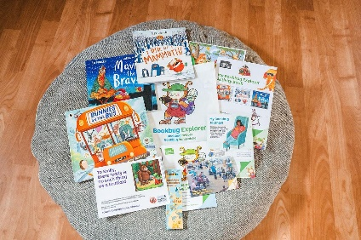 | Bookbug Explorer Bag Books | Each year, we gift picture books to children aged 3 across Scotland. Each book comes with fun and inclusive activities. Visit our website to find the resources for the books this year.
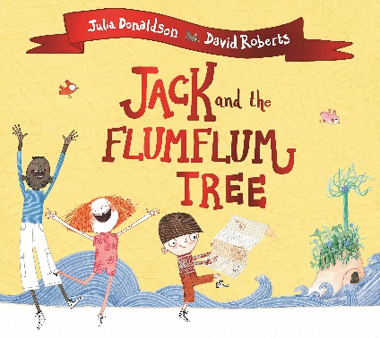 | Jack and the Flumflum Tree by Julia Donaldson and David Roberts | Make your own patchwork sack, play a memory game and experiment with floating and sinking using these eight cross-curricular activities suitable for early and first level.
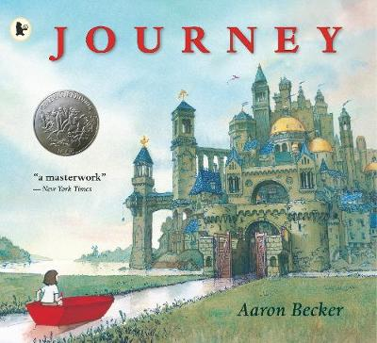 | Journey by Aaron Becker | Explore where your magical crayon might take you, create a journey stick and use mime to reflect different emotions using these cross-curricular activities. This resource can be used as a whole school core book project.
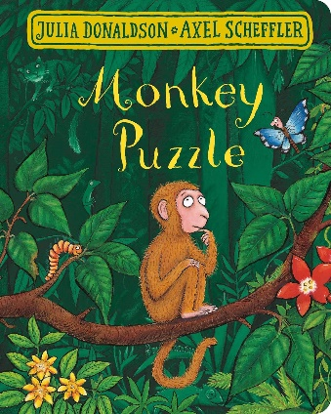 | Monkey Puzzle by Julia Donaldson and Axel Scheffler | Roleplay different animals, go for a nature walk and make your own symmetrical butterflies using these nine cross-curricular activities suitable for early and first level.
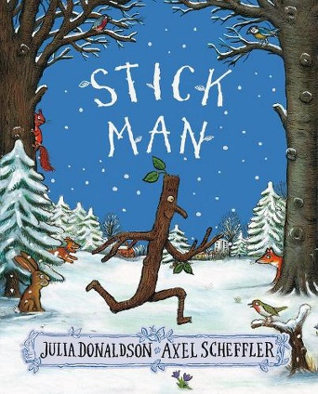 | Stick Man by Julia Donaldson and Axel Scheffler | Create a class story, play pooh sticks and design your own stick man with these seven cross-curricular activities suitable for early and first level.
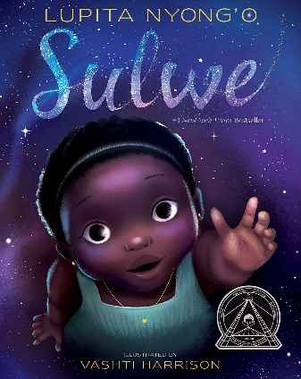 | Sulwe by Lupita Nyong’o and Vashti Harrison | Make a human sundial, explore your unique skin tone, and play with rhyming words using these eight cross-curricular activities suitable for early and first level. This is part of our Read Woke South Ayrshire resource, which empowers learners to engage with social justice issues.
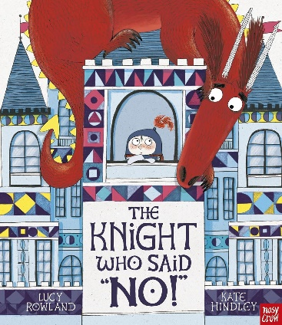 | The Knight who said “No!” by Lucy Rowland and Kate Hinley | Make a sensory castle corner, act out different jobs and use drama to role-play having a ‘yes’ and a ‘no’ day using these inclusive activities suitable for early and first level. You could then have a go at making your own dragon using our sensory art project resource.
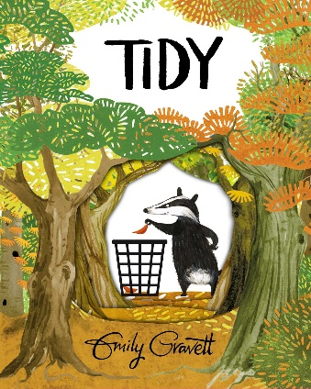 | Tidy by Emily Gravett | Design a tool to help keep your playground tidy, research different kinds of leaves and draw your own badger with these cross-curricular activities. This resource can be used as a whole school core book project.
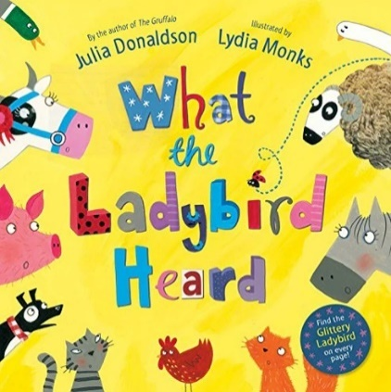 | What the Ladybird Heard by Julia Donaldson and Lydia Monks | Create a farmyard scene, throw a party or make a news report using these cross-curricular activities suitable for early and first level.

