Our learning resources for specific books

About this resource
You can search this resource for specific titles or authors. Each title is linked to the resource page on our website where you can download the activity pack for each book in different formats. You can also find all of our resources by visiting the Learning and resources section of the Scottish Book Trust website.

Third Level texts
Cover image | Title and author | Themes
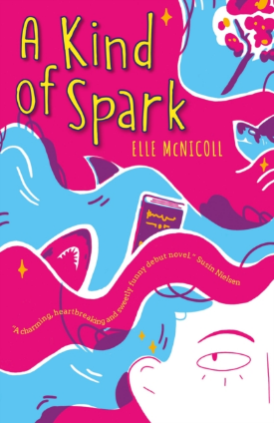 | A Kind of Spark by Elle McNicoll | A Kind of Spark follows Addie, an autistic 11-year-old who campaigns for a memorial in her town in remembrance of the women killed during the Scottish witch trials. Explore metaphors and similes, discuss ableist language, go on an empathy walk, and learn about women accused of witchcraft using these nine cross-curricular activities.
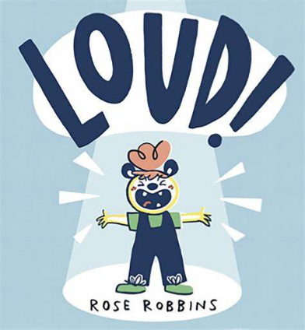 | LOUD! by Rose Robbins | LOUD! is a picture-book full of sounds and textures, making it perfect for sensory-storytelling. The recommended props and actions described in this resource will bring the book to life for all ages and abilities. Suitable for first to fourth level.
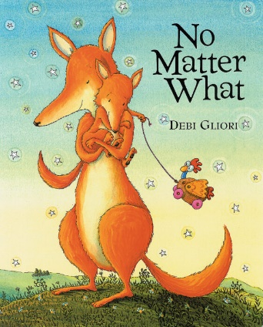 | No Matter What by Debi Gliori | Explore body language connected to different emotions and practise being a good listener using this picture book as a prompt. These health and wellbeing activities are part of a resource to support children through grief and loss. Suitable for early to third level.
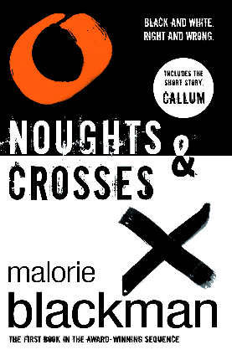 | Noughts and Crosses by Malorie Blackman | Develop a news broadcast, research the civil rights movement, and write your own powerful political speech using these five cross-curricular activities suitable for third, fourth and senior phase.
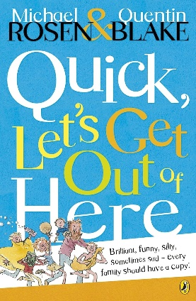 | Selection of Poems by Michael Rosen | Build confidence discussing, writing and performing poetry using these fun cross-curricular activities. These activities have been designed to be used with five poems by Michael Rosen which are included in the resource.
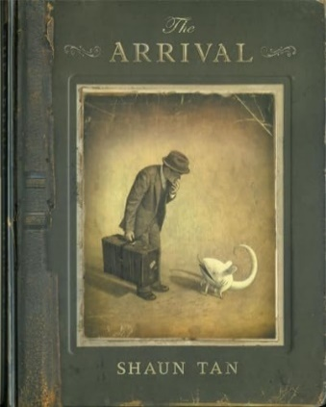 | The Arrival by Shaun Tan | Write an interactive story about a journey, discuss and create your own ‘citizenship test’, and make a scrap album of things you’d want to look at to remind you of home using these cross-curricular activities. This resource can be used for intense week or day activities, or as a yearlong project. It is designed to promote multi-disciplinary connection and collaboration and is suitable for third and fourth level.
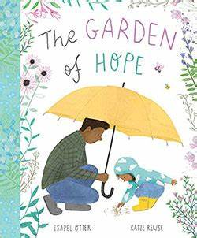 | The Garden of Hope by Isabel Otter and Katie Rewse | Using this picture book, explore how worries feel and make your own worry doll. These health and wellbeing activities are part of a resource to support children through grief and loss. Suitable for early to third level.
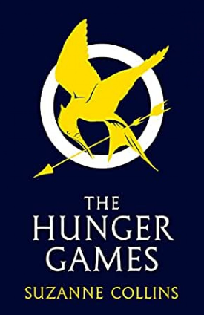 | The Hunger Games by Suzanne Collins | Have a camouflage challenge, make music like a mockingjay, learn basic first aid and how body systems work, and design your own outfit for the games using these cross-curricular activities. This resource can be used for intense week or day activities, or as a yearlong project. It can be used with one class or across the whole school and is suitable for third to senior phase.
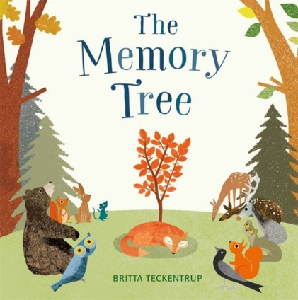 | The Memory Tree by Britta Teckentrup | Explore how memories make us feel and make a memory box for Fox using these health and wellbeing activities. This resource can be used to support children through grief and loss. Suitable for early to third level.
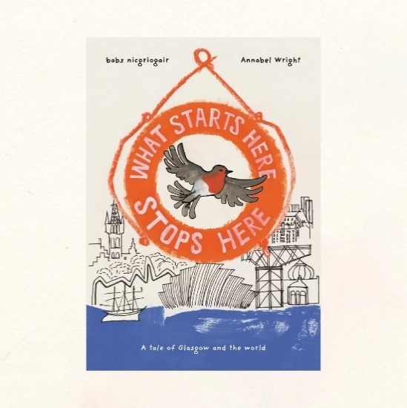 | What Starts Here Stops Here by Hope Street Collective | The book follows a robin who is blown off course by a gale, and journeys back in time through the history of Glasgow. It focuses on the connection between colonialism and climate change. This resource will help you create your own version of the book to reflect on your local area. Each activity is designed to help you gather material for the book and learn more about colonialism, protest and climate change.
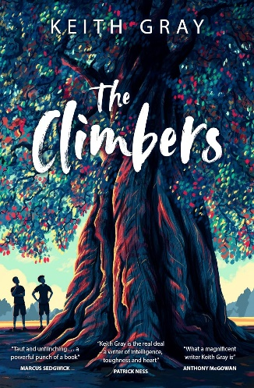 | The Climbers by Keith Gray | Part of our Teen discussion guides. Various titles suitable for 12+ readers. Each guide contains 3-4 discussion prompts and 2 creative writing prompts, as well as suggestions of other books that readers might like.
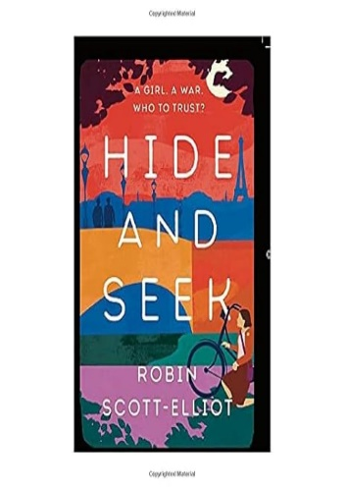 | Hide and Seek by Robin Scott-Elliot | Part of our Teen discussion guides. Various titles suitable for 12+ readers. Each guide contains 3-4 discussion prompts and 2 creative writing prompts, as well as suggestions of other books that readers might like.
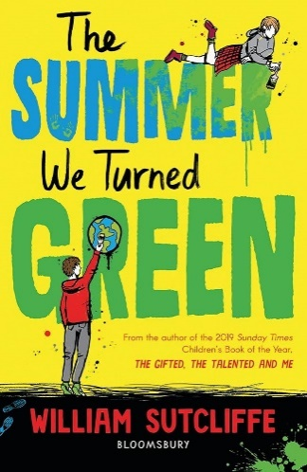 | The Summer We Turned Green by William Sutcliffe | Part of our Teen discussion guides. Various titles suitable for 12+ readers. Each guide contains 3-4 discussion prompts and 2 creative writing prompts, as well as suggestions of other books that readers might like.
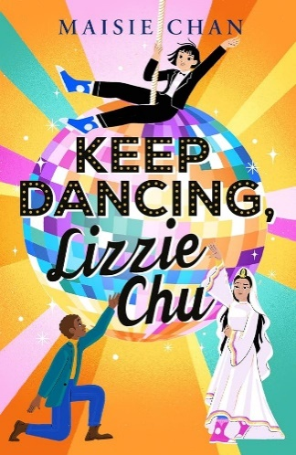 | Keep Dancing, Lizzie Chu by Maisie Chan | Part of our Teen discussion guides. Various titles suitable for 12+ readers. Each guide contains 3-4 discussion prompts and 2 creative writing prompts, as well as suggestions of other books that readers might like.
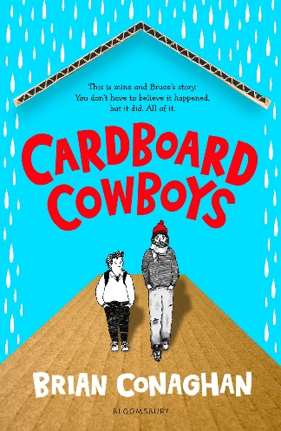 | Cardboard Cowboys by Brian Conaghan | Part of our Teen discussion guides. Various titles suitable for 12+ readers. Each guide contains 3-4 discussion prompts and 2 creative writing prompts, as well as suggestions of other books that readers might like.
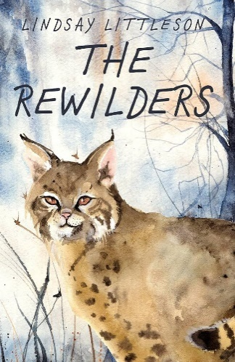 | The Rewilders by Lindsay Littleson | Part of our Teen discussion guides. Various titles suitable for 12+ readers. Each guide contains 3-4 discussion prompts and 2 creative writing prompts, as well as suggestions of other books that readers might like.
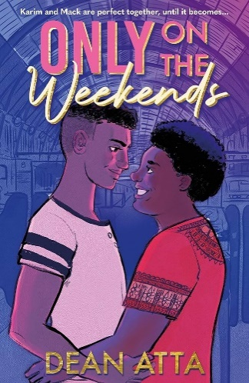 | Only On the Weekends by Dean Atta | Part of our Teen discussion guides. Various titles suitable for 12+ readers. Each guide contains 3-4 discussion prompts and 2 creative writing prompts, as well as suggestions of other books that readers might like.
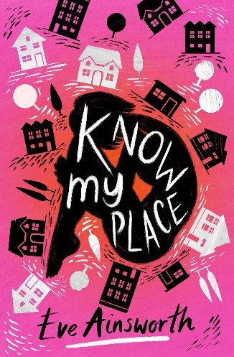 | Know My Place by Eve Ainsworth | Part of our Teen discussion guides. Various titles suitable for 12+ readers. Each guide contains 3-4 discussion prompts and 2 creative writing prompts, as well as suggestions of other books that readers might like.
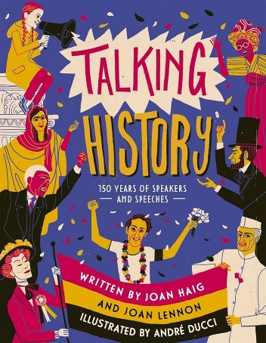 | Talking History by Joan Lennon and Joan Haig | Part of our Teen discussion guides. Various titles suitable for 12+ readers. Each guide contains 3-4 discussion prompts and 2 creative writing prompts, as well as suggestions of other books that readers might like.
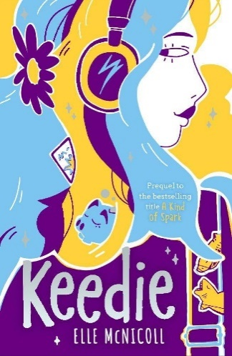 | Keedie by Elle McNicoll | Part of our Teen discussion guides. Various titles suitable for 12+ readers. Each guide contains 3-4 discussion prompts and 2 creative writing prompts, as well as suggestions of other books that readers might like.
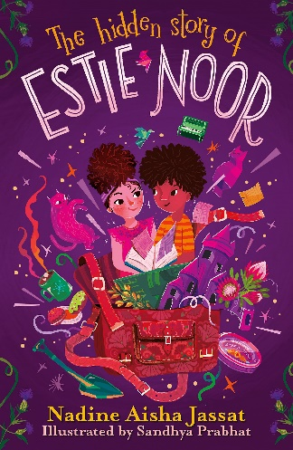 | The Hidden Story of Estie Noor by Nadine Aisha Jassat and Sandhya Prabhat | Part of our Teen discussion guides. Various titles suitable for 12+ readers. Each guide contains 3-4 discussion prompts and 2 creative writing prompts, as well as suggestions of other books that readers might like.
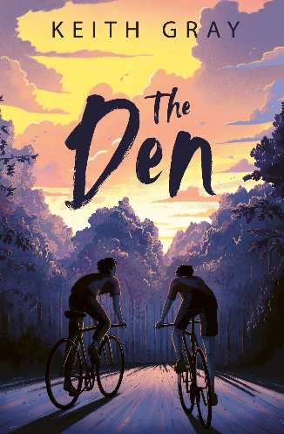 | The Den by Keith Gray | Part of our Teen discussion guides. Various titles suitable for 12+ readers. Each guide contains 3-4 discussion prompts and 2 creative writing prompts, as well as suggestions of other books that readers might like.
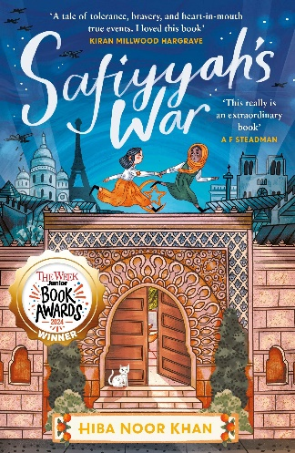 | Safiyyah's War by Hiba Noor Khan | Part of our Teen discussion guides. Various titles suitable for 12+ readers. Each guide contains 3-4 discussion prompts and 2 creative writing prompts, as well as suggestions of other books that readers might like.
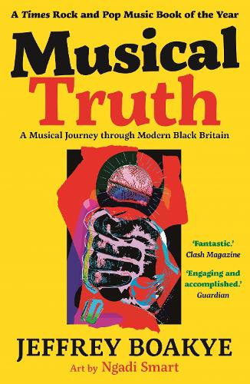 | Musical Truth by Jeffrey Boakye and Ngadi Smart | Part of our Teen discussion guides. Various titles suitable for 12+ readers. Each guide contains 3-4 discussion prompts and 2 creative writing prompts, as well as suggestions of other books that readers might like.
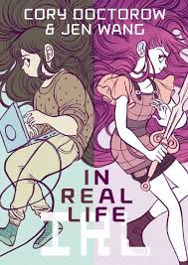 | In Real Life by Cory Doctorow and Jen Wang | Part of our Teen discussion guides. Various titles suitable for 12+ readers. Each guide contains 3-4 discussion prompts and 2 creative writing prompts, as well as suggestions of other books that readers might like.
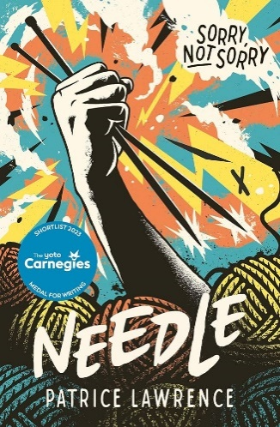 | Needle by Patrice Lawrence | Part of our Teen discussion guides. Various titles suitable for 12+ readers. Each guide contains 3-4 discussion prompts and 2 creative writing prompts, as well as suggestions of other books that readers might like.
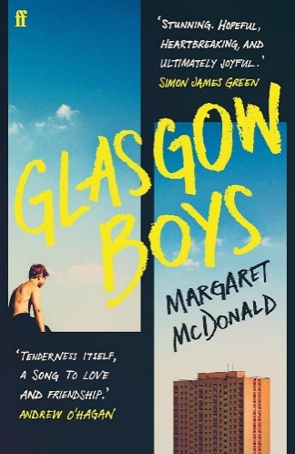 | Glasgow Boys by Margaret McDonald | Part of our Teen discussion guides. Various titles suitable for 12+ readers. Each guide contains 3-4 discussion prompts and 2 creative writing prompts, as well as suggestions of other books that readers might like.
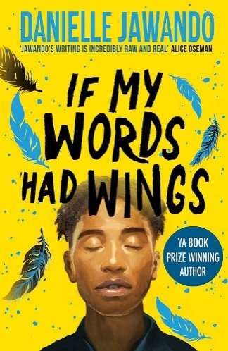 | If My Words Had Wings by Danielle Jawando | Part of our Teen discussion guides. Various titles suitable for 12+ readers. Each guide contains 3-4 discussion prompts and 2 creative writing prompts, as well as suggestions of other books that readers might like.
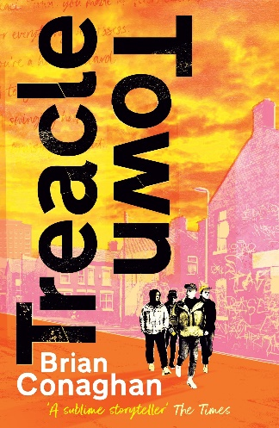 | Treacle Town by Brian Conaghan | Part of our Teen discussion guides. Various titles suitable for 12+ readers. Each guide contains 3-4 discussion prompts and 2 creative writing prompts, as well as suggestions of other books that readers might like.

